Great Basin College
STRATEGIC PLAN

2009 – 2016

August, 2009

Great Basin College
Elko, Nevada

Contents

Overview 1
The College and Its Environment 1
Planning Process 2
Major Components of Planning 3
Strategic Frameworks 3
Assessment 5
Department Planning 5
Planning with Assessment 6
On-line Planning Documentation 6
GBC Mission and Themes 7
GBC Themes and Goals 10
GBC Themes & Goals with Objectives 11

Appendix A—College Data, 2002—2008 14
Appendix B—Sample Action Plans 21

Great Basin College Strategic Plan, 2009-2016

Overview
This proposed strategic plan is presented to the Nevada System of Higher Education (NSHE) Board of Regents in fulfillment of NSHE Title 4, Chapter 14, Section 3, Institutional Strategic Plans (March 28, 2007).

Introductory information on Great Basin College and the college’s service area is followed by a brief description of the planning process. The concept of college Themes, a new requirement in the Northwest Commission on Colleges and Universities standards, is defined and illustrated in several pages of Institutional Goals and Objectives. This is the core of college-wide strategic planning for the coming six years. The college’s strategic framework consists of a conventional model of mission, goals, objectives, and action plans. In addition, we are introducing a model of four interacting components of planning—the institution, departments, students in programs, and a component we call In the Trenches. These four components, or frames, also reveal ways of thinking productively about assessment. This strategic plan features a much expanded outlook on planning, asking all departments to construct their own plan. Finally, Great Basin College is introducing an exciting new tool—on-line planning and assessment documentation.

The College and Its Environment
Great Basin College is unique in the extreme sparsity of its distribution of population. At 62,000 square miles with less than 120,000 residents, the service area of GBC has the most isolated population in the contiguous United States. The people of this region treasure the value of life that comes with living small towns. While often characterized as “rural,” the service area is actually “frontier;” most residents live within small cities and towns separated by tens to hundreds of miles, and not on farms and ranches. Most residents are in some way associated with natural resources for their livelihoods and life styles. Mining, ranching, and many varieties of outdoor recreation are important to the region and are fundamental as a way of life.

Serving the people of the Great Basin has many challenges with great rewards. It is neither simple nor inexpensive to serve these residents. Classes either must be taught in small sizes in remote locations, or courses must be delivered through distance technologies. However, the often place-bound students living in these widely separated places greatly appreciate the access provided to advance their knowledge and careers, and for providing training for basic services to communities.

Selected data about Great Basin College are provided in Appendix A. These data are presented as being some of the more significant indicators of GBC’s past and potential future for planning. Knowledge of these trends is the basis for the planning presented in this document. Highlights include the following:

- A 48% increase in FTE during the eight-year period from 2001-2002 to 2008-2009, bringing the annual FTE enrollment up to 1747.
- Average age of all students continues to drop.
- In the last two fall semesters, 49% of all students have been under 25 years-of-age, compared to 33% in the fall of 2001.
- The number of degree/certificate opportunities has more than doubled in the past eight years.
- Distance education delivery—interactive video and on-line —comprised 20% of the college’s FTE in 2001-2002 and 52% of the FTE in 2008-2009. Hybrid learning combining interactive and on-line is also used extensively.
Possible explanations for these trends include the following:
- Increased access to higher education provided to residents through distance education.
- The addition of Nye County to the GBC service area.
- Increases in dual-credit programs made possible, in part, by the special tuition rate for high school students enrolling in distance education courses.
- Enrollment in upper division courses.
- More programs available to students.
- The college reputation, always good, has taken a quantum leap in the past 5 to 10 years.

As noted above, GBC’s enrollment has increased in dramatic ways with possible explanations due, with one major exception, to changes within the college, not the environment. At this time, two weeks before classes, it appears that the FTE enrollment for Fall Semester, 2009, will be about 15% above similar dates in previous years. Also, the head count shows even greater possible increase. If this enrollment holds up with students entering and completing classes, then the enrollment increases would continue with an even more significant upward trend. The reasons will probably be a combination of economic recession and the explanations listed above.

GBC’s environment has changed with the addition of Nye County to the service area, which has and will continue to affect student enrollment for the college. Demographic projections (see Appendix A) for the five northeastern counties in service area show modest growth. Nye County, mainly the Pahrump Valley, has a much larger projected growth.

The Planning Process
GBC’s first comprehensive strategic plan was the Strategic Plan, 2003-2009 & and Beyond. However, the objectives and action plans were assigned to and maintained by respective vice-presidents. The current proposed plan broadens the planning effort to include departments, directly involving many more people than previous planning.

During the fall 2008 in-service week, two significant meetings were conducted to gather suggestions from faculty regarding directions (big projects and small ones). These suggestions formed the base for discussion by the Strategic Plan Steering Committee, which met nine times during 2008-2009. GBC’s Advisory Board discussed strategic planning in two meetings in the spring of 2009; the second meeting dealt at some length with the content of the plan. The committee set policies and procedures for departmental planning, developed the framework for strategic planning, and developed drafts of institutional themes, goals, and objectives. Notes of the meetings of the Steering Committee and the Advisory Committee are available upon request.
The January in-service provided an update to faculty and staff on the planning project as a whole. Departments continue to work on their individual strategic plans. A sample departmental strategic plan is located in Appendix B.

Major Components of Planning
The major components of planning are mission statements, themes, goals, objectives, and action plans.

The college mission, themes and goals will remain fairly stable through time. It is possible that new goals may be added, not only in subsequent planning cycles but during the current one. Objectives are priorities and they are “measurable.” When they are accomplished, they would no longer be part of the plan. However, many of the objectives in this proposed plan are not easily achieved to the college’s satisfaction. For example, Improve quality of distance education delivery will be an on-going objective. The challenge is to identify evidence of improvement. Whereas, “Create an institutional document storage and retrieval system,” is done when it’s done, to paraphrase Yogi Berra. Finally, the tasks that are part of an action plan generally fall into the “achieve” or “don’t achieve” category. Objectives in departmental plans also tend to fall into this category. Action plans are formulated for each objective. These action plans are specific, listing tasks that must be accomplished to reach an objective along with target dates and areas of responsibility.

Themes are new to the college’s strategic plans, though they are very similar to the broad goals in GBC’s 2003-2009 plan. New accreditation standards are expected to be ratified by the Northwest Commission for Colleges and Universities in early 2010. These standards require that each institution identify major areas, or themes, for evaluation. GBC has identified student success, planning and performance, sustainability, and serving rural Nevada as four central institutional themes.

As delineated in this document, the institution has an approved mission, four themes, sixteen current goals and many objectives for accomplishing the goals. The institutional action plans, including dates for completion, are under development.

Currently, all departments and programs have mission statements, most have objectives, and some have goals. All but a few have action plans for accomplishing the objectives.

Strategic Framework
To design a cohesive Strategic Plan that integrates all functions of the college, including assessment, a framework for viewing the levels and relations of planning and assessment was developed and is presented on the next page.

Frame 1, deals with the institution as a whole; Frame 2 with departments and programs (academic, student services, and administrative services), and Frame 3 settles on student learning in programs. GBC’s programs include general education and all certificate and degree programs. Each program has a set of student learning outcomes, as listed in the college catalog.

Frame 4, “In the Trenches,” recognizes college courses as the central activity for students and for teaching faculty. The “Trenches” also include student services personnel analyzing incoming transcripts or finding ways for students to fund their education. It includes building & grounds employees maintaining attractive, clean, and safe environments. And so on.

Graphic Representation of GBC’s Strategic Plan Framework:

Frame 1 |  | Frame 2 |  | Frame 3 |  | Frame 4
 |  | DEPARTMENTS |  | STUDENTS |  | COURSES
INSTITUTIONAL | ↑↓ | & PROGRAMS | ↑↓ | IN PROGRAMS | ↑↓ | & SERVICES
⬇ |  | ⬇ |  | ⬇ |  | ⬇
Mission |  | Mission Statements
⬇ |  | ⬇ |  | ⬇ |  | ⬇
Themes, Goals |  | Goals |  |  |  | (Goals/Objectives)
⬇ |  | ⬇ |  | ⬇ |  | ⬇
Objectives |  | Objectives |  | Expected Outcomes |  | Expected Outcomes
⬇ |  | ⬇ |  | ⬇ |  | ⬇
Annual Action Plans |  | Annual Action Plans |  | Measurement |  | Measurement
with Tasks |  | with Tasks
⬇ |  | ⬇ |  | ⬇ |  | ⬇
(Analysis) |  | (Analysis) |  | (Analysis) |  | (Analysis)
⬇ |  | ⬇ |  | ⬇ |  | ⬇
Assessment |  | Assessment |  | Assessment |  | Assessment
 | ↑↓ |  | ↑↓ |  | ↑↓ | 

Additional information and insight on the four frames follows:

INSTITUTIONAL—FRAME 1
The Institutional Frame contains institutional goals derived from:
(a) The college mission,
(b) GBC’s Four Themes, and
(d) NSHE and NWCCU priorities.

Also important are goals and objectives that come from
(a) Departmental objectives that affect the college as a whole, or those that cross department lines,
(b) The Faculty Senate, community needs and recommendations, and the college leadership.

DEPARTMENTS & PROGRAMS—FRAME 2
Objectives and action plans, in various stages of development, are now available for 30+ departments and programs college-wide, including academic departments, bachelor programs, the controller’s office, buildings & grounds, enrollment management, recruiting, the college centers throughout the service area, and others.

Previously, GBC’s strategic plan for 2003-2009 had collected objectives from departments and other sources that were subsequently placed under the respective vice-president’s plan. In this new planning cycle, departments have the responsibility for managing their own strategic plan.

STUDENT LEARNING IN PROGRAMS—FRAME 3
GBC is engaged in a long-term project for developing measurement systems that will assess student learning accurately and fairly. The nursing, teacher training, and technical arts programs are excellent models with clearly specified learning targets, supervised clinicals/labs, and independent testing of professional knowledge.
IN THE TRENCHES—FRAME 4
In academic affairs, the course is the unit of analysis for Frame 4. An important activity for all instruction is the periodic consideration of updates and improvement in course syllabi. This is especially crucial for those courses that are taught by a number of different instructors, where consistency in textbooks, learning outcomes, and assessment methods are necessary. For areas outside of academic affairs, services are the units of analysis.

Assessment
Each frame has Analysis and Assessment sections. In a year’s time, each frame will have collected a good deal of information, such as average GPA; progress on institutional objectives; progress on department objectives; student retention; graduate employment; enrollment; evaluative judgments; number of graduates; and a variety of other measurable features.

The framework provides for this information to be analyzed and assessed by those closest to the information. Every department, every program, and the college as a whole will be asked to submit an annual report that assesses both the planning and the accomplishments, or lack thereof. It is anticipated that these assessment activities will enrich college-wide conversation about what we do. The annual process will ensure that there will be adjustments from year to year in objectives and action plans.

Department Plans
This strategic plan is wider and deeper than any earlier cycle of planning for Great Basin College. Each department in the college was asked to develop a strategic plan: mission, goals, objectives, and action plans. As of July 31, 2009, there are 36 departmental plans from all areas, most of which meet an acceptable level of sophistication, especially considering that most people were not experienced with formal planning procedures. As a Frame 2 activity these plans relate to departmental operations—what departments can do to become more effective and efficient. Student learning is addressed in Frames 3 and 4.
Department heads will be responsible for these plans as they periodically check on progress. Deans, vice-presidents and the college president will monitor progress. An on-line system, described below, allows comments to be made at any time about completion of tasks, problems encountered, and any adjustment of an action plan.

Planning with Assessment
An important part of this Strategic Plan is the incorporation of assessment into the plan. Assessment is complex and occurs at many levels within the institution, but all levels must be interconnected and inter-supporting. The framework for viewing the levels and relations of planning and assessment is given on page 4.

In this framework the GBC institutional Strategic Plan is represented in Frame 1 by the elements of Mission, Themes, Goals, and Objectives. The details of these elements are presented in this document. Departmental and program planning (not presented in detail in this document) is represented by the same elements in Frame 2. All other elements and frames of the framework represent elements of assessment at various levels of function. This visual framework is then the basis of the online data base that will allow all planning information to be entered, reviewed, updated, and revised simply and regularly. Also, all regular assessment of functions will be maintained in this data base for easy, regular, systematic evaluation of all functions of the College.

On-Line Planning and Assessment Documentation
During the summer of 2009, GBC’s webmaster developed a web application for documenting strategic planning and assessment. The program, which is currently being tested, allows the user to enter, edit, and maintain institutional and department strategic plans. The program matches GBC’s strategic plan format: Mission, goals, objectives, and action plan. Users can type or paste the mission and the first goal, then in succession the objectives for that goal and the action plan for the objective. This process continues for all goals in the department and includes all information required by the college format—targets and target dates, responsible individual, identified tasks for the action plans, indicators of progress, baseline data, and a place for user comments.

Further, the application can be used as a supervisory tool. Supervisors may monitor and make comments on all plans from departments that are part of their responsibility. A history is maintained for every edit and every comment.

This program is potentially a very useful application: a tool that may enhance the actual process of planning, an incentive for users to work with action plan, a supervisory tool, a record of planning and activity, etc. It is not designed for employee appraisal.

Based on introductory training for administrative assistants and practice by others, the application is friendly, probably friendlier than the strategic planning components it contains. It will be demonstrated at the Board of Regents meeting in September in Elko.

GBC Strategic Plan, 2009-2016

Mission and Four Institutional Themes

GBC Mission
Treating everyone we encounter with dignity and respect, Great Basin College provides superior, student-centered, post-secondary education in rural Nevada.
Commitment Statement:
As an institution of the Nevada System of Higher Education, Great Basin College is committed to responding to the programmatic needs of our service area by providing opportunities in university transfer, applied science and technology, business and industry partnerships, developmental education, community service and student support service in associate and baccalaureate programs. We do so by:
- Effectively addressing the ever-evolving and often disparate needs of our students -- career seeking/enhancing, degree seeking, and casual -- by means of innovative practices, services, and technologies, resourcefulness, insight, and foresight, both inside and outside the classroom.
- Promoting the mutual enrichment, ongoing development, and collegiality of our faculty, staff, and administration toward the pursuit of excellence, while maintaining the personal, accessible presence of a real community college.
- Attuning with and anticipating the needs of business, industry, and government entities in our service area and tailoring our academic programs to serve them well both now and in the future by matriculating students who are competent and confident, able and willing to enter the workforce, step up in the workforce, or pursue a higher degree.
- Continually seeking improved methods and technologies for delivering education at a distance, across our rural 62,000 square mile service area.
- Celebrating the rich and unique history of our region and its indigenous peoples while also cultivating appreciation of the diversity among us, in the region and the world, during the present day, so that after they complete their time with us, our students are prepared to actively participate as members of the global community.
- Fostering awareness of our physical, natural environment for the benefit, enrichment, and edification of future generations.
- Offering cultural enrichment opportunities -- performances, lectures, concerts, exhibits, and the like -- for communities in our service area.
- Making responsible, resourceful, and worthwhile use of our funding and honoring the objectives and intentions of its sources.

GBC Themes
Theme #1 – Student Success
The entire Great Basin College community is committed to the success of students. This is not a new theme. However, the ways of achieving success are changing. Great Basin College leads the Nevada System of Higher Education in distance education technologies. The college will continue to deliver state of the art digital learning opportunities to rural Nevadans, doing so by focusing on the combined expertise of traditional educators who have adapted to technology in effective ways, and experts who will continue to develop new and effective digital pedagogy.

Student successes at GBC continue to grow because of enhanced opportunities, particularly four-year programs in teacher education, nursing, business, and others. The change in college mission in the late 1990s to include baccalaureate programs has not lessened the college’s commitment to residents interested in career and technical education.

Student success will also be nurtured through enhanced academic and career counseling for non-traditional students, including focus on programs that help them juggle the responsibility of jobs, family and higher education. Going forward, the college will use data mined through the new iNtegrate System, providing opportunities for students to reflect on every aspect of their GBC experience. That data will be incorporated into the design and implementation of future academic and student services programs. The GBC student, who is gradually becoming younger, in the future will also have more opportunity to be involved in campus and community projects, and graduate with the skills, knowledge and commitment to be vital members of their communities.

Theme #2—Planning & Performance
Great Basin College will continue to plan and collect evidence of performance. The expansion of planning to every department of the college, a project not always happily received, signals a new approach. This is a wider and deeper approach in which thinking about the future in big ways and little ways and paying attention to results (i.e., performance) can profoundly affect change. The integration of assessment planning directly into strategic planning is a new conception from previous GBC Strategic Plans.

Theme #3 – Sustainability
Sustainability is an exceedingly rich concept. First, an institution like GBC sustains itself by meeting its mission. In significant ways, it achieves its mission by meeting the needs of its residents, its industries, and the community at large. When GBC was planning its first baccalaureate programs in the late 1990s, there were residents and faculty who feared that the college would lose its community college mission. That didn’t happen. The institution sustained itself by retaining programs associated with the community college philosophy and further sustained itself through selected baccalaureate programs. Finally, sustainability occurs when professors and instructors remain current in their disciplines and strive always to improve their instruction.

Sustainability also depends upon NSHE, the state legislature and governor, and state-wide support for rural higher education. For rural Nevadans now and in the future, Great Basin College is higher education. Many are place-bound, committed to their families and their family enterprises. The option of enrolling at a distant school simply may not exist for them. For students and the communities where they live, Great Basin College is not just a center for learning, but an instrument for enhancing and sustaining the value of living in rural Nevada. Many of GBC’s students will continue to be “first generation” college attendees, and Great Basin College’s role in educating Nevada will be a significant component for the entire state’s sustainable future.

Theme #4 – Serving Rural Nevada
The communities of rural Nevada are linked by a technological infrastructure designed to deliver higher education and provide the avenues for rural Nevadans to continue to engage in the sort of leadership that has built the state. This infrastructure must be maintained and improved with new developments. Because of GBC’s leadership and innovation in distance learning technology, every single one of the tens of thousands of citizens of rural Nevada will be provided the opportunity to acquire the assets provided by post-secondary education. With those assets they will improve their own lives and make significant contributions to the social fabric of their communities.
In the coming years, as resources allow, a new campus will rise from the desert piedmonts of the Pahrump Valley. This will reflect an exemplary plan that incorporates design and energy efficiency with the academic and training needs of rural Nevada, while celebrating and utilizing the dramatic landscape and natural resources of the Great Basin.
GBC Strategic Plan, 2009-2016

Institutional Themes & Goals

Theme #1 – Student Success
Goal 1: Provide quality educational opportunities for student success.
Goal 2: Enhance quality [student] services supporting student success.
Goal 3: Facilitate seamless transfer of students from high school to community college to universities and to careers.
Goal 4: Maintain and enhance the culture that fosters faculty and staff excellence.

Theme #2—Planning & Performance
Goal 1: Develop and fully implement the GBC strategic plan and assessment plan.
Goal 2: Incorporate data in planning and decision-making.
Goal 3: Continually evaluate for developing new programs, expanding existing programs, and eliminating non-performing programs.
Goal 4: Add new programs consistent with the college mission, attractive to potential students, and conducive to the operation of the college.

Theme #3 – Sustainability
Goal 1: Obtain and make responsible use of all resources.
Goal 2: Promote a strong identity to the world, communicating both internally and externally.
Goal 3: Promote economic and cultural sustainability to the region.
Goal 4: Maintain the current base of enrollment and seek opportunities to increase enrollment through needed programs.

Theme #4 – Serving Rural Nevada
Goal 1: Act in consideration of natural and cultural environments at local and global scales.
Goal 2: Ensure college-wide consistency of instructional quality & administrative procedures, while recognizing the diverse needs and resources of the service area’s communities.
Goal 3: Continue to develop and deliver high quality distance educational opportunities.
Goal 4: Respond to community needs.

GBC Strategic Planning, 2009-2016
Institutional Themes and Goals, with Objectives

Theme #1 – Student Success
Goal 1: Provide quality educational opportunities for students.
- Provide faculty and staff tools and teach skills necessary for using current technology in all areas.

Goal 2: Enhance quality services supporting student success.
- Enhance services for non-traditional students.
- Promote student involvement in campus life through partnerships between GBC departments, student clubs and organizations, and the community.
- Continue to pursue iNtegrate for 24/7 quality access to the student information system.
- Enhance advising and communication on issues of transfer to other universities and colleges.

Goal 3: Facilitate seamless transfer of students from high school to community college to universities and to careers.
- Promote to the industry and the community the value of students earning degrees.
- Offer an effective dual credit program.
- Promote the effective use of the Tech Prep program.
- Review and formulate coherent plan for all GBC relationships with K-12 schools.
- Increase the rate of student transfer to other educational programs.

Goal 4: Maintain and enhance the culture that fosters faculty and staff excellence.
- Develop a plan for ongoing professional development in consideration of both base profession and meta profession of teaching.
- Continue to develop evaluation processes for all non-classified GBC employees.

Theme #2—Planning & Performance
Goal 1: Develop and fully implement the GBC strategic plan and assessment plan
- Monitor departmental, program, and institutional plans on a routine basis.
- Develop institutional assessment plan, to include but not be limited to the following:
- System for documenting student achievement on expected educational outcomes for programs and degrees; (Frame 3)
- Exit interviews
- Needs assessment of all six counties
- Data inventory method
- Climate survey data
- Evaluating superior education delivery
- Create an assessment of general education (Frame 3)
- Program review process (Frames 2 & 3)
- Annual evaluations of course syllabi (particularly where more than one instructor teaches the same course). (Frame 4)
- Continual evaluation of departmental/program functions (apart from student learning). (Frame 2)
- Continual evaluation of service and support functions (Frame 2)
- Evaluation of institutional objectives (Frame 1)
- Assessment of student learning in programs (Frame 3)
- Set procedures for distribution of annual assessment plan data.

Goal 2: Incorporate data in planning and decision-making.
- Use input from advisory committees.
- Document actions taken as a result of the data from processes identified in Goal 1 above and other sources.
- Incorporate data annually into adjustments to strategic goals, objectives, and action plans.

Goal 3: Continually evaluate for developing new programs, expanding existing programs, and eliminating non-performing programs.
- Conduct program reviews on the NSHE required schedule and as needed.
- Programs under consideration for increases in staffing include, in random order, admissions & records, career center, student life, housing, social sciences, business, child center, fine arts & humanities, health & human services.

Goal 4: Add new programs consistent with the college mission, attractive to potential students, and feasible with college resources.
- Implement the following programs:
- AAS – EMS (2010),
- BA, Human Services (2012),
- BAS emphasis in accounting/finance (2012),
- BAS emphasis in diagnostic medical Imaging (2011),
- Alternative energy program(s) (2010),
- Electrical powerline installer program (2010)
- Fully implement the Career Connections Center in Pahrump to enhance workforce development (2009).

Theme #3 – Sustainability
Goal 1: Obtain and make responsible use of all resources.
- Update campus facilities master plan including equipment replacement.
- Explore greater external funding resources.
- Conserve resources.
- Create an institutional document storage and retrieval system.
- Recruit and cultivate appropriate levels and a mix of full-time and adjunct faculty.

Goal 2: Promote a strong identity to the world, communicating both internally and externally.
- Investigate the feasibility of sports programs at GBC.
- Increase our connections with GBC alumni.
- Explore greater opportunities for extracurricular activities at all sites.
- Communicate the value of education and GBC.
- Establish protocols for internal communications.

Goal 3: Promote economic and cultural sustainability to the region.
- Develop economic partnerships and relationships.
- Cultivate cultural partnerships.

Goal 4: Maintain and increase enrollment.
- Improve and expand opportunities for student housing.
- Continually evaluate for expanding and developing programs (cross listed Theme 2, Goal 4, Objective 1)

Theme #4 – Serving Rural Nevada
Goal 1: Act in consideration of natural and cultural environments at local and global scales
- Provide forums in a leadership role for the good of communities of the GBC service area.

Goal 2: Ensure college-wide consistency of instructional quality & administrative procedures, while recognizing the diverse needs and resources of the service area’s communities.
- Provide greater involvement for student activities from all sites.
- Define levels of autonomy for all sites.

Goal 3: Continue to develop and deliver high quality distance educational opportunities.
- Improve quality of distance education delivery.

Goal 4: Respond to community needs.
- Plan for and develop a campus/center in Pahrump.
- Plan for and develop services for Nye County’s outlying communities.

Appendix A: Selected GBC Data, 2002—2008

FTE
2001-02 to 2008-09
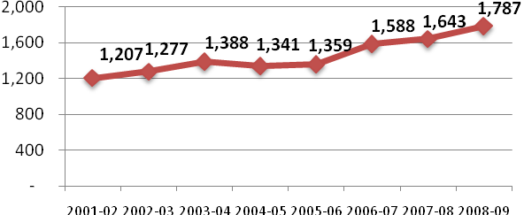

Headcount
2001-02 to 2008-09
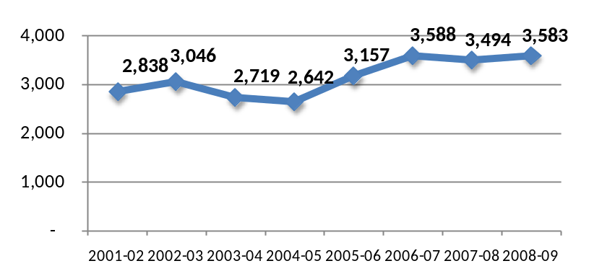

Headcount by Gender
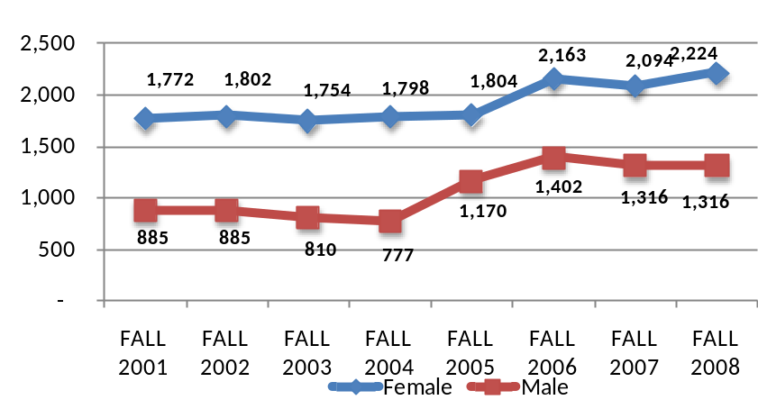
FTE by Gender
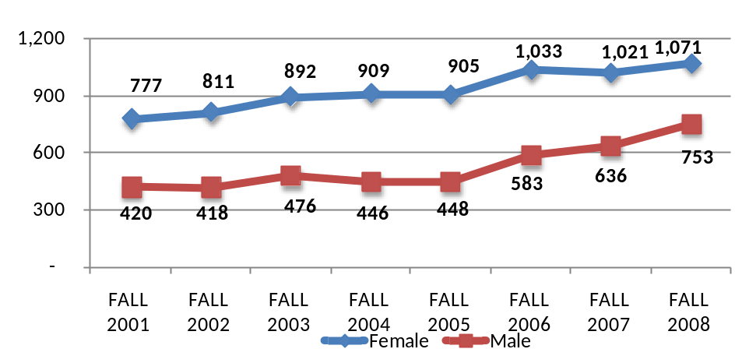

Headcount of First-time, Full-time Students
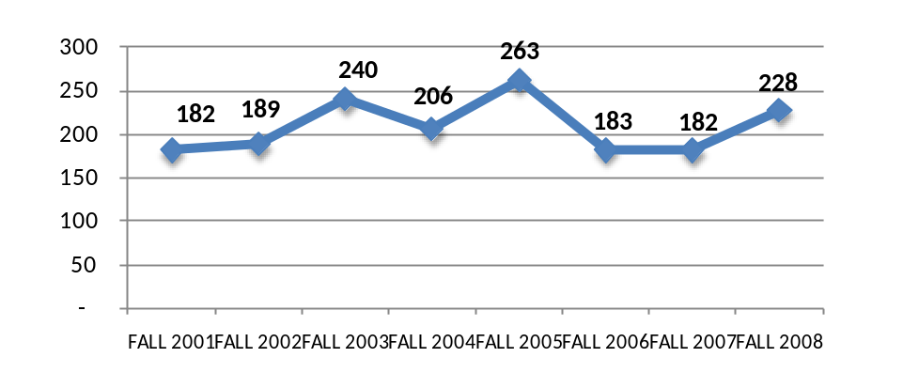

Part-time vs. Full-time
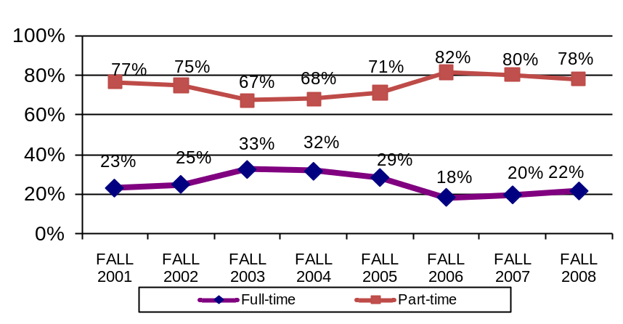
Average Age
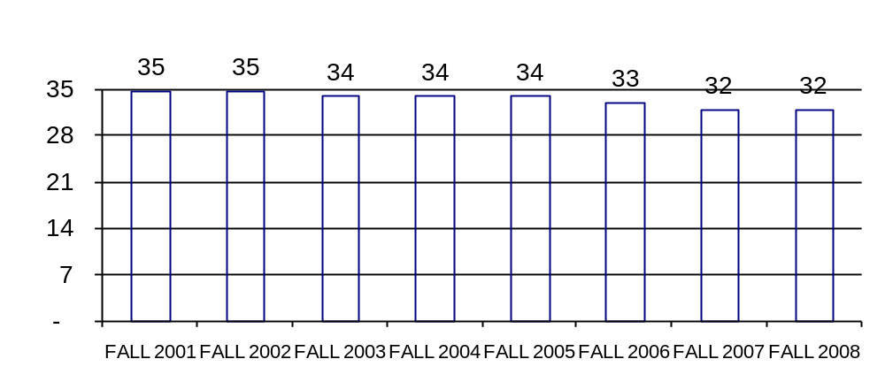

Age Category
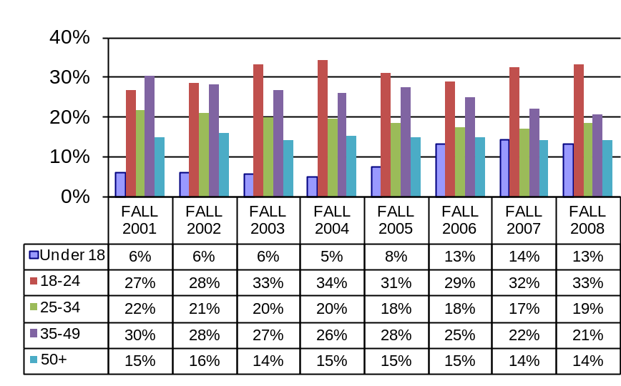

Number of Degree/Certificate Program Options
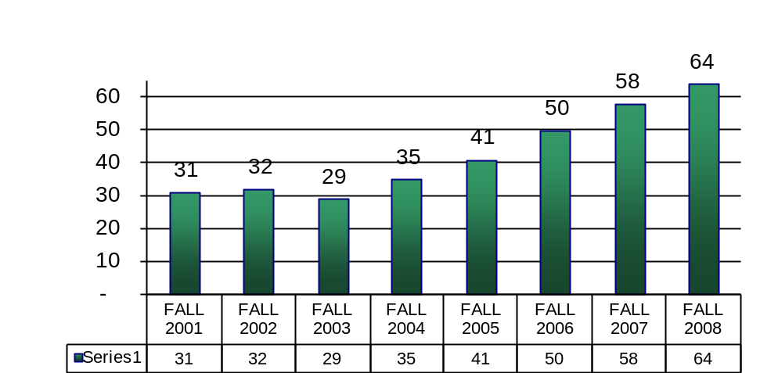

Number of Course Sections Offered
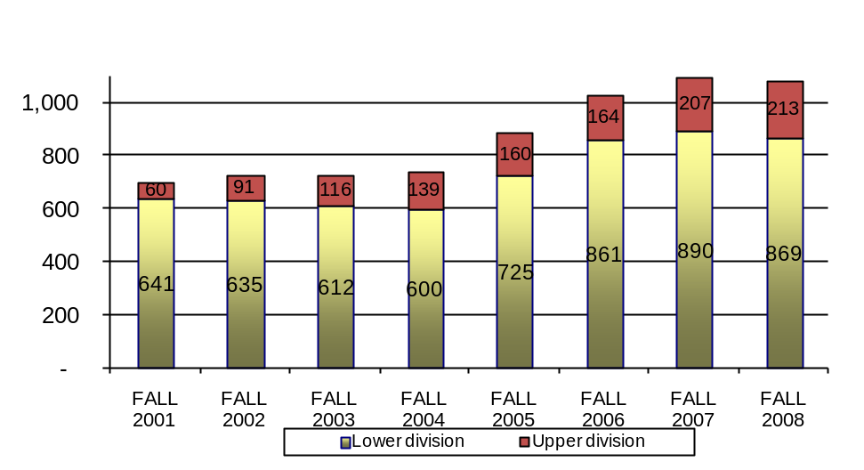

Successful Course Completion Rate

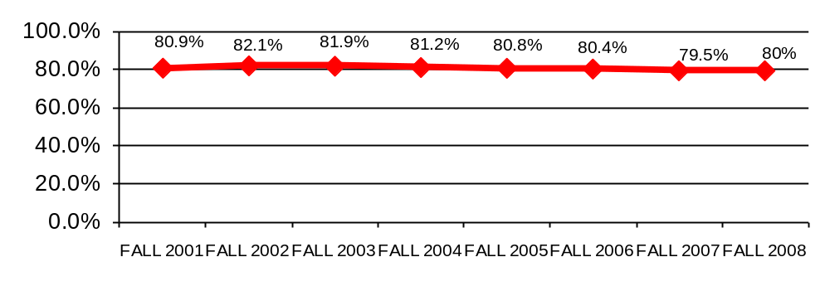
Term Retention Rate
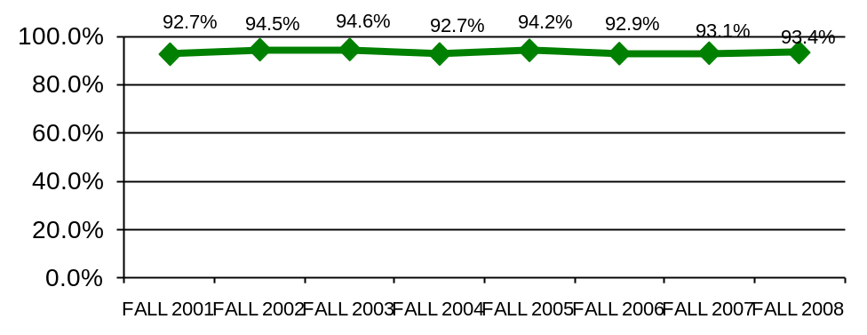

New Student Fall to Spring Persistence Rate
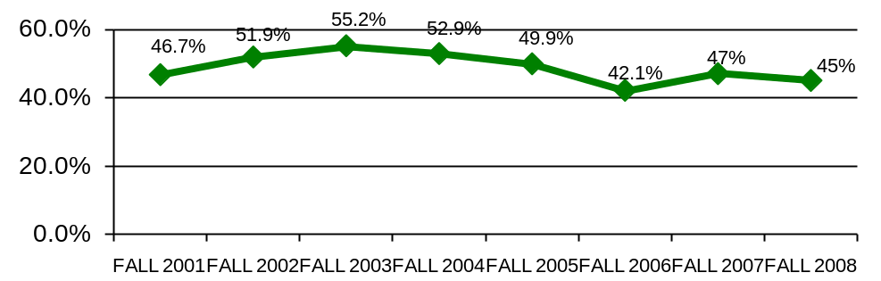

New Student Fall to Fall Persistence Rate
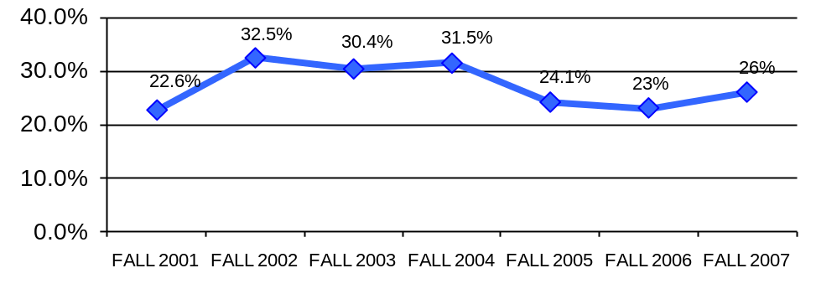

Distance Education FTE
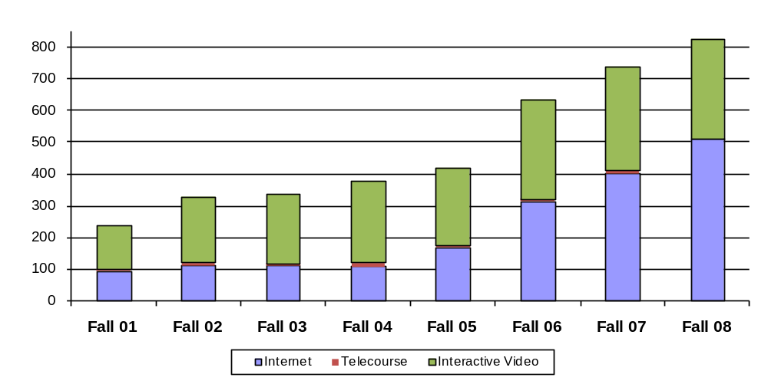

Numbers of Distance Class Sections Offered

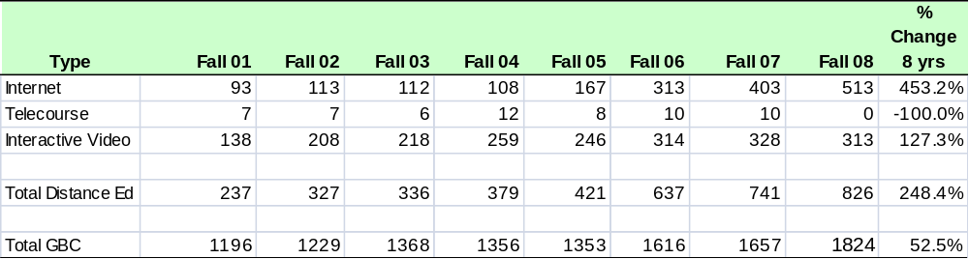

Course Completion Rates
Type | Fall 01 | Fall 02 | Fall 03 | Fall 04 | Fall 05 | Fall 06 | Fall 07 | Fall 08 | Change 8 yrs
Internet | 68% | 69% | 72% | 71% | 69% | 71% | 70% | 68% | 0.1%
Interactive Video | 82% | 84% | 83% | 86% | 82% | 81% | 82% | 77% | -5.0%
Live | 82% | 84% | 84% | 82% | 84% | 84% | 83% | 86% | 3.7%
Total GBC | 81% | 82% | 82% | 81% | 81% | 80% | 80% | 80% | -1.4%

Population Projections for GBC Service Area
2007-2008

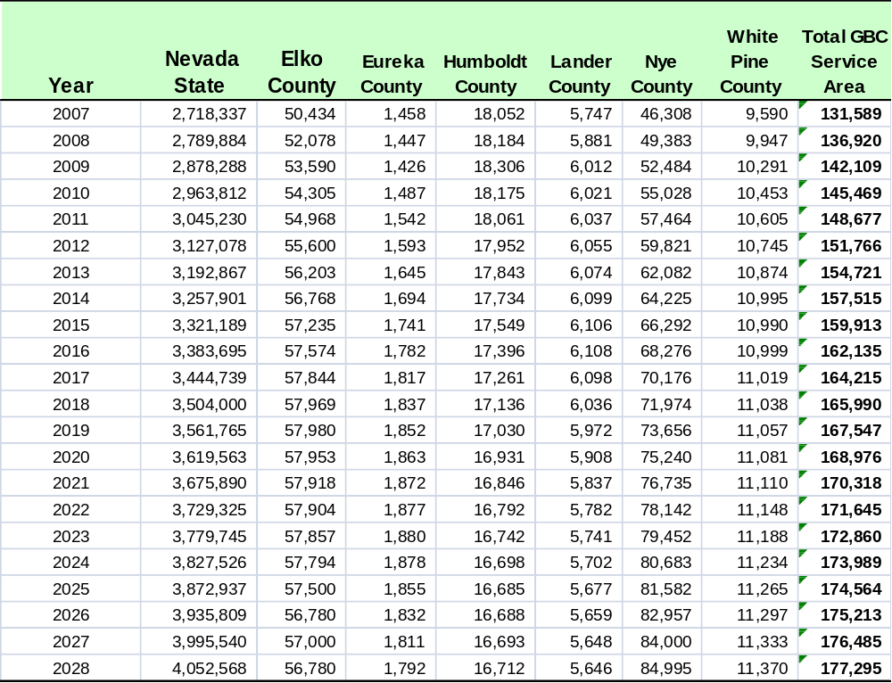

Appendix B: Sample Departmental Action Plans

Business Department
Strategic Planning, 2009-2016

MISSION
The mission of the Business Department is to provide students with practical competencies, enabling them to succeed in today’s business environment as employees and/or technicians, specifically in the accounting, economics, entrepreneurial, finance, marketing, and first-line managerial areas.
NOTE: The on-line planning format is different from the working plans shown below; the content is the same.
Business Department Goals
Goal 1: Increase distance education delivery.
Goal 2: Acquire more full-time and part-time faculty members.
Goal 3: Develop an Accounting/Finance emphasis under the BAS.
Goal 4: Acquire accreditation from International Assembly for Collegiate Business Education (IACBE).
Goal 5: Establish faculty and student enrichment programs.

Table 1
ACTION PLAN
Business Department, 2009-2016
Objectives | Indicators | Baseline | Target  Date | Target
- Convert the following courses to online/hybrid to increase enrollment in distance education:  Business Department  ACC105, BUS 273, MGT 201, MGT251, MKT265  BAS (All Emphasis Areas):  INT 349, MGT 323, MGT 367 BAS-MT:  BUS 325, MGT 480, MGT 487, MKT410 Goal 1  See NOTE 1 below. | All courses converted by Spring 2011.  Monitor enrollment in business department hybrid/on-line courses. | Student demand has been rising. These are required courses for business majors.  Spring 2009 — 48% | Spring 2010: 50%  Spring 2011: 55%  Spring 2012: 60%  Spring 2015: 70% | Enrollment in on-line and hybrid courses in business department over 70% by 2015. See column to the left.  BAS-MGT at 100% on-line hybrid by 2011.
New Hires:  Full-Time (3)  One Management/Marketing  Spring 2010  One Decision Scientist/OPS Research  Spring 2011  One Accounting/Finance  Spring 2012  Part-Time (6)  One Marketing and One PBL Advisor  Spring 2110  One Legal and One Entrepreneurship Spring 2011  One OB and one HRM, Spring 2012 Goal 2 | New full-time and adjunct instructors hired. | See NOTE 2 below | See target dates in “objective” column to the left. | See targets in “objective” column to the left.
- Create BAS emphasis in Accounting/Finance Goal 3 |  | Some courses available for such a degree; but no "Insurance/Risk Management" | 2012-2015 | AAS Accounting was approved in 2009 and BAS-ACC will be placed in 2014/2015 catalog.
- Seek IACBE Accreditation  [This is a 3-5 year process from initial application through candidacy and acceptance.]  Goal 4 |  | Without accreditation attracting new students is difficult. International students seek programs that are accredited. | Spring 2014 | To be in catalog 2014/2015
- Promote Professional Development Goal 5 | See NOTE 3 | Three years without conference attendance has negative impact. | 2011-2012 | Each faculty member should attend at least one conference each academic year.
NOTE 1: These additional courses would allow BAS areas to be online; specifically. Land Surveying/Geomatics. They would also create total online degree for BAS-M an age merit in Technology.
NOTE 2: Faculty to student ratios higher than college average. Workload reports for department faculty unreasonable. Spring 2009 semester: Dr. Larson FTE 26.53, Dr. Tenney FTE 32.60, Beatrice Wallace FTE 22.80. Enrollments have increased over 200% in four years. 60/40 ratio dictates more adjuncts are required.
NOTE: 3: Professional currency is required to be an effective faculty member. The new GBC faculty evaluation system rewards conference presenters/attendance.

TABLE 2.1
ACTION PLAN
Business Department, 2009-2016
Objective 1: Develop the fourteen courses listed on Table 1 Goal 1

TASKS | RESPONSIBILITY | TARGET DATE | COSTS | STATUS, PROGRESS, COMMENTS
- Develop Business Dept. Courses: ACC 105 BUS 273 MGT 201 MGT251 MKT265 | Adjunct Adjunct Dr. Larson Adjunct Dr. Larson | Spring 2010
- Develop for BAS - All Emphasis Areas: INT 349 MGT 323 MGT 367 | Dr. Larson New Hire New Hire | Spring 2011
- Develop for BAS-MT: BUS 325 MGT 480 MGT 487 MKT 410 | Dr. Larson New Hire Adjunct New Hire | Spring 2012

Note: Not shown are additional action plans for Objectives 2-4.

STUDENT SERVICES STRATEGIC PLANNING & ASSESSMENT, 2009 - 2016
SIS OPERATIONS

Mission
The mission of SIS Operations is to provide accuracy of data, process facilities scheduling, and to assist SIS users.

TABLE 1
SIS Operations Department
Department Objectives with Assessment Indicators, 2009-2016
Department Objectives | Indicators | Baseline | Target  Date | Target
- Move Facilities Scheduling into a more accessible location | Move to trailers. Less interruption of staff, fewer people asking for directions, increase in productivity | Location is hard to find the 1st time and thru secure areas | December 2009 | Move to trailers will open up room in Berg Hall for office moves for facilities scheduling
- Obtain offices for SIS Ops | Funding, space, movement in Berg Hall | Insufficient space for current staff and no room for expansion | Unknown | Obtain individual office space for each member in SIS Ops
- Storage reports and historical data electronically | Quantity of storage boxes will decrease, Electronic storage capacity will increase | Need higher capacity scanner and labor to put all documents and historical reports on-line. | December 2010 | 100% of all historical reports online
- Continue to pursue iNtegrate implementation | Admissions will be implemented in Fall 2010 with full implementation for Fall 2011. | Knowledge base is limited to the team members currently | Fall 2011 – full implementation complete | 75% of users trained on new system by Fall 2010 and 95% by Fall 2011
- Clean and review SIS Conversion Data | Data errors that show on SIS Clean up and conversion error reports | Data needs to be accurate as possible | By Fall 2010 begin use of Peoplesoft | 80% of errors resolved
- Optimize Facilities Scheduling | Increase in room usage revenue to approach net-zero total, Rooms occupied more often with fewer conflicts | Previous analysis identifies inefficient and potential cost savings | Dec 2010 | Cost savings & net zero on room usage

TABLE 2.3
ACTION PLAN
SIS Operations Department, 2009-2016
Objective 3: Storage reports and historical data electronically

TASKS | RESPONSIBILITY | TARGET DATE | COSTS | STATUS, PROGRESS, COMMENTS
- Evaluate what needs to be saved and what needs to be shredded | Julie Brynes, Lora McCarty, Cynthia Vaughn-Giles | Dec 2009
- Scan reports including green bar into a document imaging storage database | Student worker or temporary labor. Oversight by Cynthia Vaughn-Giles | July 2010
- Increase server size, back up capabilities to handle size of report storage | Computer Services & VP of Administrative Services | July 2010

For many years GBC, as mandated, submitted two major planning documents, an academic plan and a facilities plan.
Susanne Bentley (English Department), Angie DeBraga (Continuing Education), Carl Diekhans (President), Dr. Cliff Ferry (Co-Facilitator), Bonnie Hofland (Education Department), Cindy Hyslop (COT & Faculty Senate President), Dr. Mike McFarlane (Co-Facilitator & Vice-President for Academic Affairs), Lynn Mahlberg (Vice-President for Student Services), Bret Murphy (Dean, Applied Science), Dr. Margaret Puccinelli (Dean, Health Sciences & Human Services), Dr. John Rice (Director Institutional Advancement, Executive Director GBC Foundation), and Dr. Lijuan Zhai (Director, Institutional Effectiveness).

