–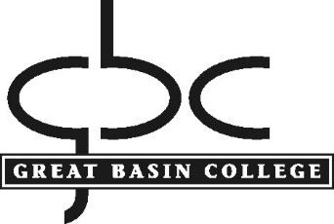

POLICY AND PROCEDURE

Procedure: Mission Fulfillment/Institutional Effectiveness Assessment
Policy No.: 2.3
Department: Office of the President
Contact: Vice President for Academic Affairs

Policy

The purpose of the Mission Fulfillment/Institutional Effectiveness Assessment policy is to document the entire assessment process for producing evidence of ongoing evaluation and planning, and to measure mission fulfillment.

Scope

This process includes institutional, program, and course assessment. The Continuous Improvement Committee provides oversight for the institutional and program assessment. The Academic Standards Committee provides oversight for course assessment and academic standards.

Assessment Principles
- Institutional Assessment aligns strategic plan goals and key performance indicators to define institutional effectiveness and therefore, mission fulfillment.
- Program Assessment aligns courses to program learning outcomes and connect to the institutional effectiveness.
- Course assessment defines student learning outcomes and their relevance to program learning outcomes.

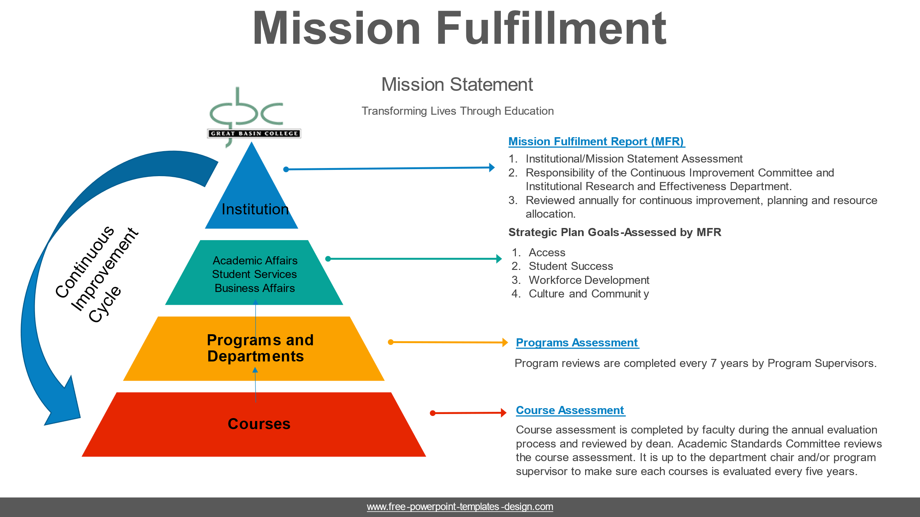

Process

Institutional Assessment:

GBC uses the annually reviewed Mission Fulfillment Report (MFR) to assess institutional effectiveness and the mission. The MFR is aligned to the strategic plan themes and goals. Key Performance Indicators (KPIs) are used to inform planning and resource allocation, along with comparison to national and regional peer institutions. The MFR data is to be reviewed and updated annually to meet the needs of the institution for continuous improvement. It is the responsibility of the Continuous Improvement Committee and Institutional Research and Effectiveness department to review and update the MFR annually.

GBC’s General Education Program learning outcomes serve as the institutional learning outcomes. The General Education Program is reviewed every five years based on an assessment plan that is developed and approved by faculty. The responsibility of the General Education program assessment is performed by the Faculty Senate Academic Standards Committee.

Program Assessment:

Program assessment will follow the policy and procedure outlined in GBC Policy and Procedure 3.40, A Guide to Program Reviews.

Non-Academic Department Assessment:

Non-academic department assessment is completed annually. The departments included in the non-academic program assessment are: Academic Success Center, Admissions, Advising, Disability Services, Facilities, Online Education, Human Resources, Institutional Research and Effectiveness, Recruitment, Library, Student Financial Aid, Student Housing, and the Veterans Resource Center. The following items are on the non-academic department assessment form:

- Department Mission
- Department Goal
- Strategic Plan Theme (This is the connection of their outcomes to GBC’s mission)
- Outcome statement. (A minimum of two statements are required)
- Assessment Year
- Assessment Measure
- Results of the data collection from the measurements
- Action Plan for the next year

The appropriate Vice President who oversees non-academic areas is accountable to ensure the non-academic department assessment is completed.

Course Assessment:

1.0 Regular Faculty Responsibility

All instructors under annual contract will assess at least two courses each academic year using the Course Assessment Report Form. At a minimum, all courses will be assessed on a seven-year rotation; departments will be responsible for deciding on the rotation and documentation. The course assessments are submitted to the appropriate dean for review during the annual faculty evaluation process.

2.0 Part-Time Faculty Responsibility

Part-Time faculty will complete a Course Assessment Report Form only for courses that are not offered by full-time regular faculty. At a minimum, courses will be assessed following their initial offering and on a five-year rotation thereafter; each department is responsible for deciding on the rotation and for providing documentation.

3.0 Department Chair Responsibility

Department Chairs are responsible to review and ensure completion of Course Assessment Report Forms by each department’s faculty, to ensure all courses are assessed according to the seven-year rotation period.

4.0 Academic Standards Committee Responsibility

The Academic Standards Committee will be responsible for assuring that the Course Assessment rotation is completed.

The Course Assessment Report Form, along with an explanation of how to use it, is available on the Institutional Research and Academic Standards Committee web pages.

After the annual evaluation cycle has been completed, the Course Assessment Reports are downloaded by the Office of the VPAA and formatted as .pdf files. The Academic Standards Committee is responsible for reading through the assessment reports, creating a brief summary of the assessment results for the Office of the VPAA, and evaluating the ongoing assessment process. This committee may also make suggestions for professional learning based on this summary. Deleted a sentence.

Completed Course Assessment Reports are submitted to the appropriate Dean during the Faculty Evaluation process and stored within the Institutional Research and Effectiveness Department. Assessment results are available upon request to any interested parties.

Approved by PC: March 31, 2025
Approved by Faculty Senate: March 21, 2025
Contact the assistant to the president for any questions, corrections, or additions.

