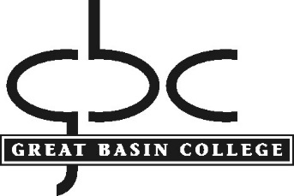
POLICY AND PROCEDURE

Title: ADULT LEARNING CENTERS
Policy No.: 3.12
Department: Academic Affairs
Contact: Director, ABE/ESL

Policy
The mission of the Adult Basic Education and English as a Second Language Department is to provide all eligible and interested adults with the highest quality coursework available so that they may develop skills according to the goals they have set for themselves. These goals include literacy, numeracy, and English language skills for work, family, achieving an HSE (High School Equivalency) or HS diploma, and for some, entering postsecondary education at Great Basin College. Particular emphasis is placed on students achieving workplace skills so that they are more readily employable or can pursue a better job.

The ABE/ESL Department offers classes at a variety of locations throughout the GBC service area with main Adult Learning Centers located in Elko, Winnemucca, Pahrump and Battle Mountain. Programs are also available in West Wendover and Owyhee.

Supported by federal funds, these programs are free of charge for students and made available at times that fit varying work schedules.

Procedure
Potential students must be at least 18 years old*. Pre and post-testing is required. A minimum number of hours of study is also required. Further information can be found online at http://www.gbcnv.edu/alc/index.html, or by calling the Elko Director at 775-753-2109, or the Accountability Specialist at 775-753-2126.

*16 and 17 year old students can attend the program if they have an excuse from compulsory public school attendance

Approved by President’s Council: March 21, 2007, June 20, 2017
Contact the assistant to the president for any questions, corrections, or additions.

