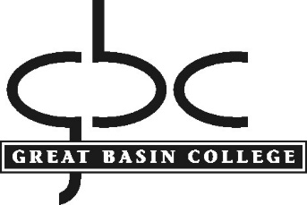

POLICY AND PROCEDURE

Procedure: Student Conduct
Policy No.: 6.10
Department: Student Services
Contact: Vice President for Student and Academic Affairs

Policy

Great Basin College has accepted the Board of Regents CODE, Title 2 Chapter 10, Rules of Conduct and Procedures for Students of the NSHE as the governing policy and procedures for all student conduct. Student conduct information for Great Basin College is provided to all students and college members as this code of conduct and accompanying policies and guidelines present the specific regulations, policies, procedures, and guidelines that are in place for all students, full and part time at GBC regardless of the method of educational learning a student may use (in person, online, interactive video or some combination of those).
The full policy is available for review and reference at https://nshe.nevada.edu/leadership-policy/board-of-regents/handbook/board-of-regents-handbook-subchapters/

Original Approved by PC: November 21, 2019
Contact the assistant to the president for any questions, corrections, or additions.

