Classified Council General Meeting
December 15, 2011
9:30 a.m. – 10:00 a.m.
Locations: Battle Mountain – Room 4, Elko- EIT 203, Ely – Room 118,
Winnemucca – Room 109, Pahrump – PVC 115

Call to Order: The meeting was called to order at 9:34 a.m. by Co-Chair, Jolina Adams.

Members Present:
Jolina Adams Carol Martin
Carmen Matlock Dianna Byers
Gaye Terras Kandy Scheel
Brandis Senecal Bundy Piscovich
Renae Jim Tami Potter
Cynthia Vaughn-Giles

Guest: Pat Anderson

Presentations: Pat Anderson presented members with a draft Laboratory, Technical, and Career Skills Course General Safety Procedures policy. She explained that the Safety Committee had drafted this policy and requested that the Classified Council review and approve. After reading the proposed policy, it was asked who would inform students of this policy. Pat explained that faculty in each department would be responsible to advise and enforce. It was agreed that a standard safety policy was needed. Since this was not an action item on the agenda, it was unanimously agreed to email the proposed policy to all classified staff, asking for comments/discussion. After 72 hours, an electronic vote will be requested with voting to close after 48 hours.

Approval of Minutes:

Minutes from the November meeting were reviewed. There were no corrections. Carmen Matlock made the motion to approve the minutes. It was seconded by Gaye Terras and passed unanimously.

Treasurer’s Reports:

The Treasurer’s Report was reviewed. It was noted that $270.00 needed to be transferred to the Salvatierra Scholarship Fund from the general account. Jolina Adams made the motion to accept the Report. The motion was seconded by Carmen Matlock and approved unanimously.

Site Reports: (Written Reports received for each site, attached to minutes)
Battle Mountain report
Ely report
Pahrump report
Winnemucca report

Committee Reports:
Web page: No Report
By-Laws: No Report
Events/Fundraisers: No Report
Scholarship: (See New Business below)
Hospitality/Awards: No Report
Grant-in-Aid: No Report

President’s Council: Jolina and Carmen could not attend the last meeting which was held December 6th. However, at the November it was reported that the 8% increase was approved by the Board of Regents and they discussed how that increase would be allocated in the budget. They discussed that it be spent on students, student services, and scholarships. 70% was to go directly to student services and the other 30% will fund instruction positions which will follow the prioritized list previously established.

Old Business:

Bake Sale: It was suggested that the Spring Bake Sale be held on Valentine’s Day, Tuesday, February 14th. All present agreed that this would be a great day.

New Business:

Scholarships: There was discussion regarding the Scholarship process. It was brought to the committee’s attention that no direction was given to recipients and the process was not clear. It was agreed that direction be given to recipients on what to expect and who was responsible for final scholarship checks. It was also agreed that applications should be sent out the first week of January for Spring semester and the first week of August for Fall semester. Applications would then be open for two weeks and scholarships awarded by the 3rd week. With this time frame, checks should be available to recipients prior to the first day of classes. Tami Potter also volunteered to help Irma. Carmen will contact Irma and set up these guidelines for future scholarships.

Meeting Schedule for 2012: The committee agreed to keep the meeting schedule as it has been in the past (executive meeting on the 2nd Thursday and the general meeting on the 3rd Thursday of each month). Dianna Byers will request the appropriate dates for IAV arrangements.

Presidential Search: The committee met last month (end of November). The committee is large with community members along with faculty, staff and regents. Each member was asked to give their opinion of what they were looking for in a new president. Carmen advised that she had voiced her concern that the new president understands the contributions that classified staff gives to the college and that they understand the importance of everyone working together... it is not just about faculty. The committee also decided to use a search consultant. (UNR and WNC are using consultants for their searches.) The cost (estimated at $80,000-$90,000) comes from the GBC budget. It is very important that the applicants understand the uniqueness of GBC. At the next meeting, the committee will review 10-12 consultant applications and resumes. They will choose 3-4 to invite for interviews. A webpage has been created to keep everyone up-to-date on the committee progress.

There being no further business to come before the committee, the meeting was adjourned at 9:40 p.m.
GBC CAMPUS REPORTS
Classified Council – December 2011

Diane T. Wrightman
Center Manager II
Great Basin College
- Shirley and Janis are keeping busy with new enrollment for Spring Semester and closing out the Fall Semester
- Tony Villalobos is working part-time at the Center doing proctoring of exams, assisting with supervision of the facilitators and helping in the front office.
- We had a go-away party for our Adjunct Donna Yarrell (art) after 8 years with GBC/CSN she will be moving to Texas
- Gearing up for the end of the semester, holiday parties by SGA was attended by over 60 students AND their families (pictures with Santa!)
- Offering new classes in Plumbing and Recreational Vehicle Repair for the Spring Semester
* * * * * * * * * *

Ami Rogers
Battle Mountain Coordinator
Great Basin College

Our SGA Senator is hosting a Teddy Bear Drive for victims of Domestic Violence and just wrapped up a coat drive.

Wil Becker will be a full time Administrative Aid until May.
Like all of the other sites, we are concentrating on advising and registering students for the spring semester. We previously offered 3 live classes in the fall and this spring we are offering 10.

On a personal note, I'd like to thank all of the classified and support staff for making me feel welcome and for all of their help as I was getting the hang of things!

* * * * * * * * * *
Mary Swetich
Ely Center Director
Great Basin College

All of our full time classified staff received longevity pins this week!! Bundy --15 years, Bill-10 years, Carol & Kandy --5 years. And Veronica, who is part time, has actually worked part time for GBC since 2005, first as IAV facilitator and now as Admin Asst. I.

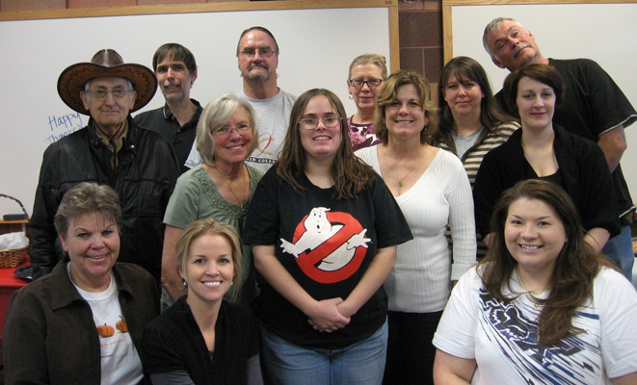
Hi, Folks:
Here's a photo and rundown of the Ely Center Thanksgiving celebration -- in case you missed it.
The buffet included:
* fresh-cooked turkey
* mushroom stuffing
* giblet dressing
* mushroom gravy
* yummy potato casserole
* fresh peas
* homemade pasta salad
* homemade deviled eggs
* chips + 2 kinds of homemade dip
* cranberry sauce
* homemade cranberry + orange chutney
* homemade pistachio "green stuff"
* rolls + butter
* cheesecake slices
* homemade pumpkin cheesecake
* homemade pecan pie
* fresh whipped cream or Cool Whip
* and cranberry/apple sparkling cider.
In addition to the faculty and staff, students and family were invited, and there was plenty of food to go around. Happy Thanksgiving everyone!!
Frank Daniels
Great Basin College – Ely
* * * * * * * * * *
Jolina Adams
Winnemucca Center
Great Basin College

We are helping with SGA food drive – the staff and faculty will be having their “end-of-the-semester-turn-in-your grades” potluck on Friday 12/16/11. We are asking all who come to bring at least one non-perishable food item to donate to the cause.

Susan French is doing well after her foot surgery, but still not back so we’ve been splitting her shifts amongst the staff and student workers. In addition, our advisor, Heather McCoy has been away with her mom who had surgery so Lisa & Jolina have been adding advising hours to their already busy schedule. We will be so excited when we have all our staff back healthy and happy!!

Everyone is working hard to get students registered and ready for spring and helping instructors get their grades in for fall.
* * * * * * * * * *

