Grade Roster
- Click on “My Schedule”.
- Grade rosters for “Dynamic Dated” classes will open within 24 hours after the class date.
- Regular semester class rosters will be available about two weeks prior to the semester’s end date.
- Icon will be to the right of “Roster” if grade roster is available.
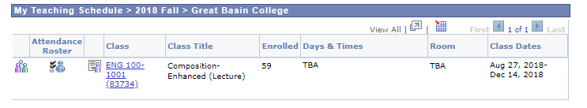
Grade Roster
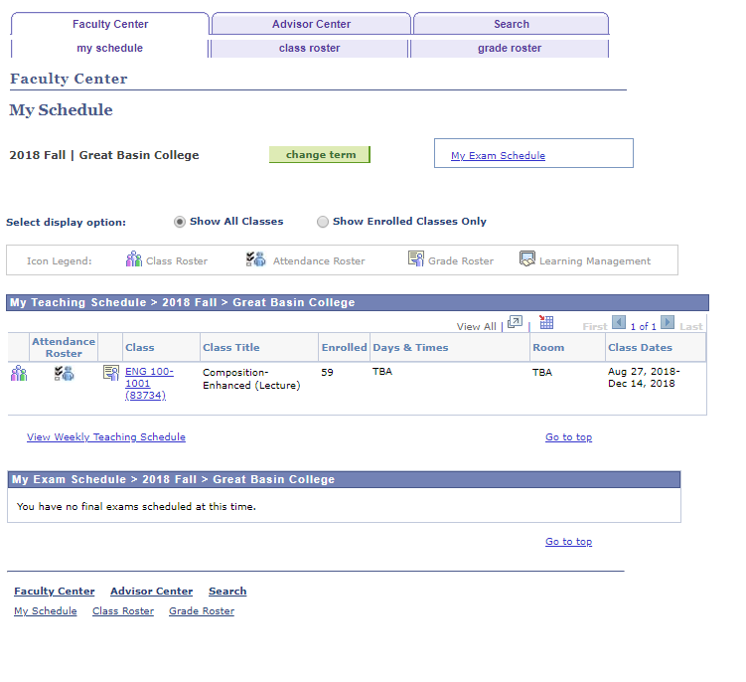
- Click on the icon and the grade roster will open.
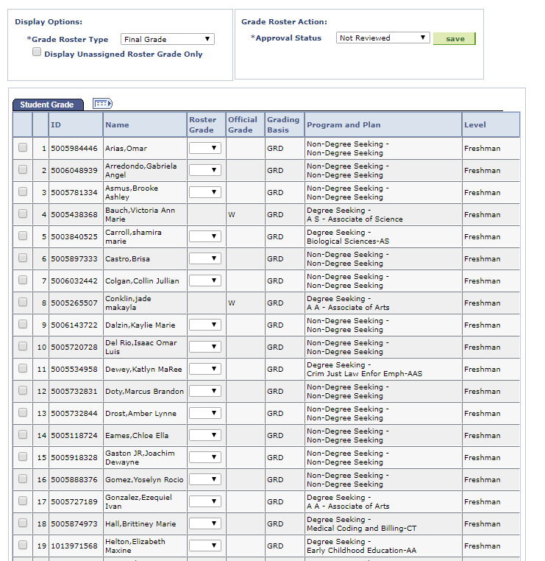
- To view all students, scroll to the bottom of the page and click on “View All”.
- You can download your roster by clicking on “Download” at the bottom of the page. The roster will open in MS Excel.
- Best practice would be to download before and after grading.

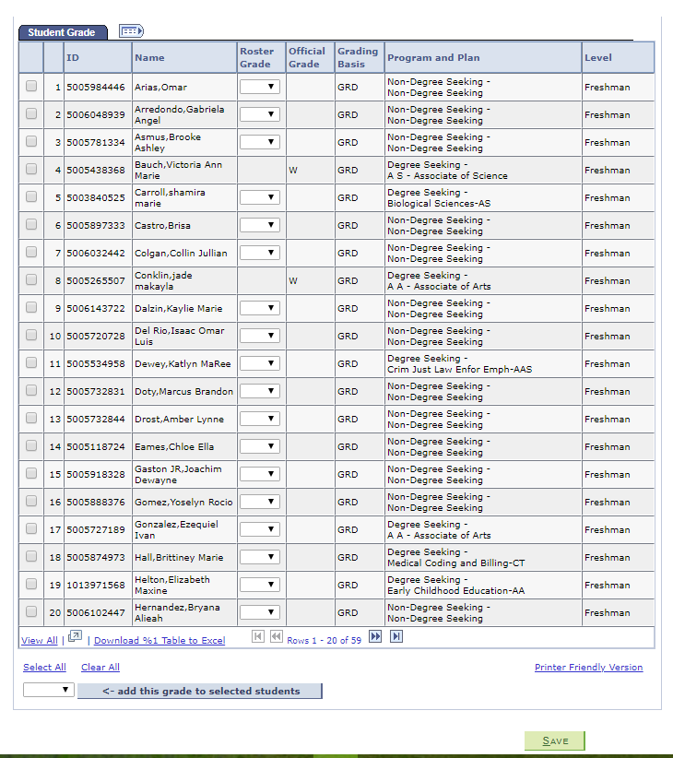

- In the Roster Grade Column, click the down arrow and a list of grades will appear.
- Click on the grade.
- Move to the next student.
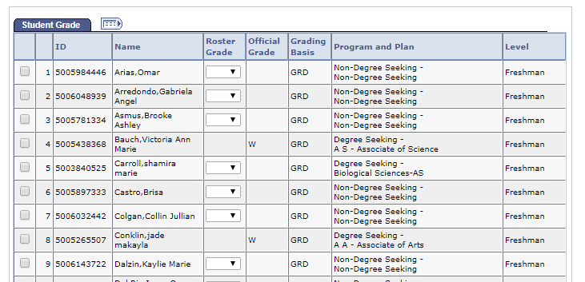
- To grade students, you can either grade all students individually or as a group.
- To grade individually, you click the down arrow under Roster Grade. Choose from the list.
- To grade as a group, you “add this grade to selected students” (see below).
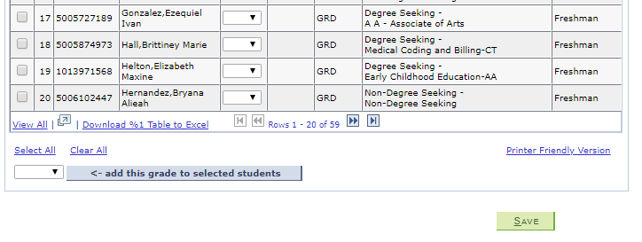

When adding a W or I grade, the last date of attendance must be added. Go back to the main menu and click on NV Customizations > Student Records > Last Date of Attendance.
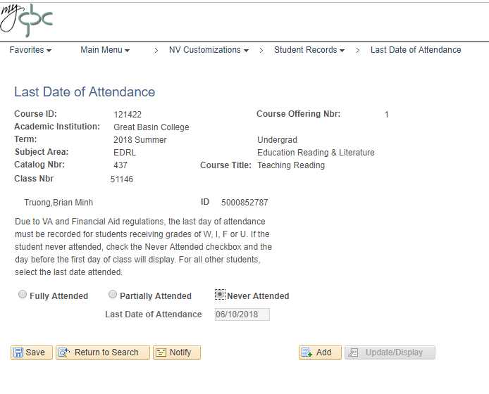
If the Student has never attended, check “Never Attended” as shown in the example above. The date will be entered automatically.
If you assign an “I” (Incomplete), you must complete the usual hard copy Record of Incomplete Form and submit it to Admissions & Records.
Make sure to click “Save”, then “Return to Search”.

Approve the roster
When grade rosters are generated, the initial approval status is Not Reviewed.
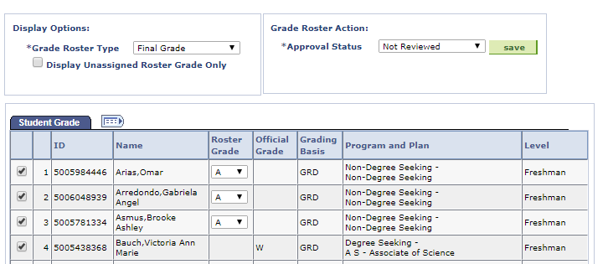

The other status options are as follows:
Ready for Review – Grades have been entered and the roster is pending approval by the instructor.
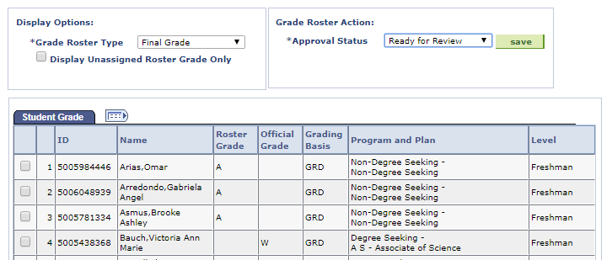

Approved – Grades have been entered for all students, the roster was approved by the instructor, and it is ready to be posted through Student Services.
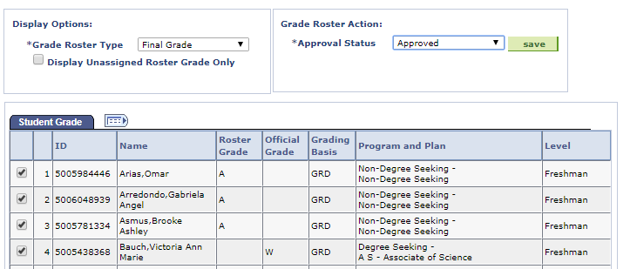
Follow these steps to approve a grade roster:
- In Not Reviewed status, continue to add and update student grades.
- When finished entering grades for all students on the roster, select the appropriate approval status:
- For instructors, select Approved.
NOTE: Approved is only an available option for the instructor. Placing the roster in Approved status and saving the file is equivalent to signing off on your roster.
- Click Save. When the save process completes, “Saved” temporarily appears at the top right corner of your screen. Check to make sure no error messages display after you click Save.
- You can confirm that your changes were saved by verifying the following:
The Approval Status field displays Approved as shown above.

Important Notes about Approving Grade Rosters
- All roster grade boxes must be populated (all students have a valid grade) before you can change the roster status to Approved.
- Once approved, the roster grade boxes are disabled, disallowing changes. All rosters that have been put into an Approved status will be automatically posted.
- This means that all rosters in an Approved status are subject to being posted even before the final grading deadline.
- If changes are required on a grade roster once it has been put into an Approved status, change the roster status to Not Reviewed and make your changes.
- When finished, change the status back to Approved (remember to press SAVE button, bottom left corner of screen) and grades will be posted the following morning.
- Once the roster is posted, changes can only be made by submitting a Grade Change Form to Admissions and Records.
