Faculty Center
Go to GBC Home page; click on “MyGBC”
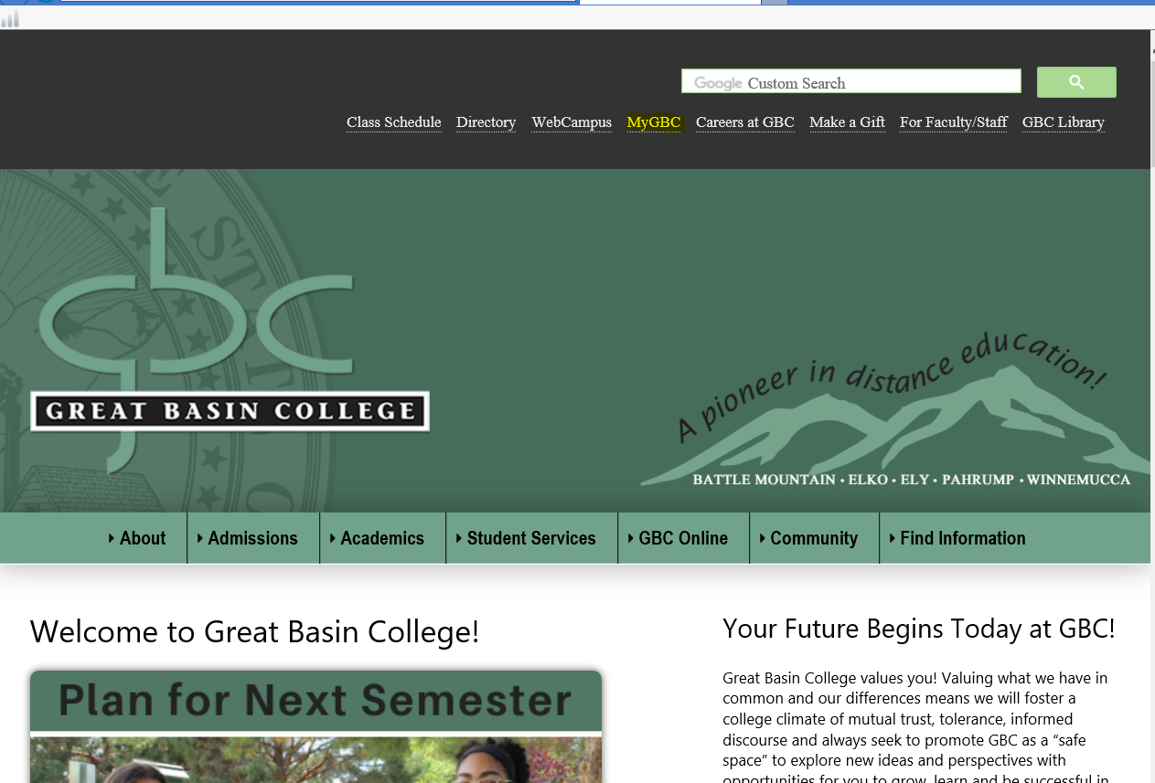
On the next page, click the blue button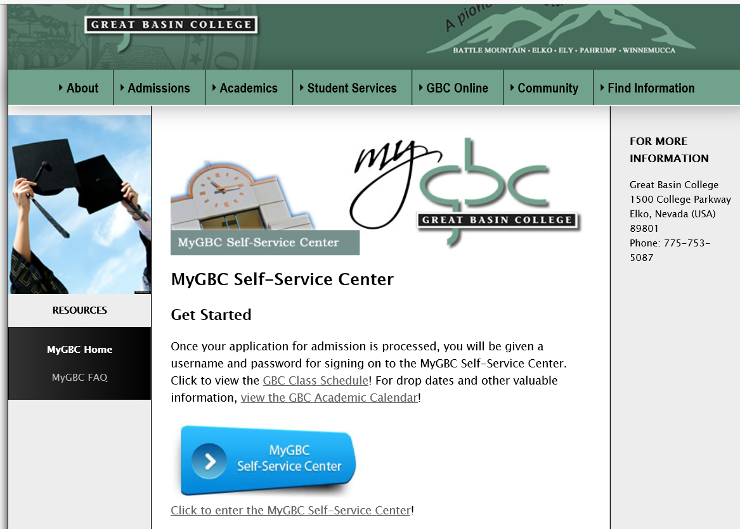

Type in your 10 digit user ID and password
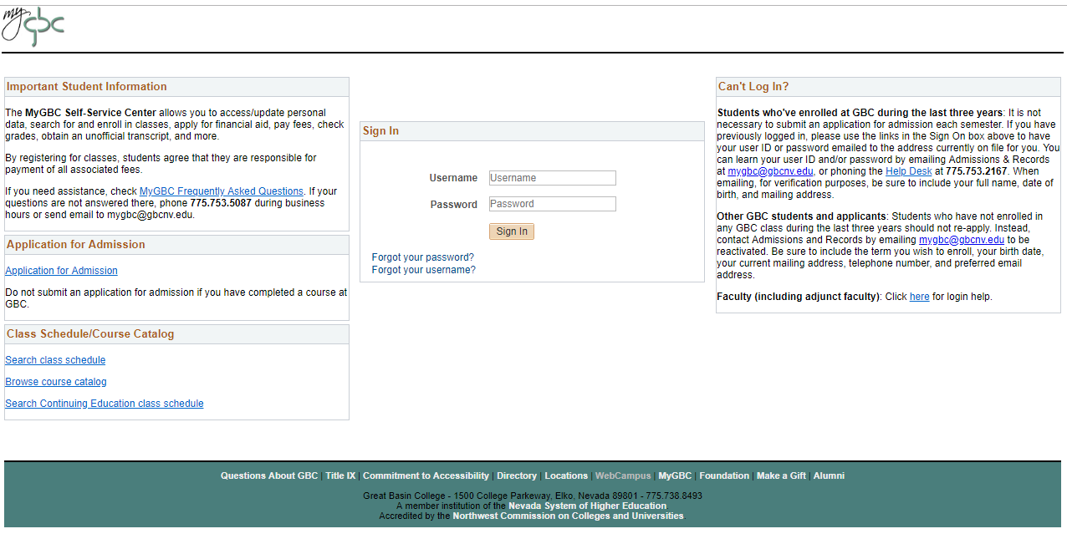
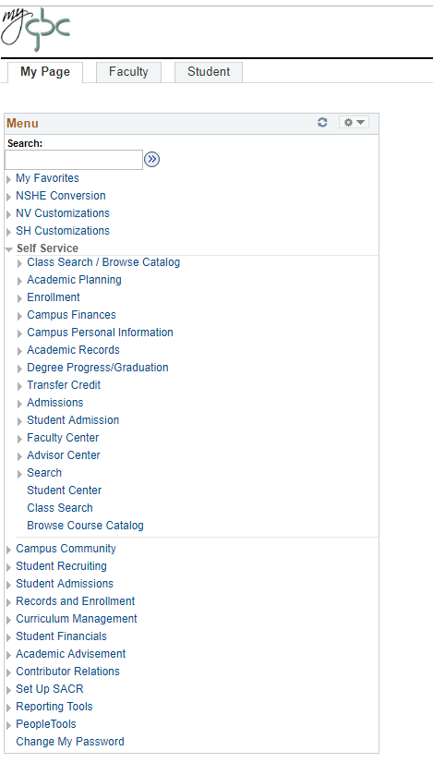
Then click on Faculty Center
Click on Self Service
You can also get there by clicking the Faculty tab: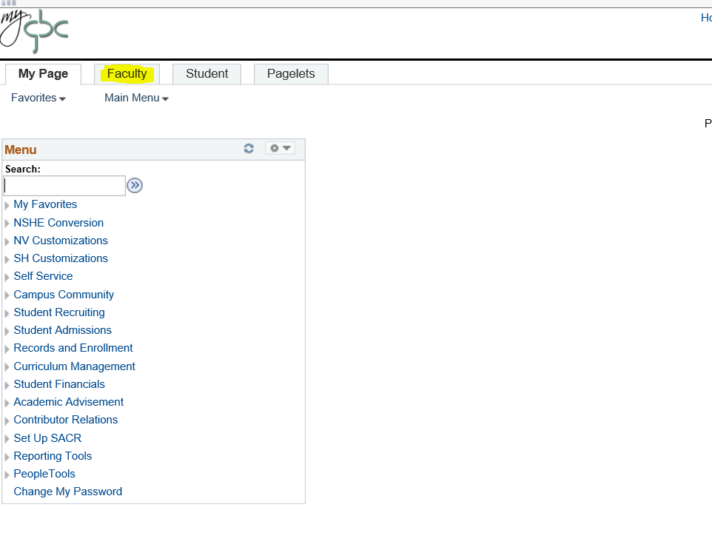 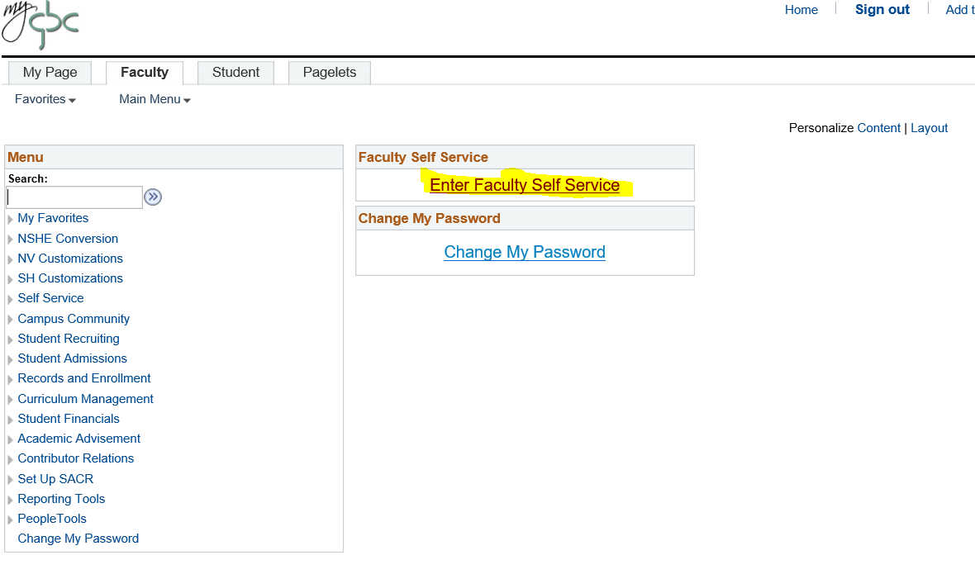
Under Faculty Center, you will see:
My Schedule
Class Roster
Grade Roster
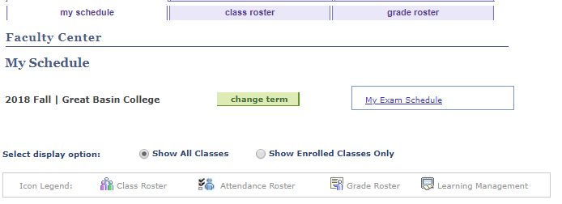
Change Term: Current default term is Fall 2018.
Select display option: Show All Classes (these are your classes only)
Show Enrolled Classes Only

Icon Legend:
Class Roster Icon: Click on Class Roster Icon and see students enrolled.
Grade Roster: Assign grades and post your grade rosters.
Click on My Schedule to view your classes:
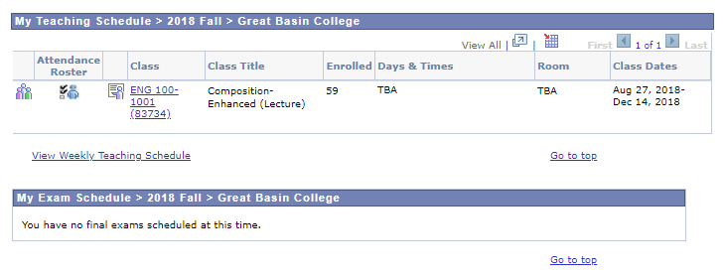
Click on Class Roster to view roster for individual classes.

Early Alert
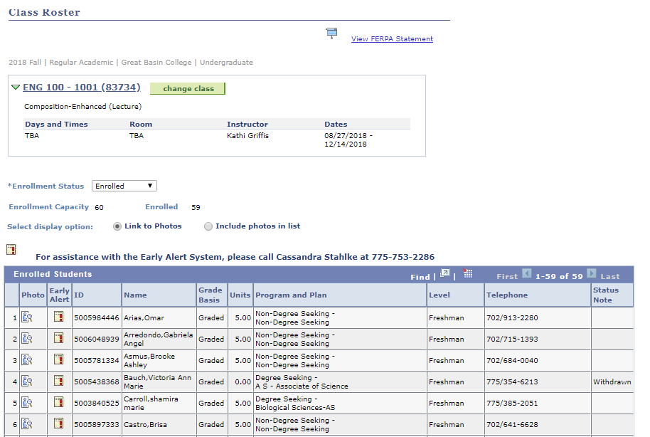
Click Early Alert for a specific student; the following screen will appear:
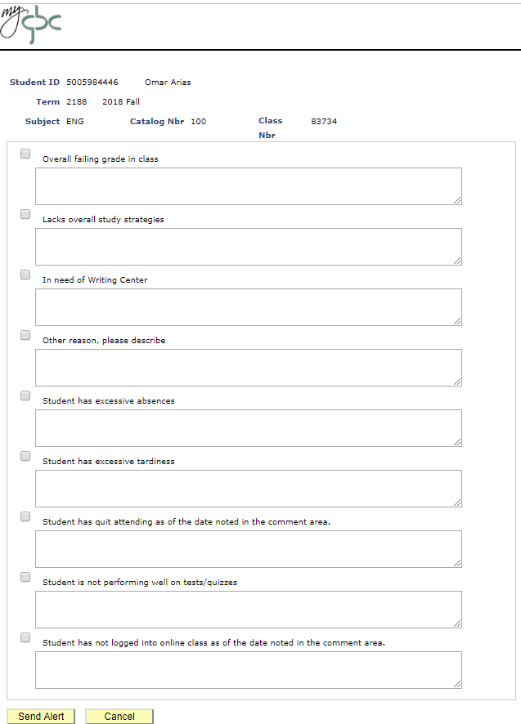
Fill out the Early Alert form and click on Send Alert. Make sure you add detailed information about the student.
Grade Rosters
- Click on “My Schedule”.
- Grade rosters for “Dynamic Dated” classes will open within 24 hours after the class date.
- Regular semester class rosters will be available about two weeks prior to the semester’s end date.
- Icon will be to the right of “Roster” if grade roster is available.
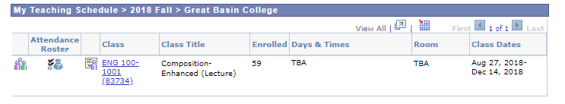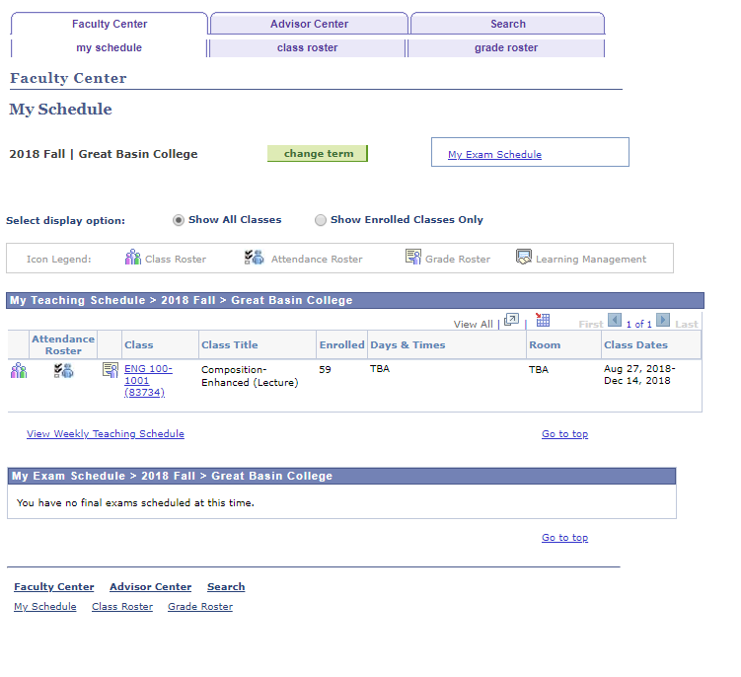
Grade Roster
- Click on the icon and the grade roster will open.
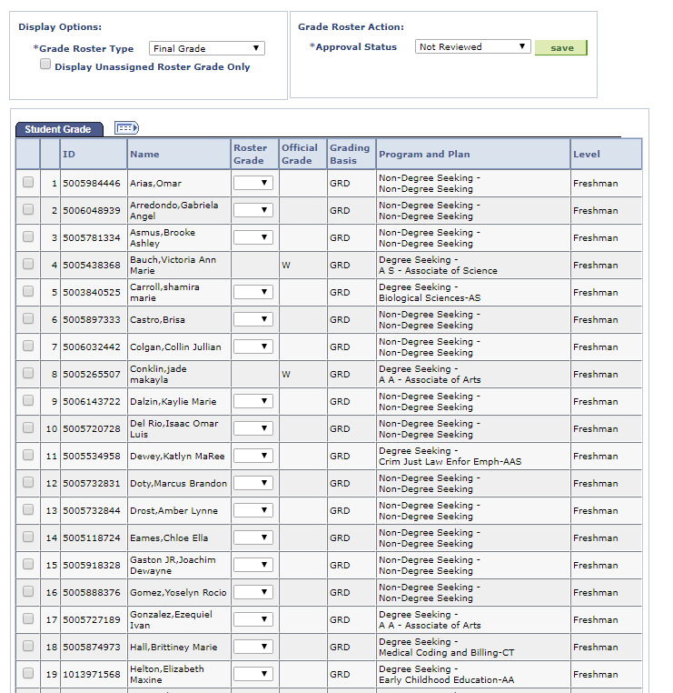
- To view all students, scroll to the bottom of the page and click on “View All”.
- You can download your roster by clicking on “Download” at the bottom of the page. The roster will open in MS Excel.
- Best practice would be to download before and after grading.

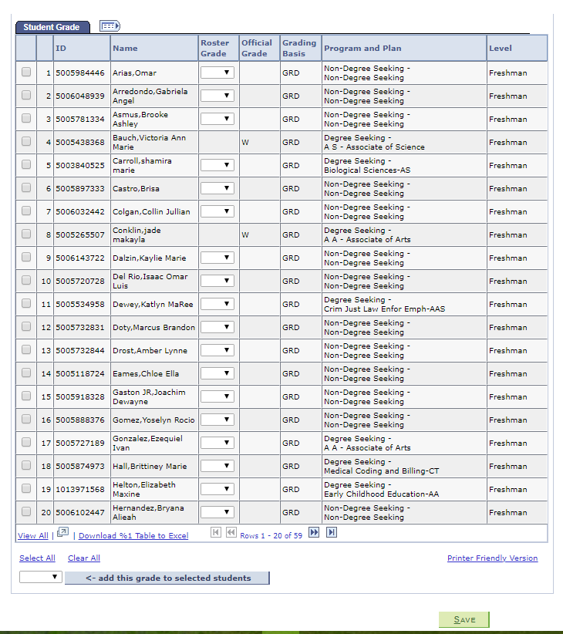
- In the Roster Grade Column, click the down arrow and a list of grades will appear.
- Click on the grade.
- Move to the next student.

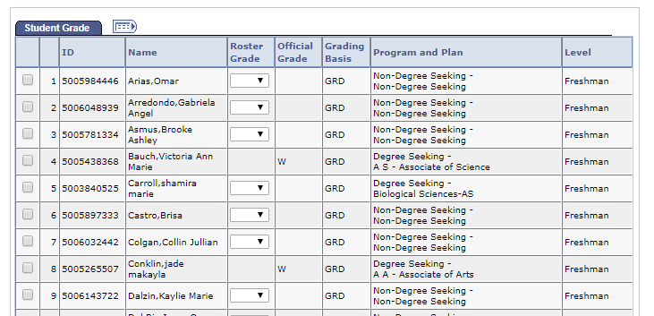
- To grade students, you can either grade all students individually or as a group.
- To grade individually, you click the down arrow under Roster Grade. Choose from the list.
- To grade as a group, you “add this grade to selected students” (see below).
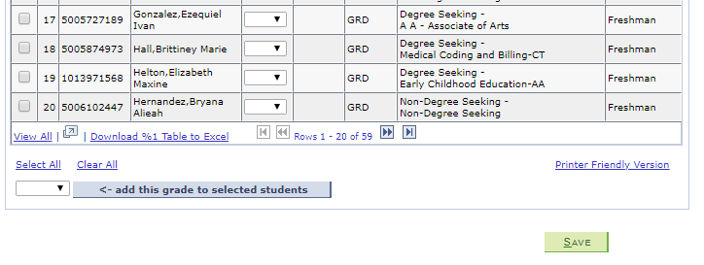
When adding a W or I grade, you will be asked for the date of the Incomplete or Withdrawal.
Review grades for accuracy. If you need to edit any grades you can use the drop down menu to post grades directly in the Roster Grade field.

From this screen you can:
- Change class
- Select all
- Clear all
- Notify selected students
- Notify all students
- Print roster
- Copy roster to spreadsheet (printer friendly version)
Search for classes: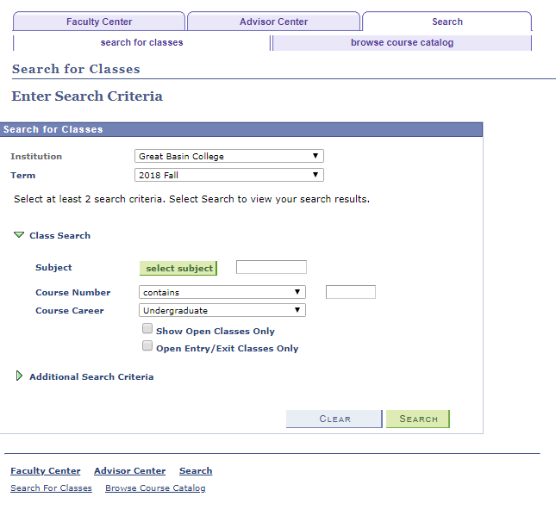
- Term should default to current term
- Under Class Search, type in the Subject (e.g. ENG) and the Course Number (e.g. 101)
- Search
- Search results will show all sections of that particular class.
You will see:

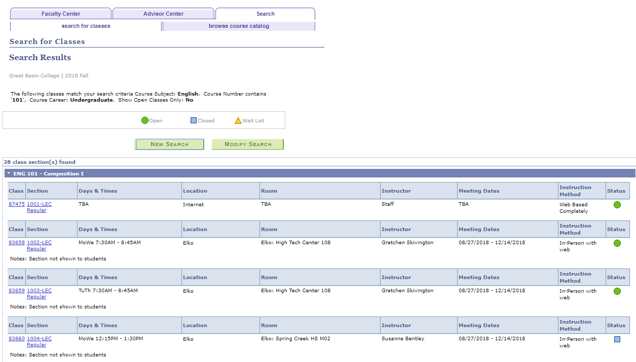

If you click on a section, you will see the class detail:
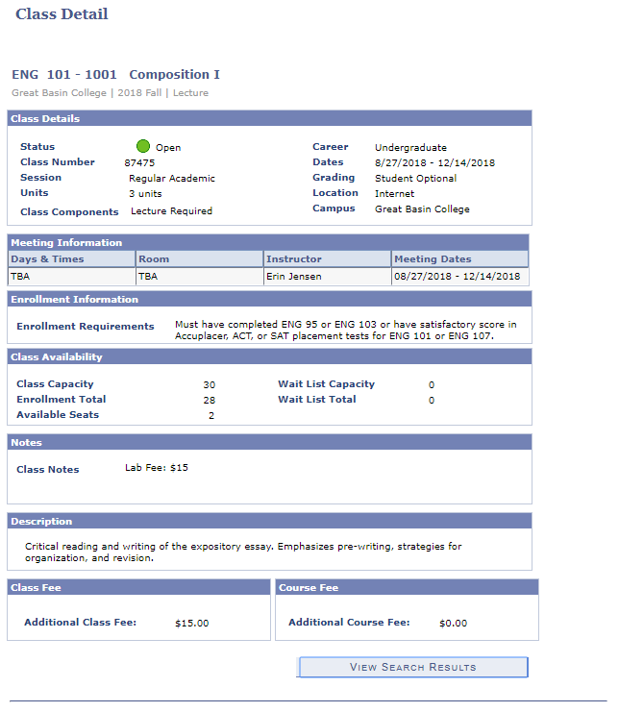

For Full Time Faculty to get to Student Services Center:
Back on the Home page, click Faculty -
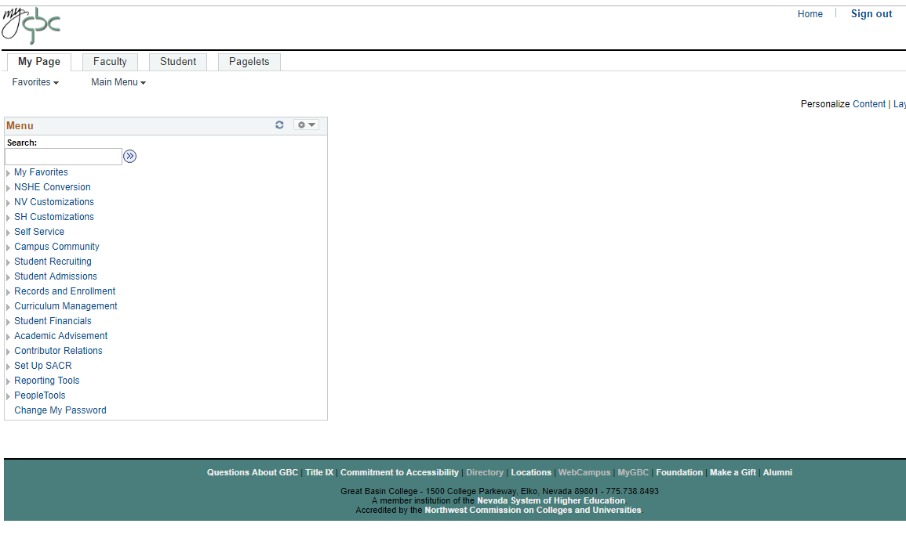
Then click Campus Community –
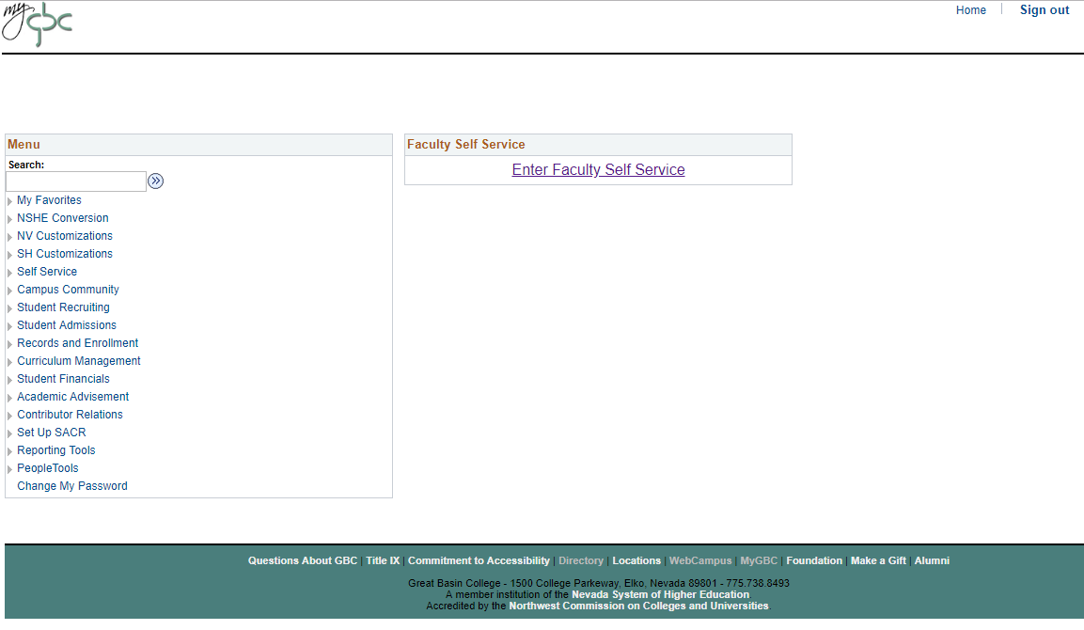

Student Services Ctr. –
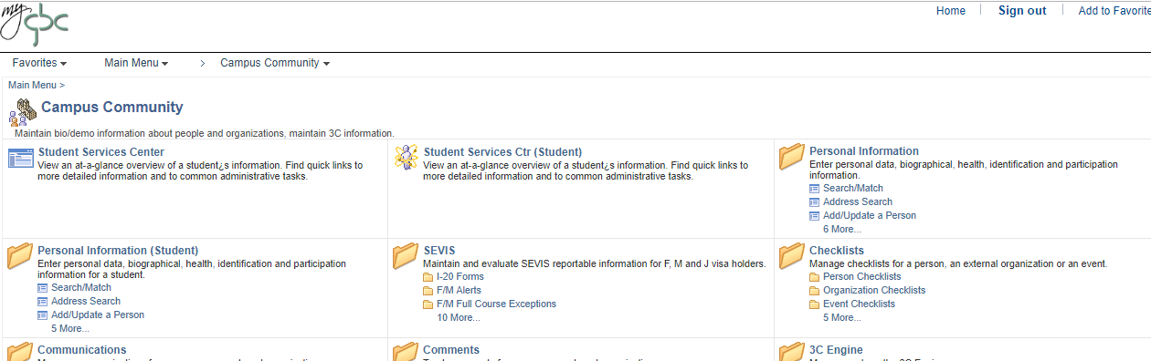

Type in the last name, first initial or, preferably, EmplID
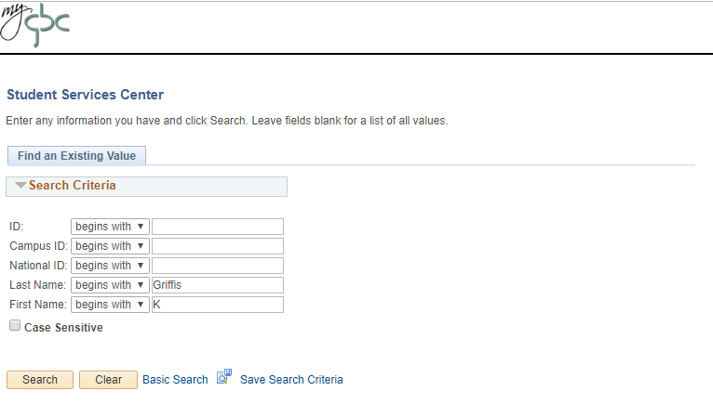
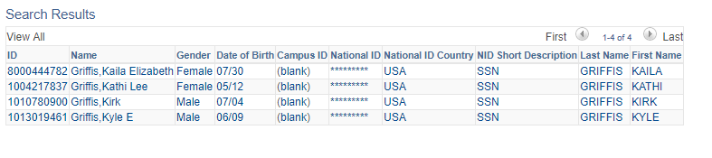
Click on the name you are searching for.
