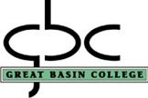

1500 College Parkway, Elko, Nevada 89801

Security Witness Statement

Security Report #: Date:
Witness Name: Witness Phone #:
Witness Address or Department:

