

MEMORANDUM

To: Cyd McMullen
Chair, Curriculum Review Committee
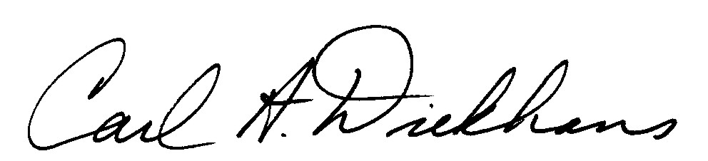
From: Carl Diekhans
President

Date: May 9, 2011
Subject: Curriculum Review Committee Recommendation

I have reviewed the Curricular Review Committee’s final recommendations for FY 2013 to eliminate one tenured position in the area of Advising and Career Center/Enrollment Management and to eliminate one position, either Librarian or Library Assistant, from the Library staff. I approved these two recommendations in the memo dated April 14, 2011. The Curricular Review Committee also recommended eliminating the READ position in the English department, a Reference Librarian in the Library, and one position in the Computer Technology department. I will accept the committee’s recommendations with the following change to the group of additional reductions:

- The elimination of the READ position is changed to the elimination of one position in the English department to be determined by “low yield” student numbers. This would bring the recommendation in line with the contract language of the positions in the English department.

The committee should invite anyone whose position might be discussed for reduction to speak if they have not already been invited to do so.

The Curriculum Review Committee will have five working days after receiving my recommendation to respond with any other changes or recommendations.

CD/mw

cc: Sarah Negrete, Faculty Senate Chair

