Library Committee Meeting Minutes
November 2, 2012
Present: Renae, Tim, Terri, David, Ashley, Eric
Guest: Matthew
Meeting
- Programming-
  - Movie Night Review-Successful first outing. Lessons learned include better advertisement, better communication/coordination with SGA, and holding event on another night of the week
  - Miniature Golf—November 15 700 PM, at the library. Faculty, staff, and students are welcomed.
  - Displays---Current displays are Banned Books and Halloween. Halloween will be taken down and a display for Thanksgiving will be going up
- Ebooks Revisited
  - No formal discussion at Nevada Library Association with UNR. However, informal discussion with NSHE institutions supportive of idea
  - Display of ebook resources available in Catalog
    - Library catalog results now display ebook holdings of GBC.

IN THE PAST DISPLAY LOOKED LIKE THIS (Result is displaying items available at GBC in print format…full-text version indicates Government Publication, available via internet )
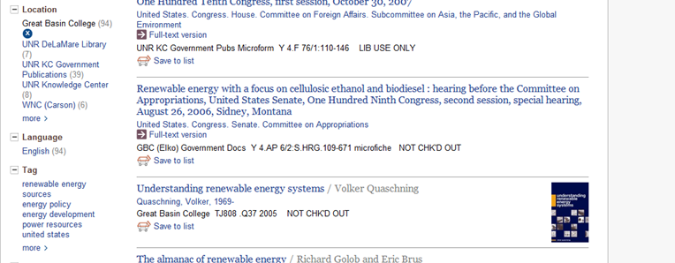

NOW, RESULTS INCLUDE EBOOK OPTIONS (note highlighted text)
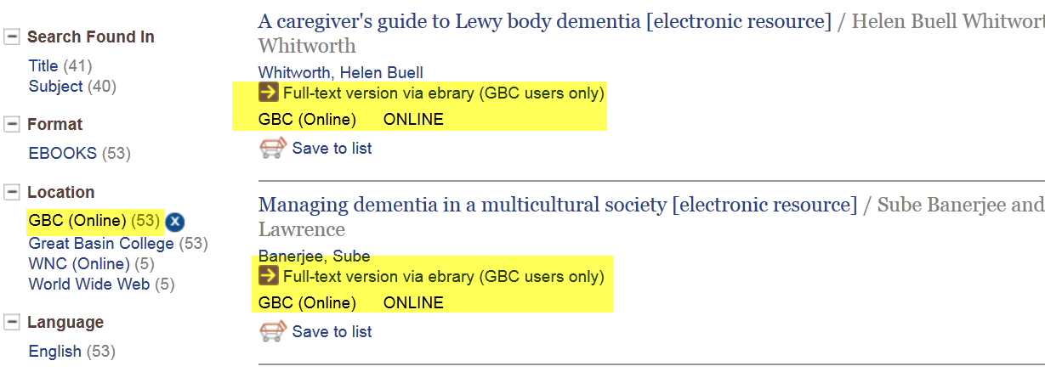
- Discussion of assessing, or surveying, ENG 102 students for feedback of Focused Research Interviews
- Meeting Closed

