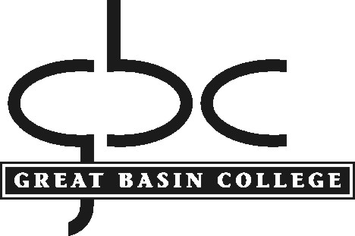

POLICY AND PROCEDURE

Procedure: Institutional Assessment
Policy No.: 2.3
Department: Office of the President
Contact: Vice President for Academic Affairs

Policy

The Assessment Committee serves to periodically review and make recommendations relevant to the standards, educational quality, implementation, oversight, and assessment of the instructional programs of the College. This committee maintains any items necessary to assess related student learning outcomes (Faculty Senate Bylaws description of the Assessment Committee).

The information gained from this process of assessment will help instructors, departments, and programs make necessary changes in courses and programs to improve student learning.

Procedures

1.0 Instructor Responsibility
All instructors under annual contract will assess one course each semester using the Course Assessment Report Form. At a minimum, courses will be assessed on a five-year rotation; departments will be responsible for deciding on the rotation. Adjunct instructors teaching courses not offered by instructors under annual contract will complete a Course Assessment Report Form for each such course at the end of the semester of the instructor’s initial offering of the course. Thereafter, adjunct instructors must submit one completed Course Assessment Report Form for the course at the time of the adjunct instructor’s five-year evaluation.

2.0 Department Chair Responsibility
Department Chairs will acknowledge by signature the completion of Course Assessment Report Forms by each department’s faculty.

3.0 Assessment Committee Responsibility
The Assessment Committee will be responsible for assuring that this rotation is completed.

The Course Assessment Report Form, along with an explanation of how to use it, is available on the Faculty Evaluation System under the Teaching Role: Assessment, as well as on the Assessment Reports, Assessment Committee, and the Evaluation Committee web pages.

After the yearly evaluation cycle has been completed, the Course Assessment Reports are downloaded by the Office of the VPAA and formatted as .pdf files. The Assessment Committee is responsible for reading through the assessment reports, creating a brief summary of the assessment results for the Office of the VPAA, and assessing the assessment process. This committee may also make suggestions for professional development based on this summary and will pass these on to the Professional Enrichment Committee.

Completed Course Assessment Reports will be published on the GBC webpage under a link titled Assessment Reports. This link will include discipline and course assessments as well as program reviews and the summary report from the Assessment Committee. (To see an example of what this might look like, go to http://www.tmcc.edu/assessment/car/.) Publication of these reports will (1) ensure that the assessment process is transparent and (2) make assessment results available to any interested parties.

Approved by PC: May 8, 2012, December 11, 2012
Approved by Faculty Senate: April 20, 2012, December 7, 2012
Contact the assistant to the president for any questions, corrections, or additions.

