Compensation and Benefits Committee
Annual Report on Merit Distribution

Colleagues,

Listed below is a chart showing the distribution of the Merit pay for the fiscal year July 2014 to June 2015. The agreed upon plan for this year was equal distribution. In future years the merit pay will be based upon rankings from our evaluations.

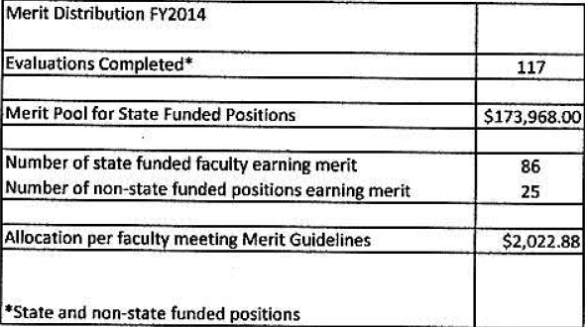

One other item of note on professional development, for July 2014 to June 2015 the compensation and benefits committee has agreed that due to the limited funding, we will only be able to pay up to $350 toward conference registration. The balance of the funding will need to come from other sources.

Respectfully submitted
George Kleeb, Chair
On behalf of the Compensation and Benefits Committee

