Faculty Senate
Friday, February 26, 2016

Battle Mountain – BM 2 Elko – HSCI 107; Ely – GBC 118;
Pahrump – PVC 122; Winnemucca – GBC 115

Meeting Minutes
- Roll call
Voting Representatives: John Rice, Stephen Theriault, Michael Whitehead, Norm Whitaker, Jill Chambliss, Byron Calkins, Tamera Allred (P), Staci Warnert, Mardell Wilkins, Xunming Du, David Freistroffer, Jodi Gerrits (P), Brandis Senecal, Ping Wang, Donald Jones

Absent Voting Members: Stacy Rust, Carrie Gaxiola, Wendy Charlebois, Janice King, Thomas Reagan, Tim Beasley

Other Members Present: Kevin Hodur, Josh Webster, George Kleeb, Brandy Nielsen, Glen Tenney, Cindy Hyslop, Tamara Mette, Justine Stout, Jinho Jung, Lynne Owens, Sherri Sanchez, Scott Gavorsky, Laurie Walsh, Annie Hicks, Heidi Allen, Carmen Matlock, Robert Hannu

Visitors: Toni Milano, Tina Nelson

- Call to order: Action
Mary Doucette called the regular meeting of Faculty Senate to order at 9:01 a.m. on February 26th, 2016.
- Approval of minutes: Action
A motion was made by Scott Gavorsky and seconded by Steve Theriault to approve the February 5th, 2016, Faculty Senate Minutes. The motion passed unanimously.

- GUEST/PUBLIC COMMENT-

- senate chair report: Information

- Mary sent out the letter of support for state college initiative to faculty. Dr. Curtis believes that it is a strong letter. This will go out as an information item in June for faculty senate. Senate approved motion of support.
- BOR Transfer Policy- BOR is next week. John Rice went to the transfer meeting since Mary was unable to attend. The biggest problem with the transfer policy is the Chancellor having the final say. The policy would have to go through BOR so the president would have an opportunity to voice their opinion in front of the regents. John Rice explained that the Chancellor receives direction from the board, then proceeds to do what he needs to do and then comes back with his recommendation to the board. In that opportunity if there was a disagreement with the Chancellor and the President, if it were not in the best interest of the college, the President would have an opportunity at the final board meeting to convince otherwise if he needed to. Mary said that the time frames were moved out on the termination policy. They are more in line with the dean’s now. Mary feels that both these items will probably go through now.

- Bylaws Action Item-

- Faculty Senate Bylaws provide the basic tenets for the faculty role in governance. The ad hoc Bylaws Committee has the responsibility of revising and updating these Bylaws. The ad hoc Bylaws Committee will be convened every three years to systematically review and update this document as needed. In the event modifications are required between those times, the Faculty Senate Chair will determine if the Bylaws Committee needs to be convened based on the nature of the changes. In general, small revisions (i.e., date changes, editorial clarification) do not require the committee be convened. More substantive changes (i.e., policy and/or procedure changes) would require the committee to be convened. Small-scale revisions not requiring the committee will be brought to Faculty Senate by the Chair and approved by a simple majority of Faculty Senate. If the committee is convened, the normal process of Faculty Senate approval will be followed.
- Administrative Representation: Add Dean of Arts and Sciences
- D. Terms of Office
The Chair and Vice Chair shall serve a one year term. In the event circumstances warrant, and as determined and approved by a two-thirds majority of the full Senate, terms may be extended for an additional year. The term for the Chair and Vice Chair is July 1 to June 30. The Secretary shall be in office for a term that ends with the election of a new Secretary on the first meeting of the next academic year.
- Succession of Officers
The Vice Chair shall assume the responsibilities of Chair on July 1. The announcement of the succession will be made by the out-going Chair at the last regular meeting of the academic year.

All in favor. Motion carries.

- State College- People were curious if Dr. Curtis has thought about doing public forums. Mary asked him. Dr. Curtis will probably have public forums done once it gets closer.
- INT 100- The programs that would like the INT course incorporated into their programs can send their requests to C&A. Some issues that arose are faculty would need to be trained to include everything in the INT course. When presented there were concerns at president’s council and Lynn will come to the next meeting. Mary will type up minutes with pros and cons and have the discussion group review the list. This will then go to academic standards, general education, curriculum and articulation and return to faculty senate. CTE was requested to drop their credit hours. This will only be another issue coming down the line. Faculty need to be aware that financial aid will only pay for credits that go towards student’s degrees. Make sure to check with financial aid to see if electives will be covered.
- Positive things- Review the packet.

COMMittee reports
- Academic Standards – Written/Verbal/Action
Academic standards is still working on honor degrees and adjustments. Why this became an issue? Faculty senate approved the shift in GPA standings. The shift was made to match UNR and UNLV. When this went to president’s council it got delayed. PC looked at it in April of 2015 and they wanted to drop credit hours for honors degrees by 25%. Academic standards counter proposed to have 30 credits for associates and certificates and 30 credits of upper division courses for bachelor degrees.
In order to forestall an idea came to look at data. Data was pulled from the last 3 years of graduation requirements and applied to the proposed models. If the requirement is dropped to 15 credits, then pretty much everyone is eligible for honors. When the model was reviewed everyone agrees to grant honors to certificates. Academic standards is proposing to change catalog listing to reflect new honors GPA levels and to change degree honors for 30 certificates and 30 upper division for bachelors.

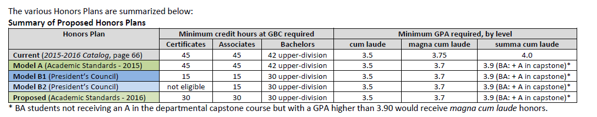

Motion made by Steven Theriault seconded by Mike Whitehead. All in favor, motion carries. 1 abstention

- Part-time Instructors –No Report

- Assessment – No Report

- Budget & Facilities – No Report

- Compensation & Benefits – No Report

- Curriculum & Articulation – Written Report/Action

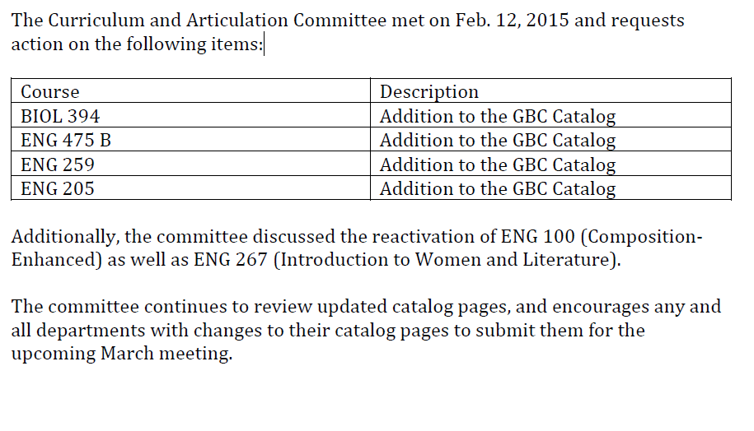
Motion made by John Rice, seconded by David Freistroffer, one abstention, motion carries

- Department Chairs – No Report

- Distance Education – Written Report

- Faculty & Administrative Evaluations – Verbal Report

John Rice presented. Started with code requirements from NSHE. This has been reviewed by Mike Macfarlan and he likes the direction it is going. We are using existing code and GBC policy to guide us through evaluation process. A couple of things came to a resolution where there had been disagreement. One is being able to lower the overall evaluation score. Supervisors were looking for a disciplinary tool for code violations. Were able to find all the places in the code where supervisors already had the authority to make decisions regarding awards of compensation and merit increases using the existing code. This has been taken out of the evaluation process. The evaluation is now on evaluation of jobs as written in job description. Administrative and academic faculty will be on same page with movement of the final evaluation. Supervisors may with cause and consultation with faculty members suggest changes to weights roles and goals submitted by the faculty. This cause will require documentation. If there were disagreements an appeals process would be put in place that would require documented justification for change from the supervisor and faculty members. It will be reviewed by the evaluation committee and senate chair.

Mardell Wilkins mentioned in the bylaws under the evaluation committee that they do not address individual evaluation concerns. Laurie Walsh mentioned that this is for merit only. This will be given a second look.

Scott Gavorsky asked to add substantiated cause in the paragraph below.

Supervisors may, with cause and in consultation with faculty members, suggest changes to weights, roles and goals submitted by faculty. In the event of a disagreement regarding weights, roles and goals, an appeals process shall be in place. (Develop a simple appeals process which requires some documented justification for change from supervisor and some documented justification for faculty member’s original submission. Review by members of Evaluation committee and senate chair?)

Evaluation outcomes- Academic Faculty who receive a less than satisfactory or unsatisfactory in the teaching role of the evaluation may can receive no more than a satisfactory overall rating.

John worked the math and said it is possible to get an unsatisfactory in the teaching role and excellence in every other role and then wind up commendable. It was felt that to reward someone who is unsatisfactory in the classroom did not make sense. If this is the case they may receive no more than a satisfactory rating. Faculty would then be required to participate in a mentoring program and the program would follow the same policy and procedure to earning tenure outlined in the tenure policy. John will check on the mentor policy. The purpose is to return the faculty’s performance to the satisfactory level. Mike is aware that this is what is being proposed. He will be sharing it with the deans. John is unaware of what the response will be.

- Faculty/Staff Safety – Written Report

- Gen Ed Ad Hoc Committee – Written Report

- Library – No Report

- Personnel- No Report

- Student Relations – No Report

Non-senate Committees

- A.C.E. – Written/Verbal Report

Toni Milano presented. The deadline for the argentum is March 11^{th.} You may have 3 submissions per entry. The committee has decided to open this up to high school students because of the dual credit population. Toni asked faculty to submit as well.

- Behavioral Intervention Team – No Report
- Child Care Center Advisory Committee – No Report
- Humanities –No Report

- iNtegrate 2 Ad Hoc – Written Report

- TAACCCT – No Report

- TEC – Written Report

FOUR-YEAR COMMITTEE REPORTS
- Bachelor of Arts in Integrative Studies – No Report

- Bachelor of Applied Science – No Report

- Career & Technical Education (CTE) – No Report

- Health Sciences & Human Services – Written Report

- UNFINISHED BUSINESS – None
- NEW BUSINESS - None

- INFORMATION-
-Black And White movie night will be April 1st. The Strangers will play. Before the movie the WWII veterans will have a discussion and answer questions.
-Nursing simulation on March 14th. Students will have headphones on with voices playing to simulate being a patient with schizophrenia. Tami will be giving a heads up to departments that day if students are heading over. This will also be taking place on the Pahrump and Winnemucca campus.
-The Smithsonian Folklife festival will focus on the Basque culture for the first two weeks in July. We are lucky to have two dance groups from our area performing. If you would like to donate to the Elko Arinak & Ardi Baltza groups please contact Angie De Braga.

- PUBLIC COMMENT –
- ADJOURNMENT – Action
It was moved to adjourn the meeting at 10:54 a.m.

