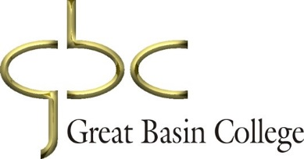

General Education Committee
Faculty Senate Report
December

1. Action Item: Approve MGT 482 as a capstone course as a planned addition to Management and Supervision bachelor’s degree.

Next Meeting: December 12

