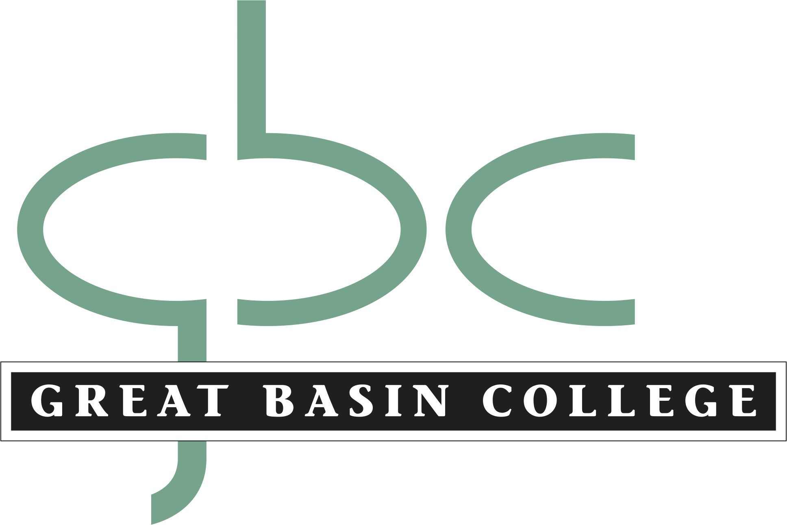

Marketing and Communications Policies and Procedures

The policies and procedures of the Marketing and Communications Office are designed to achieve consistent initiatives in print, graphic design, photography, videography and any other media that is used to promote GBC as it strives to fulfill its mission.

Mission: The Great Basin College Marketing and Communications office will provide quality information to better inform students, staff and the public about the college.
Instead:
By acting as a strategic partner to all academic and student services, the Great Basin College Marketing and Communications office will provide quality communications for recruitment, raise awareness of college programs and activities and draw attention to the impact our students, faculty, and alumni have locally and globally.

Objectives:
  - Create and implement an integrated strategic marketing plan to promote GBC’s missions, goals and values
  - Collaborate with stakeholders to provide marketing guidance and services to the college.
  - Increase awareness about GBC, its academic programs and services through integrated marketing efforts and forethought campaigns
  - Enhance the college’s image by maintaining brand principles designated and approved by GBC officials

Responsibilities and Services available:

Marketing & Advertising
- Collaborate with partners to create and implement cohesive campaign development for GBC Departments (see creative brief for more tactics available)
  - “Grab n Go” recruiting materials (Outreach kits coming soon)
  - Banners for loan
  - Tablecloths for loan
  - Give-away items
Public Relations
- Community and media relations
- News releases
- GBC website features and announcements
- Photo backdrops for loan (Coming soon)
- Photography and videography
Social Media & Web
- For assistance in web publishing or general website updates, contact the GBC Webmaster.
- For assistance in social media publishing or updates you wish to be announced on official GBC social media, contact the Assoc. Director of Marketing and Communications.
Priorities:

Not all requests may be met by the Marketing and Communications office given the limit of time and resources, as well as other priorities to fulfill its mission.

Policies

Public Information

Policy Statement: The Marketing & Communications office serves as a liaison between the college and the public. This policy is not intended to impede GBC faculty and staff’s access to the press or freedom to make public statements. The Marketing and Communications Department recognizes the rights of academic freedom and freedom of expression as provided by the First Amendment.

- The President is the college’s official spokesperson. The Marketing and Communications office will work together with the president and other college officials to both initiate press contacts and respond to the press inquiries it receives.
- Faculty and staff are encouraged to share their expertise and experience with the public and press.
- Faculty and staff wishing to contact media for promotion of events and programs should coordinate with the Associate Director of Marketing and Communications.
- In order to maintain GBC marketing initiatives, final approval of all college publications (including but not limited to marketing collateral and press releases) rests with the Associate Director of Marketing and Communications.
- All students, faculty, staff, alumni, donors and friends of the college are encouraged to recommend publication ideas. Honoring these recommendations is dependent upon newsworthiness and timeliness.
- Great Basin College is responsible only for the content of public information released through the Marketing and Communications Office.
- All marketing and published material shall meet the minimum WCAG 2.0 AA Accessibility levels.

Graphic Identity

Policy Statement: The success of GBC’s marketing efforts depends upon its ability to communicate strategically as a cohesive institution. The GBC brand is more than a graphic and tag-line alone, it is a concept that shapes and defines the college.

- Great Basin College owns its logo, as well as designs and symbols referring to Great Basin College and its brand. These designs may be used for business purposes by any official unit of the college.
- GBC reserves the right to request removal of its logo or official designs.
- The GBC logo should appear on all print, video, and electronic media produced by GBC departments or student services to promote GBC and adhere to the standards in the GBC logo Quick Reference Guide.
- If you are unsure your design meets the standards set forth by the college, the Assoc. Director of Marketing and Communications, a Media Services Staff member, or Dean will approve the publication of materials which use the GBC logo or brand in any form.
- All GBC logos shall meet the minimum WCAG 2.0 AA Accessibility levels.

College Web Pages and Electronic Publications

Policy Statement: GBC recognizes the importance of the Internet and its role in communicating, publishing, and sharing information with students and the general public. The purpose of the Great Basin College website is to recruit students and to provide high quality information about the college’s mission, educational opportunities, services, academic programs, events, and community offerings while serving the college staff in offering resources as well as business processes.
The following policies do not apply to:
- Non-forward facing web pages
- Web pages consisting of course content
- Recognized student organization webpages
- Personal web pages
- Document archives

- Web pages published by departments, academic programs and related services are considered “official” college pages. These sites are also in accordance the Graphic Identity policy, Sexual Harassment and Title IX policies, FERPA, and other policies enforced by GBC.

- Official pages are required to use standard templates provided by the college. The templates are designed to promote consistency, professionalism, and facilitate navigation within the college’s website.

- Pages published by faculty, staff, or student organizations web pages may be linked from the official college website, however, they are understood to represent the position of an individual or group, not the college as a whole.

Definitions:
- Personal web pages- web pages and electronic documents created by individual artists, authors, and scholars which may be related to the individual’s role within the college but do not officially represent GBC.
- Student Organizations- any group or club recognized by the Student Government Association. The GBC SGA maintains a current list of recognized student organizations.
- Document Archives- Content no longer in use but subject to records retention schedules.

Social Media

Policy Statement: Great Basin College recognizes the role of social media as a means to foster communication and the exchange of information.
The college establishes and maintains social media to support its mission, goals, programs and authorized efforts. The intent of GBC’s official social media sites is to disseminate scheduled information and forethought campaigns about GBC.

Policies:
- Official GBC social media sites include those sites representing the college overall or sites representing a department, division or student service. These sites are also clearly designated as such and include an official logo. These sites are also in accordance with GBC policies, the Graphic Identity guidelines, Sexual Harassment and Title IX policies, FERPA, and other policies enforced by GBC.
- Great Basin College is responsible only for social media posts published on its behalf on its official social media pages.
Procedures:
- The Assoc. Director of Marketing and Communications will approve the request for a new official GBC social media site. Vice President or Dean approval may need to be considered as well, depending on the site’s goals and purpose. All requests should be emailed to the Assoc. Director of Marketing and Communications. Please include the purpose, objectives, the name of the site, administrator(s) and their emails. Login information for one administrator must be provided. The email must use a @gbcnv.edu address.

Guidelines:
While we highly encourage the use of social media sites, GBC requests that site developers follow recommended guidelines, which we believe will help the Department, Program, committee, etc. gain media success.
- Correct Mistakes- Be upfront and maintain transparency. It’s always a good idea to be quick in solving mistakes made on social media.
- Monitor the comments made on your page- Please be sure that administrators review and approve comments made on their page by other viewers. It is also up to you to delete spam, and block individuals who become offensive.
- Keep it relevant to your objectives/audience- Keep the sharing of other organization’s posts to a minimum. The followers of your page are interested in seeing information and content that you generate as part of your department’s purpose. Keeping posts close to home will ultimately help build credibility.
- Think before you post- Search engines will turn up posts and pictures long after the publishing date. Comments may be archived.
- Maintain Confidentiality- Do not post confidential or proprietary information about GBC, its students, its alumni, or fellow employees. Use your best judgment and always follow the college’s policies and federal requirements made available at:.
- Frequency- Assign an administrator who regularly checks the content. Creating a content calendar will help your page obtain a following. Be sure not to overwhelm your followers with too many updates. Contact the Marketing and Communications Office if you have questions about what your site frequency may look like based on your audiences.

