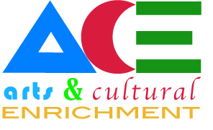
10/4/17
2 pm McMullen Hall 125

Meeting Minutes

- Members Present: Angie deBraga (Chair), Fallon Godwin-Butler, Heidi Johnston, Frank Sawyer, Gretchen Skivington, Christina Park, Guest-Russ Minter
- Reminder of the Permanent Art Collection Reception, October 19 from 4:00-6:00 pm at the Leonard Ctr. Please plan to attend!
- Jay Noller, PhD, Oregon State University, soil scientist
- Art workshop October 17 in collaboration with the art department. This is open to students, faculty, staff, and community members to come to soil painting. These paintings will then be on display during Dr. Noller’s presentation the same evening. Please RSVP to Angie 753-2231 or Patty Fox 753-2262 if you plan to attend. Bring a snack or sack dinner! Promotion ideas: Lori Gilbert, radio & TV, library bookmarks.
- On October 17 from 7:00-8:15 pm, Dr. Noller will present Art as Scientific Method. Please share this information and we hope to have a strong turnout for this fantastic lecture.
- The GBC Film Festival is February 15-17, 2018. The committee secured a $2,000 grant for advertising outside of Elko and is willing to cross promote ACE events. Volunteers are needed during the festival. There will be individual films, documentaries, and Oscar nominated short films.
The next meeting for the film festival committee is October 18 at 5:30 pm at Pizza Barn.
Reminder: First call for submission to Argentum will be January 12 with final call for submission on March 9. Ideas to encourage more student submission include hosting an Argentum workshop at GBC Housing by Fallon and Toni. Toni will also set up a day and time for students/staff/faculty/public to bring their 3-D pieces in to be photographed for the Argentum.

The meeting was adjourned at 3:00 p.m.

