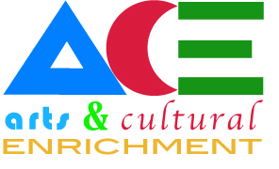
10/4/17
2 pm McMullen Hall 125

Meeting Minutes

- Members Present: Angie deBraga (Chair), Fallon Godwin-Butler, Heidi Johnston, Frank Sawyer, Gretchen Skivington
- The GBC Film Festival is in February 15-17 and 23-24, 2018. Volunteers are needed during the festival, please contact Angie if interested. There will be individual films, documentaries, and Oscar nominated short films. Please promote with students and community members.
- National Cowboy Poetry Gathering has free presentations (see flyers posted around campus):
  - Nephi Craig is presenting Indigenous Food of Turtle Island with a focus on North America on Feb 1 from 5:30 to 6:45 GTA 130
  - Vince Juaristi is presenting American Deal: A new Basque Home on the Range on Feb 1 from 1:00-2:15 in GTA 130
  - Cathy McAdoo and Caleb McAdoo will present Basque Sheepherders: The End of an Era on Feb 3 from 1:45-3:00 Elko Convention Center
  - Please promote with students and community members.
- The library will have Inner Strength: Portraits of Basque Immigrant Women on display Jan 22-Feb 28. Please encourage your students and community members to visit this wonderful display.
- Argentum- follow up with Toni to see where this is at.

The meeting was adjourned at 3:00 p.m.

