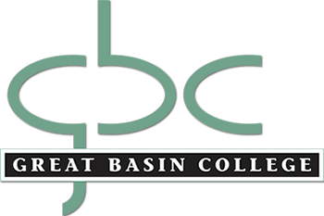

CONTINUING EDUCATION ADVISORY BOARD MINUTES
2/01/2021
9 am via Zoom

Present: Dori Andrepont, Susanne Bentley, Cara Caldwell, Laura Debenham, Angie de Braga, Stephen Theriault, Norm Whittaker.

- Advisory board members introduced themselves and discussed the challenges, changes, and successes they have seen in their departments this year. Generally, we are seeing more students enrolling in GBC classes from outside our local areas. Many instructors are frustrated by the lack of active student participation in online classes. Cara noted that the IAV format works better for many students, as many of them did not participate in Zoom-type classes.

- Angie presented a 2020 summary of Continuing Education enrollment showing the addition of online courses purchased through 3rd party providers.
- Overall enrollment totaled 769, slightly less than the previous year.
- As of January 31, 2021, Continuing Education has enrolled 128 students

- The possible addition of the Medical Scribe (online) program was discussed. Pros and cons were brought up, and it was decided that the cost of the program ($3,199) outweighed the benefit ($10.41 average wage in today’s market) for those who might complete the program. The program will not be offered at GBC.

- Dori presented an update on GBC summer session. 64 courses were offered in 2020, and there is still plenty of time for administrative assistants to add classes to the summer 2021 schedule. The summer salary formula and a pay calculation chart has been emailed to all faculty. Pay will be issued on August 2. If anyone has questions, please contact the Continuing Education department.

- Dori reported that there have been nine submissions for 2021 Argentum. This year’s edition will be digital rather than print. Only students are eligible to win prize money. John Rice’s Theatre class will present audio recordings of the written submissions.

- There was no additional business, and the meeting was adjourned at 10 am.

