Faculty Senate
Friday, March 18, 2016

Battle Mountain – BM 2 Elko – GTA 130; Ely – GBC 118;
Pahrump – PVC 122; Winnemucca – GBC 115

Meeting Minutes
- Roll call
Voting Representatives: John Rice, Stephen Theriault, Staci Warnert, Carrie Gaxiola, Xunming Du, Wendy Charlebois, Stacy Rust, Justine Stout (P), Jodi Gerrits, Janice King, Brandis Senecal, Ping Wang, Thomas Reagan, Kara Coates (P)

Absent Voting Members: Mardell Wilkins (P), David Freistroffer (P), Michael Whitehead, Norm Whitaker, Jill Chambliss, Byron Calkins, Tim Beasley,

Other Members Present: Josh Webster, Brandy Nielsen, Glen Tenney, Heather Steel, Michael Bail, Lynne Owens, Sherri Sanchez, Robert Hannu

Visitors:

- Call to order: Action
Mary Doucette called the regular meeting of Faculty Senate to order at 9:01 a.m. on March 18th, 2016.
- Approval of minutes: Action
A motion was made by Stephen Theriault and seconded by Sheri Sanchez to approve the February 26th, 2016, Faculty Senate Minutes. The motion passed unanimously.

- GUEST/PUBLIC COMMENT-

- senate chair report: Information

- Transfer and Termination Policy- Transfer and termination policy did pass. They were discussed at the chairs meeting with the chancellor. Time frames did get changed depending on years of service.
- INT 100- Gone to Curriculum and Articulation, Academic Standards & Gen Ed. Gen Ed voted no because there was no one there to explain what they wanted. AS and C&A still have not met
- Positive Things- Professional Surveying organization won second place in nationals. Camelot is a success!
- Budget- People thought this would be the year of higher education. It was last heard to cut 5% (governor is proposing cut). Mary mentioned that information can change at any time so be prepared. Mary is requesting to move FS April 22nd to April 29th due to the fact that there is a special board of regents meeting. Wendy Charlebois motioned, Steven Theriault seconded. Motion passed. Executive Committee will be on the same day (15th). There can still be plenty of changes in the budget.
- Vice Chair- Next month the Vice Chair position will open and we will be taking nominations until May.
- Bonus Policy- Policy going around went back for more changes. Bonus policy is for any faculty member who has done extraordinary service. Faculty can only receive this award once and not back to back. Each institution can have 5 awards. This bonus comes from soft money. Unsure if it is only for teaching faculty. It is still going back for review and some changes.
- Guest- Dr. Curtis would like to come to the next faculty senate meeting and give a presentation on state college proposal (April 29th). Senate would like a campus forum where everyone from the institution will be included.

PC Report- No report this month. Mary will be presenting academic standards and the bylaws at the next meeting.

COMMittee reports
- Academic Standards – No Report

- Part-time Instructors –No Report

- Assessment – No Report

- Budget & Facilities – No Report

- Compensation & Benefits – Written/Action

The section of the workload policy stating the number of credit hours a part-time instructor can teach needs to be changed from 10 to 6 credit hours. This change is due to ACA regulations that NSHE adopted last year.

Motion made by Stephen Theriault, seconded by Sheri Sanchez, motion carries. 3 Abstentions

- Curriculum & Articulation – Written/Action

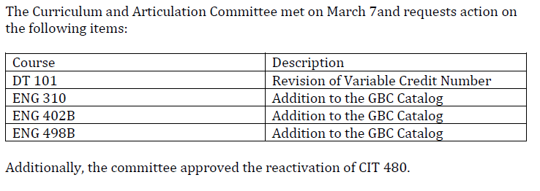

Motion made by John Rice, seconded by Jan King, motion carries. 2 Abstentions

- Department Chairs – Written/Action

Department Chairs recommends that the biology faculty positon be filled for the Winnemucca Center.

The Science Department learned Doug Hogan, our Biology Professor in Winnemucca, is retiring effective the end of the Spring 2016 semester. Department chairs are requesting an emergency vote for Department Chairs to approve rehiring his position. We are currently searching for a biologist in Elko and would like to combine it with the Winnemucca search.

This news is of particular importance for the growing nursing program in Winnemucca, because this position is responsible for BIOL 223, BIOL 224 and BIOL 251 lab, all pre-reqs for the AS in Nursing. Additionally, it would be very difficult for our department to adequately support the new BS in Biological Sciences and the BA in Natural Resources without this position. Additionally, this position supports general education BIOL 190 lecture and lab to our Winnemucca students.

Sheri Sanchez motions to approve, John Rice seconded, 1 Abstention, motion passes.

- Distance Education – Written Report

- Faculty & Administrative Evaluations – No Report

- Faculty/Staff Safety – No Report

- Gen Ed Ad Hoc Committee – No Report

- Library – Written Report

- Personnel- No Report

- Student Relations – Written Report

Non-senate Committees

- A.C.E. – Written

- Behavioral Intervention Team – No Report
- Child Care Center Advisory Committee – No Report
- Humanities –No Report

- iNtegrate 2 Ad Hoc – Written Report

- TAACCCT – No Report

- UNFINISHED BUSINESS –

- NEW BUSINESS –
New Curator- Sally Rampe has left so Mica Johnson will be the new GBC curator. She is president of the Elko Art Club.

- INFORMATION-
-Black And White movie night will be April 1st. The Strangers will play. Before the movie the WWII veterans will have a discussion and answer questions.
-Emeritus due 4/1/16
- 2016-17 catalog changes will no longer be accepted

- PUBLIC COMMENT –
When the draft of the catalog is sent out. Jan is begging every faculty member to read through their catalog carefully. There have been an enormous number of changes and there is new formatting that is causing things to be lost. Estimate will be April 4th.
If you update your student learning outcomes make sure they match and if there were changes they need to be sent to Brandis.
- ADJOURNMENT – Action
It was moved to adjourn the meeting at 10:54 a.m.

