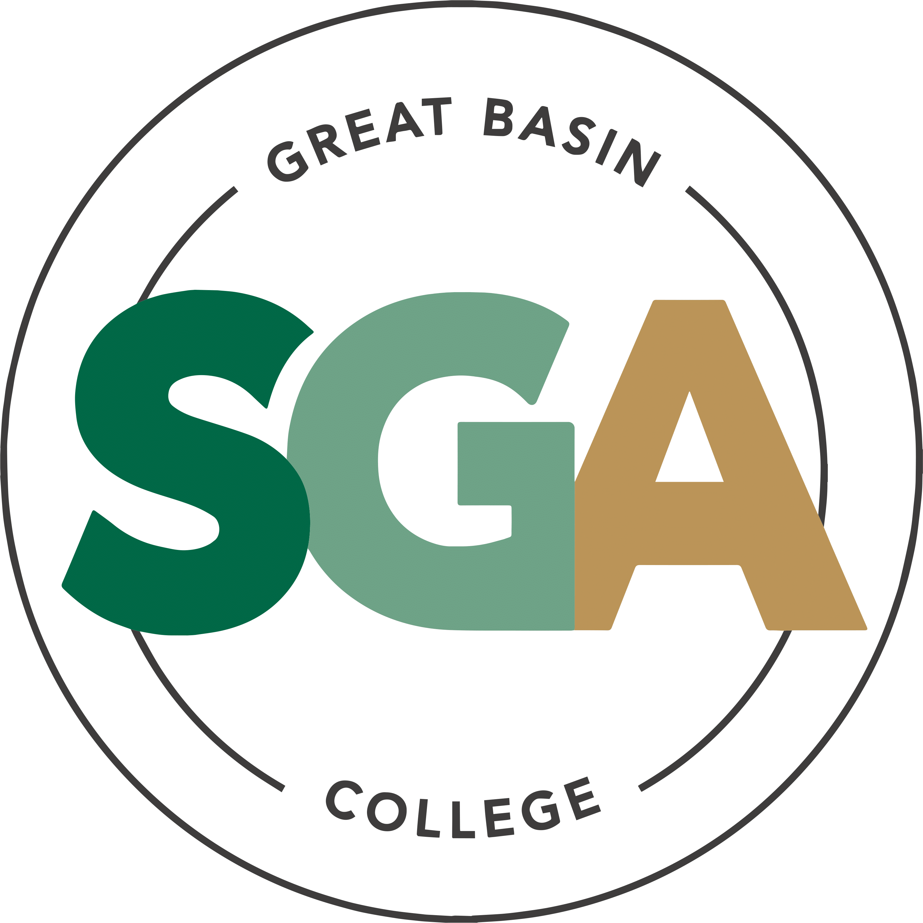

STUDENT GOVERNMENT ASSOCIATION (SGA)

AGENDA
January 27, 2026
3:00PM

VIDEO OR TELEPHONE CONFERENCE CONNECTION FROM THE MEETING SITE TO: 1500 COLLEGE PARKWAY; SGA OFFICE, LEONARD CENTER FOR STUDENT LIFE, GREAT BASIN COLLEGE CAMPUS, ELKO NV 89801
A VIDEO CONFERENCE CONNECTION WILL BE MADE FROM THE MEETING SITE TO ALL OTHER CAMPUS LOCATIONS.
THE PUBLIC MAY ATTEND THE MEETING AND PROVIDE PUBLIC COMMENT AT THIS SITE. PUBLIC COMMENT MAY ALSO BE SUBMITTED VIA ONLINE BY EMAILING SGA@GBCNV.EDU. COMMENTS MUST BE RECEIVED BY 5 PM PST THE DAY PRIOR TO THE MEETING. MEMBERS OF THE PUBLIC WISHING TO VIEW OR ATTEND THE MEETING MAY DO SO VIA ZOOM AT:
https://gbcnv-edu.zoom.us/j/84298011629?pwd=u7cz48zIwBHMP2dBEHkFAQ9r3DEMQR.1

EXECUTIVE MEMBERS:

JENNIFER RODRIGUEZ SERRANO, PRESIDENT
JULIA STOKES, VICE PRESIDENT
DENIELLE KIRKMAN, SECRETARY

SENATORS:

IAN MITCHEL, ELKO

MUHAMMED SALIKHOV, ELKO

STORM RAINE, ELKO

YULIANA MENDEZ-BARAJAS, ELKO

ELIZABETH NASH, ELY

CATHERINE HANSON, ELY

CATHERINE COLE, ONLINE

SOFIA MAYORGA, WINNEMUCCA

CALVIN COWAN, PAHRUMP

IMPORTANT INFORMATION ABOUT THE AGENDA AND PUBLIC MEETING

NOTE: Below is an agenda of all items scheduled to be considered. Notification is hereby provided that items on the agenda may be taken out of the order presented, two or more agenda items may be combined for consideration, and an agenda item may be removed from the agenda or discussion relating to an item on the agenda may be delayed at any time.
The agenda and any supporting material, including materials submitted after the posting of this agenda but before the meeting, may be accessed on the Internet by visiting the SGA page of the GBC website: Great Basin College: Student Life - Meetings.
In accordance with NRS241.020(6), supporting materials that are submitted to the Student Government Association (SGA) will be made available in advance of the meeting. Reasonable efforts will be made to assist and accommodate physically disabled persons attending the meeting. Please call the Office for Students with Disabilities (775) 327-2336 in advance so that arrangements may be made.

ROLL CALL

Roll call of members and any persons serving as a proxy for a member will be taken.
Estimated Time: 5 minutes

PUBLIC COMMENT INFORMATION ONLY

Public comment will be taken during this agenda item. No action may be taken on a matter raised under this item until the matter is included on an agenda as an item on which action may be taken. Comments will be limited to two minutes per person. Persons making comment will be asked to begin by stating their name for the record and to spell their last name. The SGA President may elect to allow additional public comment on a specific agenda item when that agenda item is being considered.

Pursuant to NRS 241.023, members of the public may also participate in the meeting by submitting written public comment messages via email to james.kendall@gbcnv.edu. Written statements received by 4:30 p.m. on THURSDAY, January 22, 2026, will be distributed to SGA members and included in the permanent meeting record and names of those who provide public comment via email will be announced at the meeting, however messages will no longer be read into the record. Members of the public may attend the meeting and provide public comment.

In accordance with Attorney General Opinion No. 00-047 (April 27, 2001), as restated in the Attorney General’s Open Meeting Law Manual, the President may prohibit comment if the content of that comment is a topic that is not relevant to, or within the authority of, the SGA, or if the content is willfully disruptive of the meeting by being irrelevant, repetitious, slanderous, offensive, inflammatory, irrational or amounting to personal attacks or interfering with the rights of other speakers.

Estimated Time: 5 minutes

APPROVAL OF AGENDA POSSIBLE ACTION
A Request is made for approval of the GBC SGA Agenda for the meeting on 1/27/2026.
Estimated Time: 1 minutes

APPROVAL OF MINUTES POSSIBLE ACTION
A Request is made for approval of the GBC SGA Minutes for the meeting on 1/20/2026.
Estimated Time: 1 minutes

PRESIDENT’S REPORT INFORMATION ONLY

SGA PRESIDENT RODRIGUEZ will discuss current SGA events and activities as SGA President
Estimated Time: 5 minutes

VICE PRESIDENT’S REPORT INFORMATION ONLY

SGA VICE PRESIDENT STOKES will discuss current SGA events and activities as SGA Vice President.
Estimated Time: 2 minutes

SECRETARY’S REPORT INFORMATION ONLY

SGA Secretary KIRKMAN will discuss current SGA events and activities as SGA Secretary.

Estimated Time: 2 minutes

STUDENT ADVOCATE’S REPORT INFORMATION ONLY

Student Advocate, JAMES KENDALL, will discuss current SGA events and items concerning SGA.

Estimated Time: 5 minutes

SENATOR REPORTS INFORMATION ONLY

Senators from each location will discuss their current and future events: Elko, Ely, Online, Winnemucca, and Pahrump.
Estimated Time: 10 minutes

Upcoming items

Pahrump Welcome Back Health and Wellness Week with Christopher Salute
Christopher would like to request funding for a Welcome Back Health and Wellness Week event. He would like to provide water cups, meditation/relaxation, mental health cards, a healthy snack, a sticker or pen from GBC, and a small calendar of events. He is requesting $50 for supply funding and $250 for food and prizes.

Estimated Time: 5-10 minutes

Pahrump Cold Food Vending Machine with Louellen Monte
Louellen would like to request funding for a cold food vending machine for the Pahrump campus. This would provide students with healthier meal options, such as salads and sandwiches, that they are currently unable to provide. There are no stores or restaurants within walking distance of the campus, which makes it difficult for students to get breakfast or lunch. They are requesting $2250 or supplies and $2250 for food and prizes.

Estimated Time: 5-10 minutes

NEW BUSINESS INFORMATION ONLY
Items for consideration at future meetings may be suggested. Any discussion of an item under “New Business” is limited to description and clarification of the subject matter of the item, which may include the reasons for the request, and no substantive discussion may occur at this meeting on new business items in accordance with the Nevada Open Meeting Law (NRS 241.010 et seq.).

Estimated Time: 5 minutes

PUBLIC COMMENT INFORMATION ONLY

Public comment will be taken during this agenda item. No action may be taken on a matter raised under this item until the matter is included on an agenda as an item on which action may be taken. Comments will be limited to two minutes per person. Persons making comment will be asked to begin by stating their name for the record and to spell their last name. The SGA President may elect to allow additional public comment on a specific agenda item when that agenda item is being considered.

Pursuant to NRS 241.023, members of the public may also participate in the meeting by submitting written public comment messages via email to james.kendall@gbcnv.edu. Written statements received by 4:30 p.m. on THURSDAY, January 15, 2026, will be distributed to SGA members and included in the permanent meeting record and names of those who provide public comment via email will be announced at the meeting, however messages will no longer be read into the record. Members of the public may attend the meeting and provide public comment.

In accordance with Attorney General Opinion No. 00-047 (April 27, 2001), as restated in the Attorney General’s Open Meeting Law Manual, the President may prohibit comment if the content of that comment is a topic that is not relevant to, or within the authority of, the SGA, or if the content is willfully disruptive of the meeting by being irrelevant, repetitious, slanderous, offensive, inflammatory, irrational or amounting to personal attacks or interfering with the rights of other speakers.

Estimated Time: 5 minutes
Posted in accordance with Nevada Open Meeting Law (NRS Ch. 241), at the following locations:
GBC, Berg Hall, 1500 College Parkway, Elko, NV 89801
Nevada Public Notice Website - https://notice.nv.gov
GBC SGA Website - Great Basin College: Student Life - Meetings.

