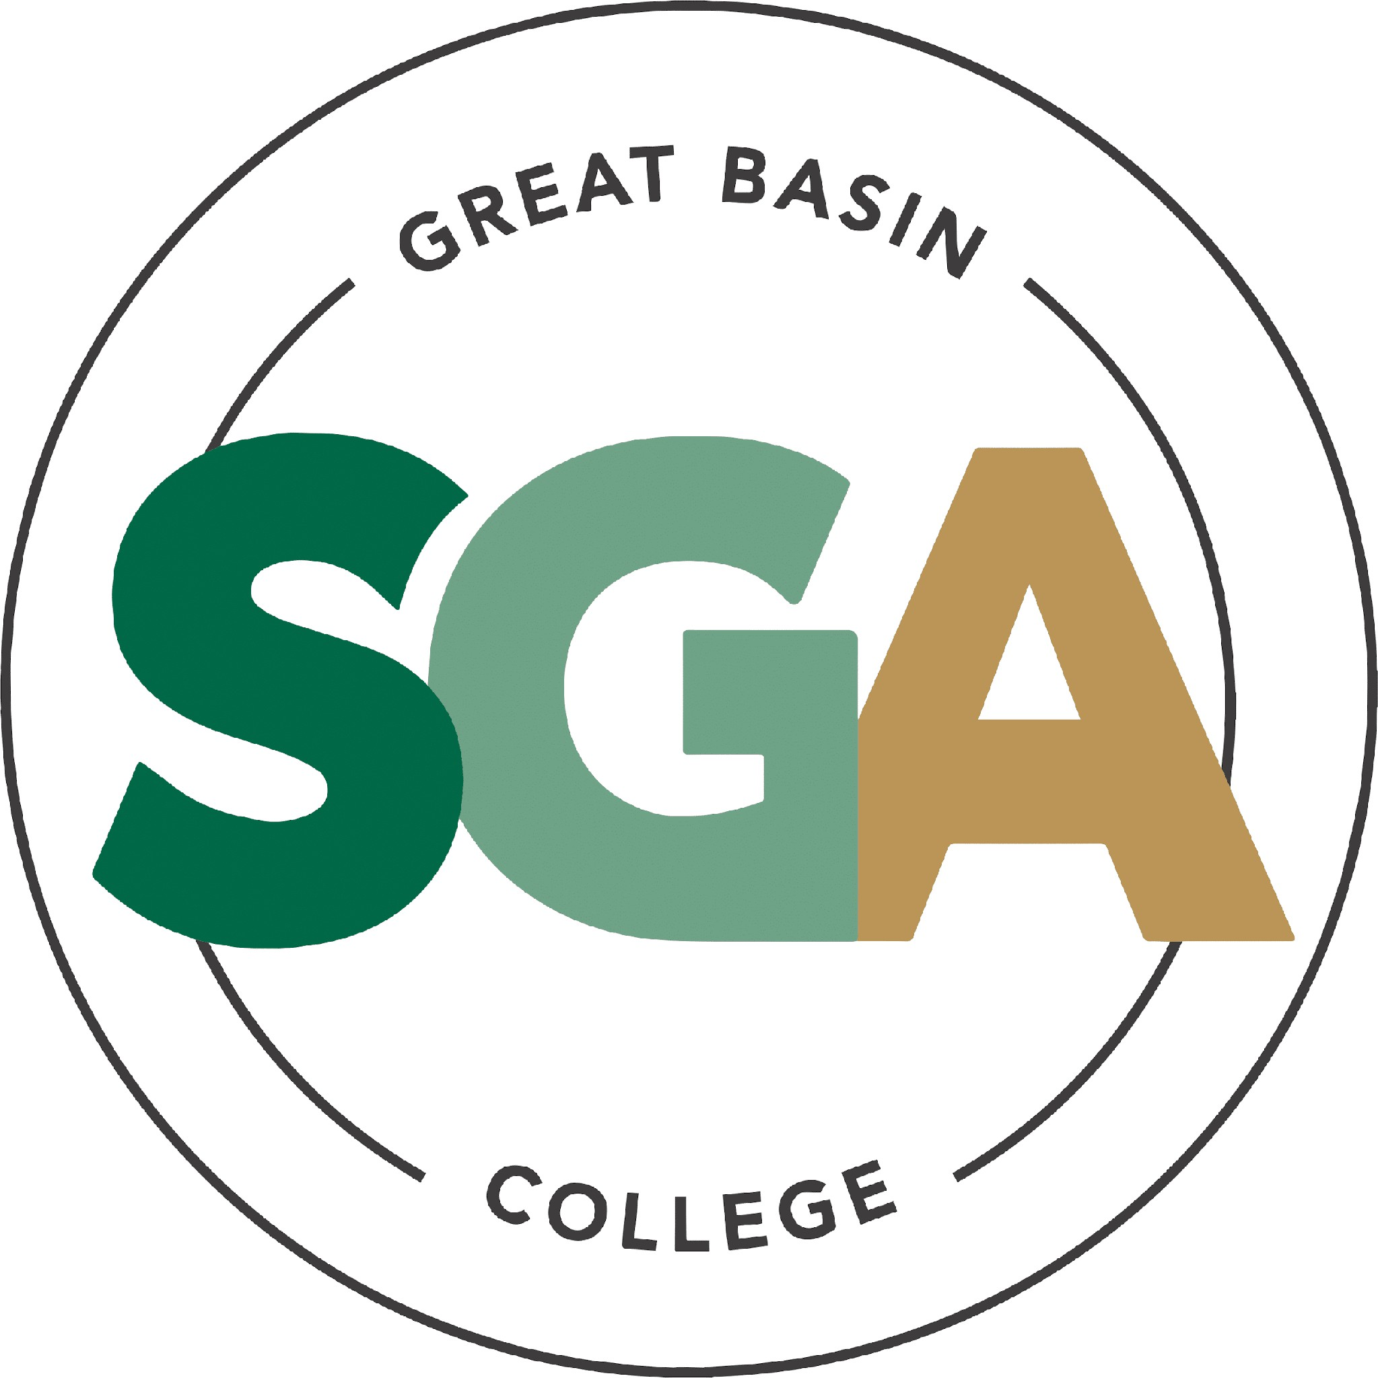
STUDENT GOVERNMENT ASSOCIATION (SGA)

AGENDA
OCTOBER 13, 2026
3:00 PM
VIDEO OR TELEPHONE CONFERENCE CONNECTION FROM THE MEETING SITE TO: 1500 COLLEGE PARKWAY; SGA OFFICE, LEONARD CENTER FOR STUDENT LIFE, GREAT BASIN COLLEGE CAMPUS, ELKO NV 89801

A VIDEO CONFERENCE CONNECTION WILL BE MADE FROM THE MEETING SITE TO ALL OTHER CAMPUS LOCATIONS.

THE PUBLIC MAY ATTEND THE MEETING AND PROVIDE PUBLIC COMMENT AT THIS SITE. PUBLIC COMMENT MAY ALSO BE SUBMITTED VIA ONLINE BY EMAILING SGA@GBCNV.EDU. COMMENTS MUST BE RECEIVED BY 5 PM PST THE DAY PRIOR TO THE MEETING. MEMBERS OF THE PUBLIC WISHING TO VIEW OR ATTEND THE MEETING MAY DO SO VIA ZOOM AT:

https://gbcnv-edu.zoom.us/j/84298011629?pwd=u7cz48zIwBHMP2dBEHkFAQ9r3DEMQR.1

EXECUTIVE MEMBERS:
STORM RAINE, PRESIDENT
JULIAN SOSA, VICE PRESIDENT
MUHAMMED SALIKHOV, SECRETARY
MATT ASCHENBRENER, STUDENT ADVOCATE
SENATORS:
DAVID BERNARDINO LOPEZ, ELKO
JAVIER TOVAR, ELKO
JOCKSSAN CONTRERAS, ELKO
ERICA WRIGHT, ELKO
DAPHANE TAYLOR, ELKO
KASSIDY WAKLEY, ELKO
JULIA STOKES, ELKO
DIVINE JACOBSON, ELKO
CATHERINE COLE, ONLINE
SOFIA MAYORGA, ONLINE
DYLAN MARTIN, ONLINE
PAYTON MINYARD, WINNEMUCCA
CAMILA CONTRERAS, WINNEMUCCA
LIZ NASH, ELY
CALVIN COWAN, PAHRUMP
NOTE: Below is an agenda of all items scheduled to be considered. Notification is hereby provided that items on the agenda may be taken out of the order presented, two or more agenda items may be combined for consideration, and an agenda item may be removed from the agenda or discussion relating to an item on the agenda may be delayed at any time.
The agenda and any supporting material, including materials submitted after the posting of this agenda but before the meeting, may be accessed on the Internet by visiting the SGA page of the GBC website: Great Basin College: Student Life - Meetings.
In accordance with NRS241.020(6), supporting materials that are submitted to the Student Government Association (SGA) will be made available in advance of the meeting. Reasonable efforts will be made to assist and accommodate physically disabled persons attending the meeting. Please call the Office for Students with Disabilities (775) 327-2336 in advance so that arrangements may be made.

- ROLL CALL

  - Roll call of members and any persons serving as a proxy for a member will be taken.

- PUBLIC COMMENT INFORMATION ONLY

Public comment will be taken during this agenda item. No action may be taken on a matter raised under this item until the matter is included on an agenda as an item on which action may be taken. Comments will be limited to two minutes per person. Persons making comment will be asked to begin by stating their name for the record and to spell their last name. The SGA President may elect to allow additional public comment on a specific agenda item when that agenda item is being considered.

Pursuant to NRS 241.023, members of the public may also participate in the meeting by submitting written public comment messages via email to matt.aschenbrener@gbcnv.edu. Written statements received by 4:30
p.m. on THURSDAY, OCTOBER 8th, 2026, will be distributed to SGA members and included in the permanent meeting record and names of those who provide public comment via email will be announced at the meeting, however messages will no longer be read into the record. Members of the public may attend the meeting and provide public comment.

In accordance with Attorney General Opinion No. 00-047 (April 27, 2001), as restated in the Attorney General’s Open Meeting Law Manual, the President may prohibit comment if the content of that comment is a topic that is not relevant to, or within the authority of, the SGA, or if the content is willfully disruptive of the meeting by being irrelevant, repetitious, slanderous, offensive, inflammatory, irrational or amounting to personal attacks or interfering with the rights of other speakers.
Posted in accordance with Nevada Open Meeting Law (NRS Ch. 241), at the following locations: GBC, Leonard Hall, 1500 College Parkway, Elko, NV 89801
Nevada Public Notice Website - https://notice.nv.gov
GBC SGA Website - Great Basin College: Student Life - Meetings.

- APPROVAL OF AGENDA POSSIBLE ACTION
A Request is made for approval of the GBC SGA Agenda for the meeting on 10/13/26.
Estimated time: 2 Minutes.

- APPROVAL OF PREVIOUS MINUTES POSSIBLE ACTION
A Request is made for approval of the GBC SGA Minutes for the meeting on 10/06/2026.
Estimated time: 2 Minutes.
- PRESIDENT’S REPORT INFORMATION ONLY

SGA PRESIDENT RAINE will discuss current SGA events and activities as SGA President.
Estimated time: 3 Minutes.

- VICE PRESIDENT’S REPORT INFORMATION ONLY

SGA VICE PRESIDENT SOSA will discuss current SGA events and activities as SGA Vice President.
Estimated time: 3 Minutes.

- SECRETARY REPORT INFORMATION ONLY

SGA SECRETARY SALIKHOV will discuss current SGA events and activities as SGA Secretary.
Estimated time: 3 Minutes.

- STUDENT ADVOCATE’S REPORT INFORMATION ONLY

INTERIM STUDENT ADVOCATE MATT ASCHENBRENER will discuss current SGA events and activities as interim student advocate.

Estimated time: 3 Minutes.

- SENATOR REPORTS INFORMATION ONLY

Senators from each location will discuss their current and future events: Elko, Ely, Online, Winnemucca, and Pahrump.

Estimated time: 10 Minutes.

- COMMITTEE REPORTS INFORMATION ONLY

Chairs of each Committee (Beats and Bites, Constitution and Amendments, Student Survey, Student Organization) will discuss the progress of their committees.

Estimated time: 10 Minutes

UNFINISHED BUSINESS

Land Acknowledgment – Senator Cowan POSSIBLE ACTION

We are requesting approval for the Land Acknowledgment Statement to be brought forward for a vote again. The statement will be presented to Faculty Senate for a vote on October 16 and, if approved, will be used at commencement ceremonies and other events where deemed appropriate.

The Land Acknowledgment recognizes the Indigenous lands on which our campuses are located and honors the Indigenous peoples of Nevada who have been here since time immemorial. It is an important step toward recognizing and respecting the history, cultures, and enduring presence of Nevada’s Indigenous communities.

Great Basin College is currently the only institution of higher education in the state of Nevada without a Land Acknowledgment Statement. Approval of this statement would allow our institution to take an important step toward honoring the Indigenous communities connected to the lands on which our campuses are located.

Senator Cowan will elaborate more on this item
Estimated time: 5-10 Minutes.
- Pickleball Club Requesting to Move up from a tier 3 to a tier 1 – Senator Tovar POSSIBLE ACTION
  - Senator Tovar is requesting to bring this item back to the table for all SGA members to vote on.
  - Senator Tovar will elaborate more on this item.
Estimated time: Less than 5 Minutes
- Impeachment Process Discussion
  - Deliberation of action to move forward with the impeachment of VP Sosa
  - Discussion of creating the impeachment committee
Estimated time: 5-10 Minutes.

- NEW BUSINESS

Information on the NSHE Eyes Open Campaign – Jeff Hills INFORMATIONAL ITEM
  - Awareness of how to report concerning behavior
  - Jeff will elaborate more on this item
Estimated time: Less than 5 Minutes.
- Winnemucca Requesting $100 for Pumpkins and Paint - Senator Camila POSSIBLE ACTION
  - SGA Winnemucca is requesting $100 monthly for pumpkins and paint for their October pumpkin painting event
  - Senator Camila will elaborate more on this item
Estimated time: Less than 5 Minutes.
- Beats & Bites at Pahrump Valley Center – Senator Cowan POSSIBLE ACTION
  - Senator Cowan is requesting $1,200 for food, prizes, and decorations
  - The fund will cover tacos from Roberto’s Tacos, Games, Pumpkins, Candy, Supplies, and decorations
  - They are working with SNO for this event (Student Nursing Org)
  - Senator Cowan will elaborate more on this item
Estimated time: Less than 5 Minutes.
- Pahrump Valley Center SGA Lounge Enhancing – Senator Cowan POSSIBLE ACTION
  - Senator Cowan is requesting $2,000 in funding from the Pahrump Valley Center SGA Budget to enhance the new SGA lounge.
  - The requested funding will be used to purchase a new SGA cabinet, wall-mounted lock boxes for the Nintendo Switch consoles, a television, and a vinyl SGA logo to be displayed on the wall.
  - The SGA lounge will provide a welcoming space for student organizations to host club events, SGA Senators to organize activities and events, and students to have a place to relax, socialize, and enjoy time on campus. This funding will help create a more engaging and inviting environment that promotes student involvement, connection, and campus community.
  - Senator Cowan will elaborate more on this item
Estimated time: 5-10 Minutes.

- President Raine Discussing The Mascot Use Policy POSSIBLE ACTION
  - President Raine is seeking approval of a new SGA mascot use policy
  - President Raine will elaborate more on this item
Estimated time: Less than 5 Minutes.

- NEW BUSINESS REQUESTS INFORMATION ONLY

Items for consideration at future meetings may be suggested. Any discussion of an item under “New Business Requests” is limited to description and clarification of the subject matter of the item, which may include the reasons for the request, and no substantive discussion may occur at this meeting on new business items in accordance with the Nevada Open Meeting Law (NRS 241.010 et seq.).
President Raine can ask for any additional new business for consideration at the following meeting.
Estimated time: 3 Minutes.

- PUBLIC COMMENT INFORMATION ONLY
Public comment will be taken during this agenda item. No action may be taken on a matter raised under this item until the matter is included on an agenda as an item on which action may be taken. Comments will be limited to two minutes per person. Persons making comments will be asked to begin by stating their name for the record and to spell their last name. The SGA President may elect to allow additional public comment on a specific agenda item when that agenda item is being considered.

Pursuant to NRS 241.023, members of the public may also participate in the meeting by submitting written public comment messages via email to matt.aschenbrener@gbcnv.edu. Written statements received by 4:30
p.m. on THURSDAY, OCTOBER 8th, 2026, will be distributed to SGA members and included in the permanent meeting record, and names of those who provide public comment via email will be announced at the meeting, messages will no longer be read into the record. Members of the public may attend the meeting and provide public comment.

In accordance with Attorney General Opinion No. 00-047 (April 27, 2001), as restated in the Attorney General’s Open Meeting Law Manual, the President may prohibit comment if the content of that comment is a topic that is not relevant to, or within the authority of, the SGA, or if the content is willfully disruptive of the meeting by being irrelevant, repetitious, slanderous, offensive, inflammatory, irrational or amounting to personal attacks or interfering with the rights of other speakers.
Posted in accordance with Nevada Open Meeting Law (NRS Ch. 241), at the following locations: GBC, Leonard Hall, 1500 College Parkway, Elko, NV 89801
Nevada Public Notice Website - https://notice.nv.gov
GBC SGA Website - Great Basin College: Student Life - Meetings.

- ADJOURNMENT POSSIBLE ACTION

