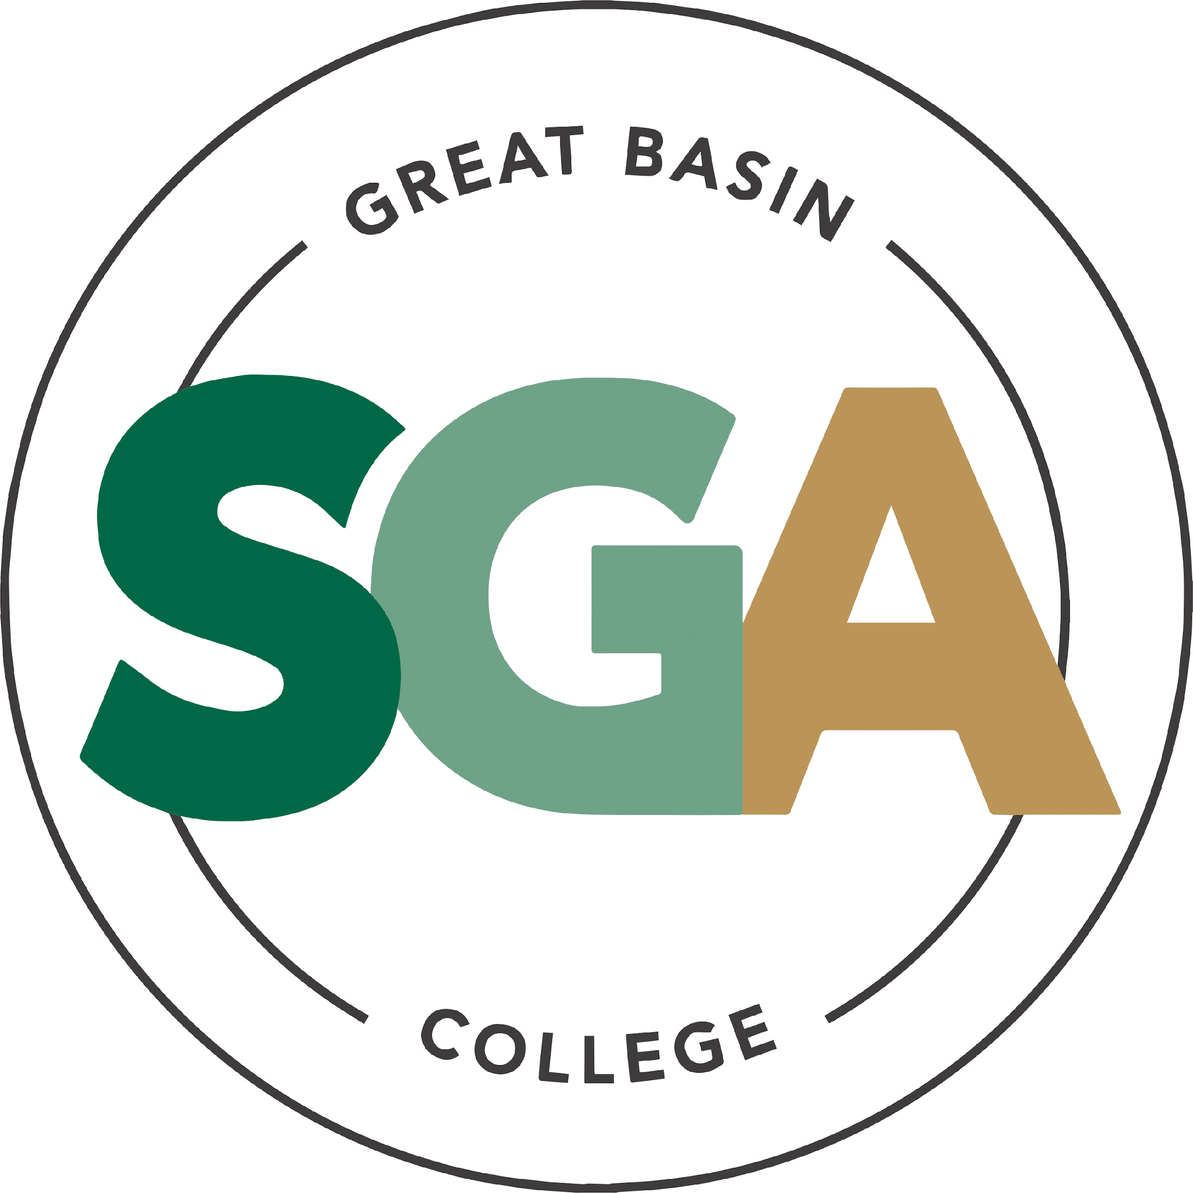

STUDENT GOVERNMENT ASSOCIATION (SGA)

AGENDA
SEPTEMBER 8, 2026
3:00 PM

VIDEO OR TELEPHONE CONFERENCE CONNECTION FROM THE MEETING SITE TO: 1500 COLLEGE PARKWAY; SGA OFFICE, LEONARD CENTER FOR STUDENT LIFE, GREAT BASIN COLLEGE CAMPUS, ELKO NV 89801
A VIDEO CONFERENCE CONNECTION WILL BE MADE FROM THE MEETING SITE TO ALL OTHER CAMPUS LOCATIONS.
THE PUBLIC MAY ATTEND THE MEETING AND PROVIDE PUBLIC COMMENT AT THIS SITE. PUBLIC COMMENT MAY ALSO BE SUBMITTED VIA ONLINE BY EMAILING SGA@GBCNV.EDU. COMMENTS MUST BE RECEIVED BY 5 PM PST THE DAY PRIOR TO THE MEETING. MEMBERS OF THE PUBLIC WISHING TO VIEW OR ATTEND THE MEETING MAY DO SO VIA ZOOM AT:
https://gbcnv-edu.zoom.us/j/84298011629?pwd=u7cz48zIwBHMP2dBEHkFAQ9r3DEMQR.1
MEETING CALLED TO ORDER AT 3:00 PM

EXECUTIVE MEMBERS:

STORM RAINE, PRESIDENT PRESENT
JULIA STOKES, VICE PRESIDENT PRESENT

SENATORS

MUHAMMED SALIKHOV, ELKO PRESENT

DAVID BERNADINO-LOPEZ, ELKO PRESENT

DIVINE JACOBSON, ELKO PRESENT

JULIAN SOSA, ELKO PRESENT

CATHERINE COLE, ONLINE ABSENT UNEXCUSED

TERILYN MARINO, ONLINE ABSENT UNEXCUSED

CALVIN COWAN, PAHRUMP PRESENT

ELIZABETH NASH, ELY PRESENT

NOTE: Below is an agenda of all items scheduled to be considered. Notification is hereby provided that items on the agenda may be taken out of the order presented, two or more agenda items may be combined for consideration, and an agenda item may be removed from the agenda or discussion relating to an item on the agenda may be delayed at any time.
The agenda and any supporting material, including materials submitted after the posting of this agenda but before the meeting, may be accessed on the Internet by visiting the SGA page of the GBC website: Great Basin College: Student Life - Meetings.
In accordance with NRS241.020(6), supporting materials that are submitted to the Student Government Association (SGA) will be made available in advance of the meeting. Reasonable efforts will be made to assist and accommodate physically disabled persons attending the meeting. Please call the Office for Students with Disabilities (775) 327-2336 in advance so that arrangements may be made.

ROLL CALL

- Roll call of members and any persons serving as a proxy for a member will be taken.

PUBLIC COMMENT INFORMATION ONLY

Public comment will be taken during this agenda item. No action may be taken on a matter raised under this item until the matter is included on an agenda as an item on which action may be taken. Comments will be limited to two minutes per person. Persons making comment will be asked to begin by stating their name for the record and to spell their last name. The SGA President may elect to allow additional public comment on a specific agenda item when that agenda item is being considered.

Pursuant to NRS 241.023, members of the public may also participate in the meeting by submitting written public comment messages via email to james.kendall@gbcnv.edu. Written statements received by 4:30 p.m. on THURSDAY, September 3rd, 2026, will be distributed to SGA members and included in the permanent meeting record and names of those who provide public comment via email will be announced at the meeting, however messages will no longer be read into the record. Members of the public may attend the meeting and provide public comment.

In accordance with Attorney General Opinion No. 00-047 (April 27, 2001), as restated in the Attorney General’s Open Meeting Law Manual, the President may prohibit comment if the content of that comment is a topic that is not relevant to, or within the authority of, the SGA, or if the content is willfully disruptive of the meeting by being irrelevant, repetitious, slanderous, offensive, inflammatory, irrational or amounting to personal attacks or interfering with the rights of other speakers.
NO PUBLIC COMMENT AT THIS TIME.

APPROVAL OF AGENDA POSSIBLE ACTION
A Request is made for approval of the GBC SGA Agenda for the meeting on 8/18/2026.
VICE PRESIDENT STOKES MOTIONED TO APPROVE THE AGENDA, SENATOR SOSA SECONDED THE MOTION. MOTION IS PASSED UNANIMOUSLY

APPROVAL OF PREVIOUS MINUTES POSSIBLE ACTION
A Request is made for approval of the GBC SGA Minutes for the meeting on 9/1/2026.
SENATOR SALIKHOV MOTIONED TO APPROVE THE MINUTES, SENATOR BERNARDINO SECONDED THE MOTION. MOTION PASSES UNANIMOUSLY SENATOR SOSA AND SENATOR JACOBSON ABSTAINED FROM LAST WEEKS MEETING

PRESIDENT’S REPORT INFORMATION ONLY

SGA PRESIDENT RAINE will discuss current SGA events and activities as SGA President
PRESIDENT RAINE REPORTED THAT ITS AN EXCITING TIME FOR GBC, HE WILL BE MEETING WITH PRESIDENT DENALLI TOMORROW AND ASKED IF THERE WAS ANY COMMENTS OR CONCERNS TO LET HIM KNOW BEFORE HE MEETS WITH HER. HE ALSO REPORTED THAT THE BOARD OF REGENTS MEETING WENT WELL AND THAT WE HAVE FULL SUPPORT FROM THEM ON THE REBRANDING. HE ALSO ASKED IF ANYONE WAS AVAILBLE TO HELP OUT WITH LORI’S SUICIDE WALK THIS FRIDAY. SENATOR NASH POSTED A SURVEY AND HE WOULD LIKE ALL OF US TO CHECK IT OUT. THANKED JAMES FOR ALL HIS HARD WORK AND DEDICATION FOR US AT SGA.

VICE PRESIDENT’S REPORT INFORMATION ONLY

SGA VICE PRESIDENT STOKES will discuss current SGA events and activities as SGA Vice President.

VICE PRESIDENT STOKES REPORTED THAT SETTING UP FOR BEATS AND BITES HAS BEEN ROUGH AS A LOT OF VENDORS ARE NOT ABLE TO ATTEND. AS WELL AS WISHED JAMES LUCK IN HIS FUTURE ENDEAVORS.

STUDENT ADVOCATE’S REPORT INFORMATION ONLY

Student Advocate, JAMES KENDALL, will discuss current SGA events and items concerning SGA.

ADVOCATE KENDALL REPORTED THAT HE WISHES ALL OF US LUCK IN OUR FUTURE ENDEAVORS, AS WELL AS LET US KNOW THAT WE WILL HAVE A TEMPORARY ADVOCATE VICE PRESIDENT MATT ASHUNBARUNER. HE ALSO

SENATOR REPORTS INFORMATION ONLY

Senators from each location will discuss their current and future events: Elko, Ely, Online, Winnemucca, and Pahrump.

SALIKHOV – DIDN’T HAVE MUCH TO REPORT BESIDES WISHING JAMES LUCK ON HIS FUTURE ENDEAVORS.
BERNADINO – REPORTED THAT HES TRYING TO GET BACK INTO THE GROOVE OF THINGS AFTER A 4 DAY WEEKEND BUT ALSO WISHED JAMES LUCK IN HIS FUTURE.

NASH – REPORTED THAT ELY’S 30 YEAR ANNIVERSARY WAS COMING UP AND TO LET US KNOW IF WE WERE ATTENDING IT SO SHE CAN SHOW US AROUND

JACOBSON – APOLOGIZED FOR MISSING THE LAST COUPLE OF MEETINGS, FORMALLY ANNOUCED SHE WILL NO LONGER BE IN CHARGE OF BEATS AND BITES AS WELL AS WISHED JAMES FAREWELL AND LUCK IN HIS FUTURE.

COWAN – REPORTED THAT HE IS GRATEFUL FOR ADVOCATE KENDALL MAKING HIM FEEL HEARD AND ALL THE HELP HE HAS GIVEN HIM. HE ALSO STATED THAT WE SHOULD NOT LET ADMINISTRATION RUIN OUR PLANS THAT HAVE ALREADY BEEN MADE AND APPROVED.
SOSA – REPORTED THAT HE IS GLAD TO BE BACK, TOLD SENATOR NASH SHE DID GREAT
ON HER SURVEY AS WELL AS WISHED ADVOCATE JAMES KENDALL LUCK IN HIS FUTURE.

COMMITTEE REPORTS INFORMATION ONLY

AMENDAMENT – NO REPORTS ON IT AT THIS TIME

BEATS & BITES – NO REPORTS ON IT AT THIS TIME

Unfinished Business
NONE

UPCOMING ITEMS POSSIBLE ACTION

- MINI SNACK BOXES FOR ONLINE B&B -$200

SENATOR NASH REPORTED THAT STUDENTS WILL FILL OUT A SURVEY AND WHOEVER QUALIFIES, WILL RECEIVE THE SNACK BOX. SENATOR JACOBSON MOTIONED TO APPROVE, SENATOR COWAN SECONDED THAT MOTION. MOTION PASSES UNANIMOUSLY

- VOTE FOR REMOVAL OF SENATOR MARINO

ADVOCATE JAMES KENDALL REPORTED THAT SENATOR MARINO HAS NOT ATTENDED
THE LAST 5 SGA MEETINGS AND THAT IS BREAKING THE SGA AMENDMENTS. SENATOR
SALIKHOV MOTIONED TO APPROVE THE REMOVAL OF SENATOR MARINO, SENATOR
COWAN SECONDED THAT MOTION. MOTION PASSES UNANIMOUSLY

NEW BUSINESS INFORMATION ONLY
Items for consideration at future meetings may be suggested. Any discussion of an item under “New Business” is limited to description and clarification of the subject matter of the item, which may include the reasons for the request, and no substantive discussion may occur at this meeting on new business items in accordance with the Nevada Open Meeting Law (NRS 241.010 et seq.).
SENATOR COWAN WOULD LIKE TO PROMOTE A CULTURAL EVENT FOR HERITAGE EVENTS.

Estimated Time: 5 minutes
NONE

PUBLIC COMMENT INFORMATION ONLY

Public comment will be taken during this agenda item. No action may be taken on a matter raised under this item until the matter is included on an agenda as an item on which action may be taken. Comments will be limited to two minutes per person. Persons making comment will be asked to begin by stating their name for the record and to spell their last name. The SGA President may elect to allow additional public comment on a specific agenda item when that agenda item is being considered.

Pursuant to NRS 241.023, members of the public may also participate in the meeting by submitting written public comment messages via email to james.kendall@gbcnv.edu. Written statements received by 4:30 p.m. on THURSDAY, September 3, 2026, will be distributed to SGA members and included in the permanent meeting record, and names of those who provide public comment via email will be announced at the meeting, messages will no longer be read into the record. Members of the public may attend the meeting and provide public comment.

In accordance with Attorney General Opinion No. 00-047 (April 27, 2001), as restated in the Attorney General’s Open Meeting Law Manual, the President may prohibit comment if the content of that comment is a topic that is not relevant to, or within the authority of, the SGA, or if the content is willfully disruptive of the meeting by being irrelevant, repetitious, slanderous, offensive, inflammatory, irrational or amounting to personal attacks or interfering with the rights of other speakers.

Posted in accordance with Nevada Open Meeting Law (NRS Ch. 241), at the following locations:
GBC, Berg Hall, 1500 College Parkway, Elko, NV 89801
Nevada Public Notice Website - https://notice.nv.gov
GBC SGA Website - Great Basin College: Student Life - Meetings.

14. Adjournment INFORMATION ONLY

SENATOR SALIKHOV MOTIONS TO ADJOURN. SENATOR BERNARDINO SECONDS. MOTION TO ADJOURN PASSES UNANIMOUSLY.

MEETING ADJOURNED AT 3:42 PM

PRESIDENT:_________________________________. DATE:____________

