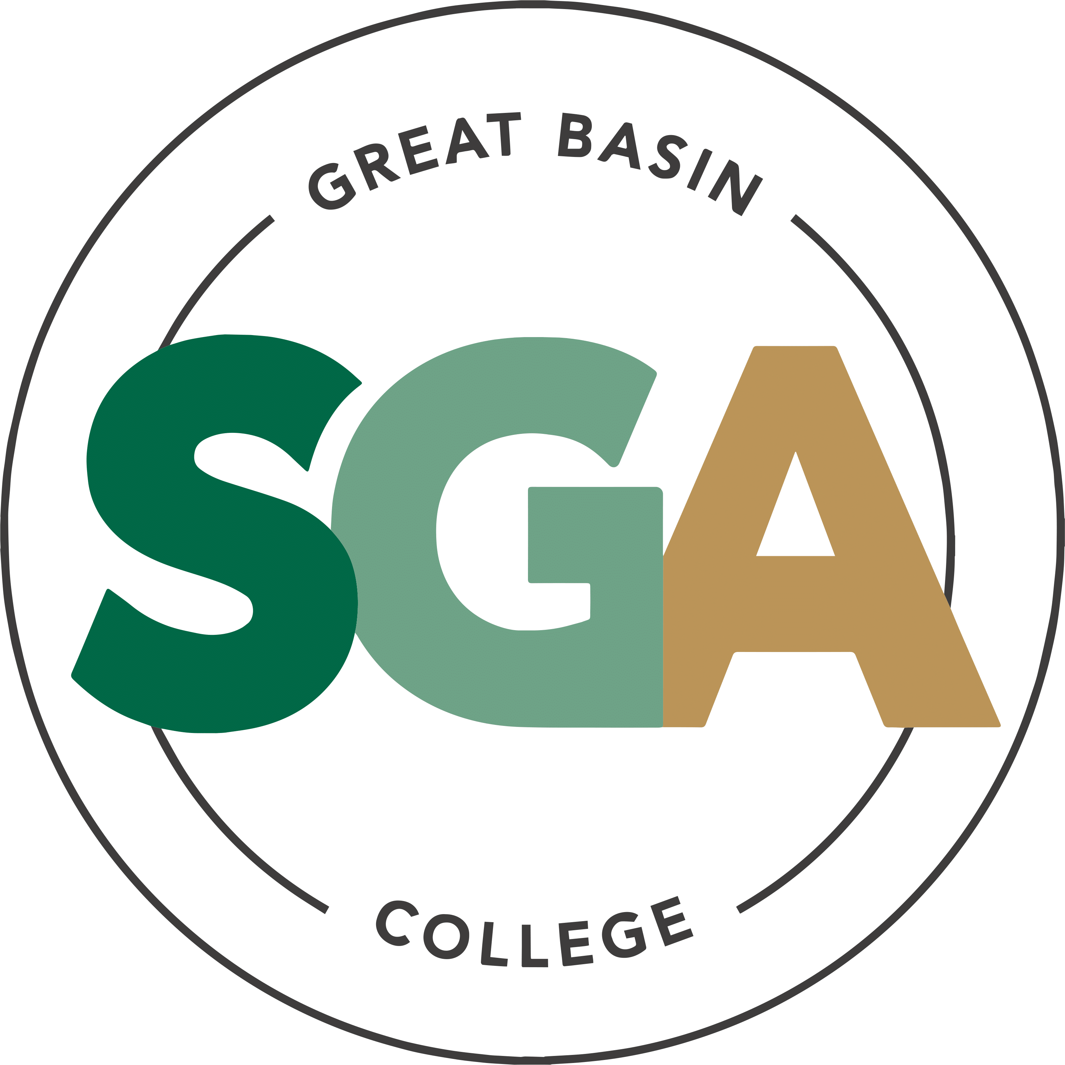

STUDENT GOVERNMENT ASSOCIATION (SGA)

MINUTES
January 27, 2026
Meeting Called to Order at 3:00PM

VIDEO OR TELEPHONE CONFERENCE CONNECTION FROM THE MEETING SITE TO: 1500 COLLEGE PARKWAY; SGA OFFICE, LEONARD CENTER FOR STUDENT LIFE, GREAT BASIN COLLEGE CAMPUS, ELKO NV 89801
A VIDEO CONFERENCE CONNECTION WILL BE MADE FROM THE MEETING SITE TO ALL OTHER CAMPUS LOCATIONS.
THE PUBLIC MAY ATTEND THE MEETING AND PROVIDE PUBLIC COMMENT AT THIS SITE. PUBLIC COMMENT MAY ALSO BE SUBMITTED VIA ONLINE BY EMAILING SGA@GBCNV.EDU. COMMENTS MUST BE RECEIVED BY 5 PM PST THE DAY PRIOR TO THE MEETING. MEMBERS OF THE PUBLIC WISHING TO VIEW OR ATTEND THE MEETING MAY DO SO VIA ZOOM AT:
https://gbcnv-edu.zoom.us/j/84298011629?pwd=u7cz48zIwBHMP2dBEHkFAQ9r3DEMQR.1

EXECUTIVE MEMBERS:
JENNIFER RODRIGUEZ SERRANO, PRESIDENT PRESENT
JULIA STOKES, VICE PRESIDENT PRESENT
DENIELLE KIRKMAN, SECRETARY PRESENT

SENATORS:

IAN MITCHEL, ELKO PRESENT

MUHAMMED SALIKHOV, ELKO ABSENT EXCUSED

STORM RAINE, ELKO PRESENT

YULIANA MENDEZ-BARAJAS, ELKO PRESENT

ELIZABETH NASH, ELY PRESENT

CATHERINE HANSON, ELY ABSENT EXCUSED

CATHERINE COLE, ONLINE PRESENT

SOFIA MAYORGA, WINNEMUCCA PRESENT

CALVIN COWAN, PAHRUMP PRESENT

GUESTS:

Karl Stevens- Dean of Business and Computer Science

Christopher Salute- Pahrump Center Director

Shemayne Pitts- Ely Center Director

Jessica Ortiz- Student Life Coordinator

Shakira Chesebro- Administrative Assistant 3 Pahrump

IMPORTANT INFORMATION ABOUT THE AGENDA AND PUBLIC MEETING

NOTE: Below is an agenda of all items scheduled to be considered. Notification is hereby provided that items on the agenda may be taken out of the order presented, two or more agenda items may be combined for consideration, and an agenda item may be removed from the agenda or discussion relating to an item on the agenda may be delayed at any time.
The agenda and any supporting material, including materials submitted after the posting of this agenda but before the meeting, may be accessed on the Internet by visiting the SGA page of the GBC website: Great Basin College: Student Life - Meetings.
In accordance with NRS241.020(6), supporting materials that are submitted to the Student Government Association (SGA) will be made available in advance of the meeting. Reasonable efforts will be made to assist and accommodate physically disabled persons attending the meeting. Please call the Office for Students with Disabilities (775) 327-2336 in advance so that arrangements may be made.

ROLL CALL

Roll call of members and any persons serving as a proxy for a member will be taken.

PUBLIC COMMENT INFORMATION ONLY

Public comment will be taken during this agenda item. No action may be taken on a matter raised under this item until the matter is included on an agenda as an item on which action may be taken. Comments will be limited to two minutes per person. Persons making comment will be asked to begin by stating their name for the record and to spell their last name. The SGA President may elect to allow additional public comment on a specific agenda item when that agenda item is being considered.

Pursuant to NRS 241.023, members of the public may also participate in the meeting by submitting written public comment messages via email to james.kendall@gbcnv.edu. Written statements received by 4:30 p.m. on THURSDAY, January 22, 2026, will be distributed to SGA members and included in the permanent meeting record and names of those who provide public comment via email will be announced at the meeting, however messages will no longer be read into the record. Members of the public may attend the meeting and provide public comment.

In accordance with Attorney General Opinion No. 00-047 (April 27, 2001), as restated in the Attorney General’s Open Meeting Law Manual, the President may prohibit comment if the content of that comment is a topic that is not relevant to, or within the authority of, the SGA, or if the content is willfully disruptive of the meeting by being irrelevant, repetitious, slanderous, offensive, inflammatory, irrational or amounting to personal attacks or interfering with the rights of other speakers.

None

APPROVAL OF AGENDA POSSIBLE ACTION
A Request is made for approval of the GBC SGA Agenda for the meeting on 1/27/2026.
Senator Cole Motions to Approve. Senator Raine Seconds. Motion Passes Unanimously.

APPROVAL OF MINUTES POSSIBLE ACTION
A Request is made for approval of the GBC SGA Minutes for the meeting on 1/20/2026.
Senator Mayorga Motions to Approve. Secretary Kirkman Seconds. Motion Passes Unanimously.
Absentions: President Rodriguez, Senator Mitchel

PRESIDENT’S REPORT INFORMATION ONLY

SGA PRESIDENT RODRIGUEZ will discuss current SGA events and activities as SGA President

President Rodriguez mentioned she took a trip on break to Mexico to visit family. She thought school started a week later than it actually did. She reports that the fee increases were approved, but she has not had time to look into the details. She finally reported that she will not be running this semester from president and will be leaving SGA for the time being after elections.

VICE PRESIDENT’S REPORT INFORMATION ONLY

SGA VICE PRESIDENT STOKES will discuss current SGA events and activities as SGA Vice President.

Vice President Stokes mentioned that John Evans is pushing to have receipts in for activities and events quickly after the items are purchased to keep the budget spreadsheet accurate. The receipts can be sent to her or James. Professor Kleeb will be joining SGA sometime in February to go over the changes he is proposing for the business program.

SECRETARY’S REPORT INFORMATION ONLY

SGA Secretary KIRKMAN will discuss current SGA events and activities as SGA Secretary.

She mentioned she got to join the SGA Welcome Back Week Bowling event and had a lot of fun. She is sad that President Rodriguez is stepping down and will miss her.

STUDENT ADVOCATE’S REPORT INFORMATION ONLY

Student Advocate, JAMES KENDALL, will discuss current SGA events and items concerning SGA.

James went home, but Jessica reported for him. She reported that executive leadership is looking into athletics at GBC. The SGA retreat is scheduled for March 27th. If there are any GBC employees interested in coming, please let James know, because they can use GBC vehicles, and if needed, do the training for using them. Our constitution is still in process at the Chancellor’s office.

SENATOR REPORTS INFORMATION ONLY

Senators from each location will discuss their current and future events: Elko, Ely, Online, Winnemucca, and Pahrump.

Senator Mitchel- He missed last week. He wishes everyone luck. He is sad about President Rodriguez leaving.

Senator Raine- He mentioned that he wanted to thank President Rodriguez for all her hard work and friendship. He stood in at the President’s Council meeting. They went over student fee increases. He believes it will be 9% over 3 years. There are prospects for new clubs. He would also like to start a Dungeons and Dragons club. He decided to run for President in the Spring election.

Senator Mendez- She mentioned that she has been working a lot and getting into the swing of homework and classes. The bowling event was packed and so much fun. She also said she is going to miss President Rodriguez. She appreciates all the work she put in.

Senator Nash- She mentioned that everyone has enjoyed the welcome back snacks. They were devoured quickly.

Senator Cole- She apologized for the wrong information provided last week. There was a hiccup with how late she enrolled, and the charges dropped off that night. She was sorry that President Rodriguez was leaving and thanked her as well for all the work she has done with SGA and NSHE.

Senator Mayorga- She hopes everyone is doing well. She is getting organized. She thanked President Rodriguez again.

Senator Cowan- He mentioned his thanks to President Rodriguez and all the hard work she has done. He got sick on top of having classes, and he will be planning the Welcome Back Event.

Upcoming items

Pahrump Welcome Back Health and Wellness Week with Christopher Salute
Christopher would like to request funding for a Welcome Back Health and Wellness Week event. He would like to provide water cups, meditation/relaxation, mental health cards, a healthy snack, a sticker or pen from GBC, and a small calendar of events. He is requesting $50 for supply funding and $250 for food and prizes.
Senator Mitchel Motions to Approve. Senator Cowan Seconds. Motion Passes Unanimously.

Explaining SGA Canva Pages with Karl Stevens
Karl will be joining us to explain to the prospective senators how to use the Canva pages while running elections.
Karl joined us to explain how to customize your SGA election pages. He explained that we would be in 10 groups and that it is a good idea to check the discussions for any questions. He explained speeches and what can be done.

NEW BUSINESS INFORMATION ONLY
Items for consideration at future meetings may be suggested. Any discussion of an item under “New Business” is limited to description and clarification of the subject matter of the item, which may include the reasons for the request, and no substantive discussion may occur at this meeting on new business items in accordance with the Nevada Open Meeting Law (NRS 241.010 et seq.).

None

PUBLIC COMMENT INFORMATION ONLY

Public comment will be taken during this agenda item. No action may be taken on a matter raised under this item until the matter is included on an agenda as an item on which action may be taken. Comments will be limited to two minutes per person. Persons making comment will be asked to begin by stating their name for the record and to spell their last name. The SGA President may elect to allow additional public comment on a specific agenda item when that agenda item is being considered.

Pursuant to NRS 241.023, members of the public may also participate in the meeting by submitting written public comment messages via email to james.kendall@gbcnv.edu. Written statements received by 4:30 p.m. on THURSDAY, January 15, 2026, will be distributed to SGA members and included in the permanent meeting record and names of those who provide public comment via email will be announced at the meeting, however messages will no longer be read into the record. Members of the public may attend the meeting and provide public comment.

In accordance with Attorney General Opinion No. 00-047 (April 27, 2001), as restated in the Attorney General’s Open Meeting Law Manual, the President may prohibit comment if the content of that comment is a topic that is not relevant to, or within the authority of, the SGA, or if the content is willfully disruptive of the meeting by being irrelevant, repetitious, slanderous, offensive, inflammatory, irrational or amounting to personal attacks or interfering with the rights of other speakers.

Shemayne Pitts commended SGA for how much work we put in. Secretary Kirkman asked if President Rodriguez was quitting SGA completely. Senator Raine asked about the NSA and how it would work once she wasn’t President anymore. President Rodriguez explained as much as she is aware of. Senator Mayorga asked to confirm date for the spring retreat, which is March 27th.
Meeting Adjourned at 3:50 PM

Posted in accordance with the Nevada Open Meeting Law (NRS Ch. 241), at the following locations:
GBC, Berg Hall, 1500 College Parkway, Elko, NV 89801
Nevada Public Notice Website - https://notice.nv.gov
GBC SGA Website - Great Basin College: Student Life - Meetings.

