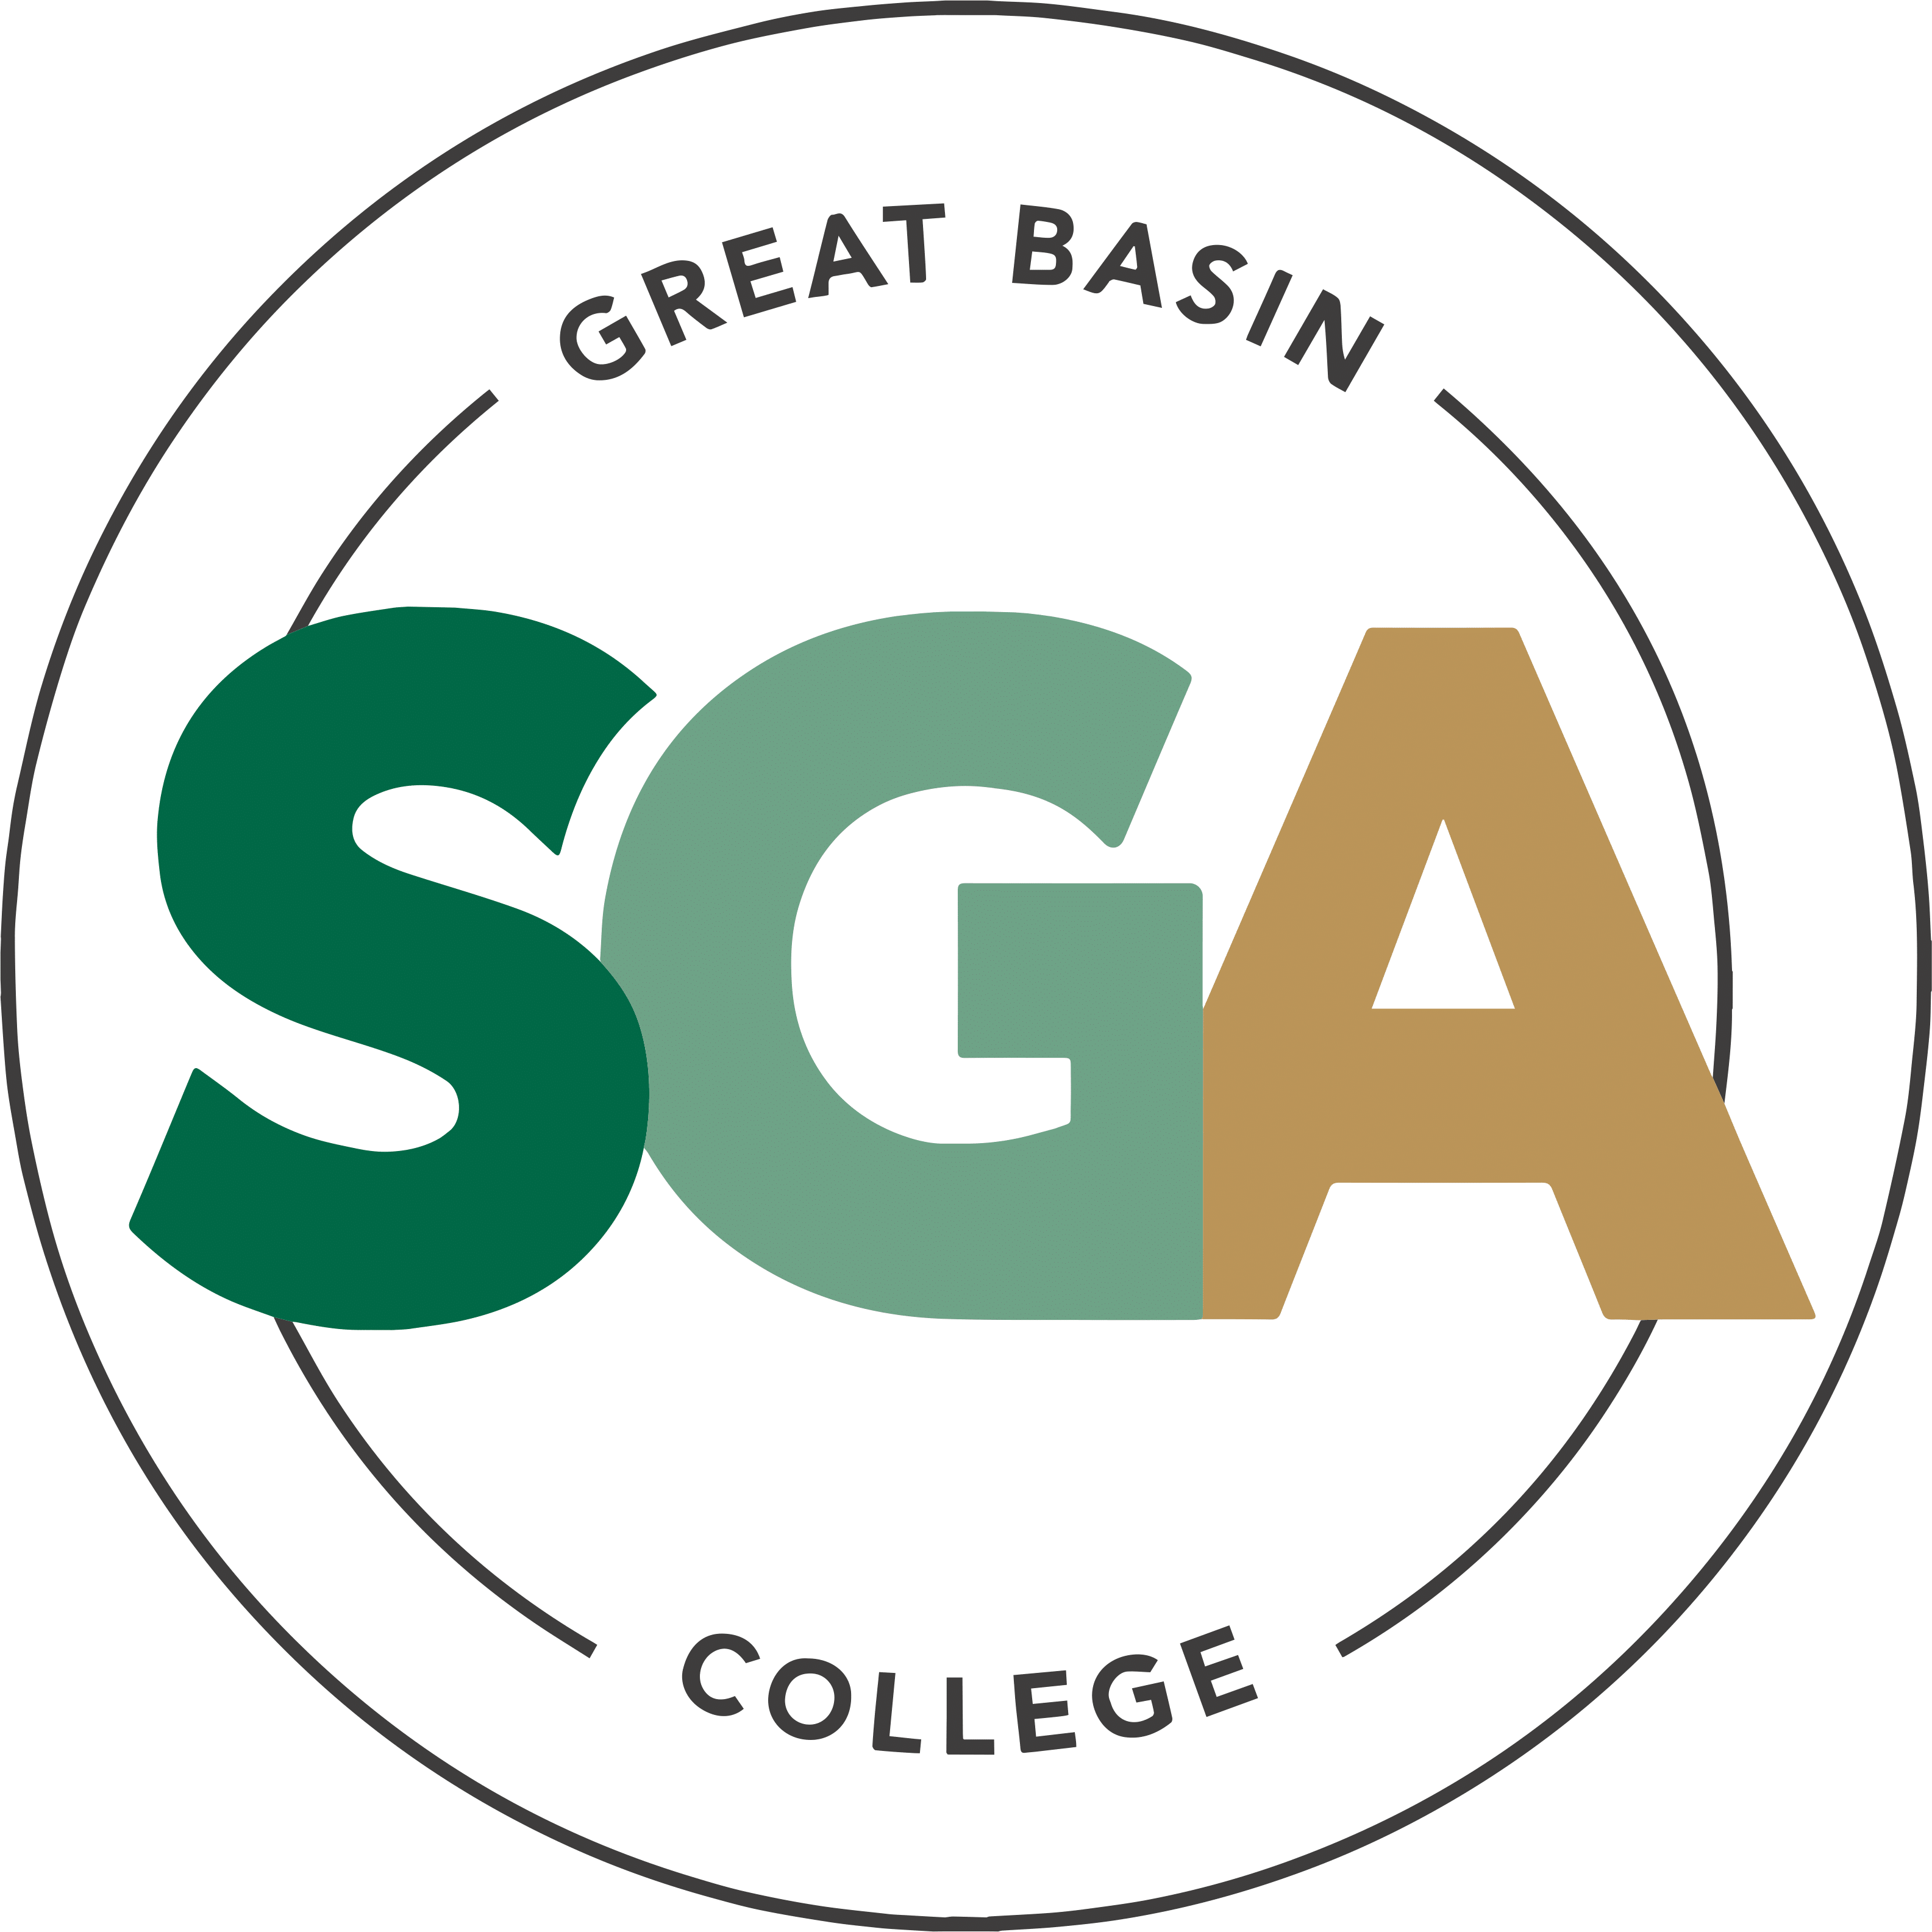

STUDENT GOVERNMENT ASSOCIATION (SGA)

MINUTES
January 20, 2026
3:00PM

VIDEO OR TELEPHONE CONFERENCE CONNECTION FROM THE MEETING SITE TO: 1500 COLLEGE PARKWAY; SGA OFFICE, LEONARD CENTER FOR STUDENT LIFE, GREAT BASIN COLLEGE CAMPUS, ELKO NV 89801
A VIDEO CONFERENCE CONNECTION WILL BE MADE FROM THE MEETING SITE TO ALL OTHER CAMPUS LOCATIONS.
THE PUBLIC MAY ATTEND THE MEETING AND PROVIDE PUBLIC COMMENT AT THIS SITE. PUBLIC COMMENT MAY ALSO BE SUBMITTED VIA ONLINE BY EMAILING SGA@GBCNV.EDU. COMMENTS MUST BE RECEIVED BY 5 PM PST THE DAY PRIOR TO THE MEETING. MEMBERS OF THE PUBLIC WISHING TO VIEW OR ATTEND THE MEETING MAY DO SO VIA ZOOM AT:
https://gbcnv-edu.zoom.us/j/84298011629?pwd=u7cz48zIwBHMP2dBEHkFAQ9r3DEMQR.1

Meeting called to order at 3:00 PM

EXECUTIVE MEMBERS:
JENNIFER RODRIGUEZ SERRANO, PRESIDENT Absent/Excused
JULIA STOKES, VICE PRESIDENT Present
DENIELLE KIRKMAN, SECRETARY Present

SENATORS:

IAN MITCHEL, ELKO Absent/Excused

MUHAMMED SALIKHOV, ELKO Absent/Excused

STORM RAINE, ELKO Present

YULIANA MENDEZ-BARAJAS, ELKO Present

ELIZABETH NASH, ELY Present

CATHERINE HANSON, ELY Absent/Excused

CATHERINE COLE, ONLINE Present

SOFIA MAYORGA, WINNEMUCCA Present

CALVIN COWAN, PAHRUMP Present

Guests:

David Bernardino- Running for SGA

Shakira Chesboro- Admin Assistant 3, Pahrump

Terilyn Marino- SGA Prospect

Jessica Ortiz- Student Life Coordinator

Christopher Salute- Director, Pahrump Center

IMPORTANT INFORMATION ABOUT THE AGENDA AND PUBLIC MEETING

NOTE: Below is an agenda of all items scheduled to be considered. Notification is hereby provided that items on the agenda may be taken out of the order presented, two or more agenda items may be combined for consideration, and an agenda item may be removed from the agenda or discussion relating to an item on the agenda may be delayed at any time.
The agenda and any supporting material, including materials submitted after the posting of this agenda but before the meeting, may be accessed on the Internet by visiting the SGA page of the GBC website: Great Basin College: Student Life - Meetings.
In accordance with NRS241.020(6), supporting materials that are submitted to the Student Government Association (SGA) will be made available in advance of the meeting. Reasonable efforts will be made to assist and accommodate physically disabled persons attending the meeting. Please call the Office for Students with Disabilities (775) 327-2336 in advance so that arrangements may be made.

ROLL CALL

Roll call of members and any persons serving as a proxy for a member will be taken.
Estimated Time: 5 minutes

PUBLIC COMMENT INFORMATION ONLY

Public comment will be taken during this agenda item. No action may be taken on a matter raised under this item until the matter is included on an agenda as an item on which action may be taken. Comments will be limited to two minutes per person. Persons making comment will be asked to begin by stating their name for the record and to spell their last name. The SGA President may elect to allow additional public comment on a specific agenda item when that agenda item is being considered.

Pursuant to NRS 241.023, members of the public may also participate in the meeting by submitting written public comment messages via email to james.kendall@gbcnv.edu. Written statements received by 4:30 p.m. on THURSDAY, January 15, 2026, will be distributed to SGA members and included in the permanent meeting record and names of those who provide public comment via email will be announced at the meeting, however messages will no longer be read into the record. Members of the public may attend the meeting and provide public comment.

In accordance with Attorney General Opinion No. 00-047 (April 27, 2001), as restated in the Attorney General’s Open Meeting Law Manual, the President may prohibit comment if the content of that comment is a topic that is not relevant to, or within the authority of, the SGA, or if the content is willfully disruptive of the meeting by being irrelevant, repetitious, slanderous, offensive, inflammatory, irrational or amounting to personal attacks or interfering with the rights of other speakers.

None

Estimated Time: 5 minutes

APPROVAL OF AGENDA POSSIBLE ACTION
A Request is made for approval of the GBC SGA Agenda for the meeting on 1/20/2026.
Secretary Kirkman Motions to Approve. Senator Raine Seconds.
Motion Passes Unanimously
Estimated Time: 1 minutes

APPROVAL OF MINUTES POSSIBLE ACTION
A Request is made for approval of the GBC SGA Minutes for the meeting on 1/13/2026.
Senator Raine Motions to Approve the Minutes. Senator Cowan Seconds.
Motion Passes Unanimously.
Senator Cole and Senator Mendez Abstain from Minutes
Estimated Time: 1 minutes

PRESIDENT’S REPORT INFORMATION ONLY

SGA PRESIDENT RODRIGUEZ will discuss current SGA events and activities as SGA President

President Rodriguez is absent.
Estimated Time: 5 minutes

VICE PRESIDENT’S REPORT INFORMATION ONLY

SGA VICE PRESIDENT STOKES will discuss current SGA events and activities as SGA Vice President.

Vice President Stokes reported that she hopes everyone has a wonderful first day of school, as well as the semester. She knows everyone will do great.
Estimated Time: 2 minutes

SECRETARY’S REPORT INFORMATION ONLY

SGA Secretary KIRKMAN will discuss current SGA events and activities as SGA Secretary.

Secretary Kirkman welcomed everyone back and mentioned that she is not ready for this semester. She got locked out of her email this morning and realized the agenda and minutes never sent. She apologizes for that. She hopes everyone has a good semester and mentioned that this is her last semester here at GBC.
Estimated Time: 2 minutes

STUDENT ADVOCATE’S REPORT INFORMATION ONLY

Student Advocate, JAMES KENDALL, will discuss current SGA events and items concerning SGA.

Student Advocate Kendall is absent.
Estimated Time: 5 minutes

SENATOR REPORTS INFORMATION ONLY

Senators from each location will discuss their current and future events: Elko, Ely, Online, Winnemucca, and Pahrump.

Storm Raine- Senator Raine reported he is glad to start up again. He loves the busyness of the campus. They are preparing for the other events.

Yuliana Mendez- Senator Mendez reported that she has been working a lot and she is excited for future events. She is going to try to take time off work to attend the events.

Liz Nash- Senator Nash reported that they have snacks out for this week for students for welcome back week. She is thinking of future events and ideas.

Cathy Cole- Senator Cole reported that she is just getting over a bad cold. She forgot that classes started this week, and she was shocked when she saw the fees. She may not be able to graduate and wants us to look into it. She hopes everyone had a good break.

Sofia Mayorga- Senator Mayorga reported she hopes everyone has a good first day back. She is trying to balance work and school. She is focusing on doing some more events.

Calvin Cowan- Senator Cowan reported that he hopes everyone’s semester is off to a great start. He was not prepared for the workload this semester, as he already has a paper due next week. He mentioned how well Senator Raine did on his speech. He is planning the Welcome Back event and getting things ready for that. He got to speak with Shakira and Dr. Salute about some things they will be doing initiative-wise.
Estimated Time: 10 minutes

Upcoming items

Ely Drink Station Refill Request with Senator Nash
Senator Nash would like to request funding for cups and stirrer sticks for the drink station. She is requesting $100 for supply funding.
Senator Cowan Motions to Approve. Senator Raine Seconds. Motion Passes Unanimously
Estimated Time: Less than 5 minutes

Pahrump Vending Machine with Christopher Salute
Christopher Salute would like to request funding for half the funding necessary for a new vending machine on campus. The current vending machine is having some issues with springs popping out, items not dispensing, and items being stuck in the springs. He is requesting $2,250 for supply funding.
Senator Cowan Motions to Table this item. Senator Raine Seconds. Motion to Table Passes Unanimously.
Estimated Time: 5-10 minutes

NEW BUSINESS INFORMATION ONLY
Items for consideration at future meetings may be suggested. Any discussion of an item under “New Business” is limited to description and clarification of the subject matter of the item, which may include the reasons for the request, and no substantive discussion may occur at this meeting on new business items in accordance with the Nevada Open Meeting Law (NRS 241.010 et seq.).
Secretary Kirkman asked Vice President Stokes about Professor Kleeb coming to a meeting to speak with us about the changes he wants to make to the BAS business program. Vice President Stokes mentioned she was going to bring that up next meeting. He will be coming in February. Senator Cowan mentioned that he reached out to students to find out what they want from SGA. Some of the members of SNO would like to collaborate with us and do some events. They are also working on getting food stocked for evening students. Senator Cole mentioned the SNO bingo we collaborated on a few years ago. Senator Raine was talking to students, and there were some groups there that were interested in starting up some clubs. Senator Cowan let Senator Raine know he can reach out to him for help with these clubs.

Estimated Time: 5 minutes

PUBLIC COMMENT INFORMATION ONLY

Public comment will be taken during this agenda item. No action may be taken on a matter raised under this item until the matter is included on an agenda as an item on which action may be taken. Comments will be limited to two minutes per person. Persons making comment will be asked to begin by stating their name for the record and to spell their last name. The SGA President may elect to allow additional public comment on a specific agenda item when that agenda item is being considered.

Pursuant to NRS 241.023, members of the public may also participate in the meeting by submitting written public comment messages via email to james.kendall@gbcnv.edu. Written statements received by 4:30 p.m. on THURSDAY, January 15, 2026, will be distributed to SGA members and included in the permanent meeting record and names of those who provide public comment via email will be announced at the meeting, however messages will no longer be read into the record. Members of the public may attend the meeting and provide public comment.

In accordance with Attorney General Opinion No. 00-047 (April 27, 2001), as restated in the Attorney General’s Open Meeting Law Manual, the President may prohibit comment if the content of that comment is a topic that is not relevant to, or within the authority of, the SGA, or if the content is willfully disruptive of the meeting by being irrelevant, repetitious, slanderous, offensive, inflammatory, irrational or amounting to personal attacks or interfering with the rights of other speakers.

Senator Mendez mentioned that if we can do the online survey and offer a cookie or food to incentivize students to fill it out. Senator Cowan encouraged everyone to let other students know that the SGA scholarship is live and to encourage students to apply.
Estimated Time: 5 minutes
Posted in accordance with Nevada Open Meeting Law (NRS Ch. 241), at the following locations:
GBC, Berg Hall, 1500 College Parkway, Elko, NV 89801
Nevada Public Notice Website - https://notice.nv.gov
GBC SGA Website - Great Basin College: Student Life - Meetings.

Meeting Adjourned at 3:31 PM

