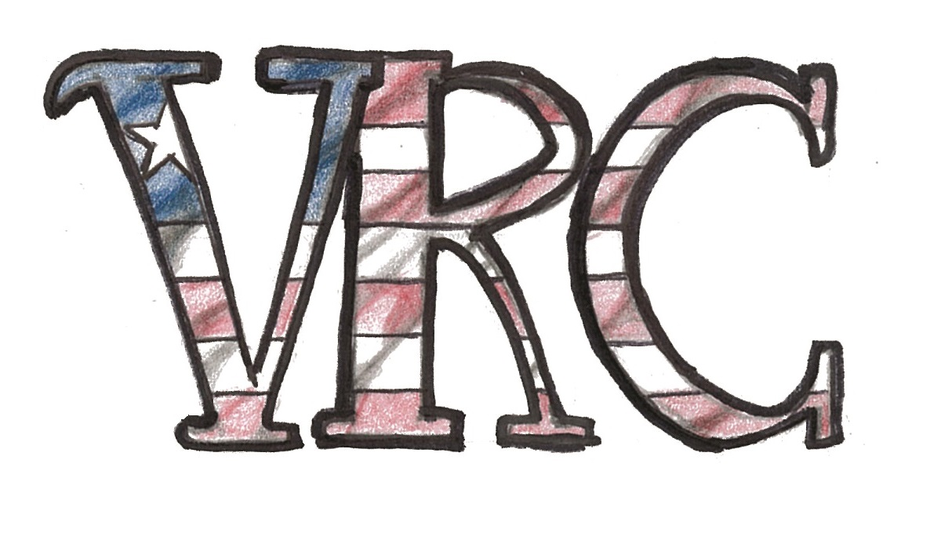

GREAT BASIN COLLEGE
WAIVER, RELEASE, AND INDEMNIFICATION AGREEMENT

I, ____________________________________________, hereby acknowledge that I have voluntarily elected to participate in the VRC Warrior of the Canyon walk, run, cycle event (the “Activity”) organized by the Veteran Resource Center of Great Basin College (“GBC”), a member institution of the Nevada System of Higher Education (“NSHE”). I understand and agree that the Activity involves certain risks which include, but are not limited to, the following:

1. Traveling to and from the Activity (transportation is not provided by GBC).
2. Walking, Running and/or Cycling — individuals should be aware of their own physical limitations.
3. Inclement weather that can impact safety (rain, cold, wind, heat).
4. Steep slopes, uneven terrain, loose rocks and gravel, slippery conditions.
5. Working with other volunteers from organizations of the community outside of GBC.
6. Viewing, participation or proximity to displays, events, demonstrations and flights of various aircraft.

I understand the nature of the “Warrior of the Canyon” Activity I wish to participate in may require mental judgment and a high degree of physical fitness, agility, and dexterity, and that this may include strenuous exercise that requires physical fitness, strength, and stamina. Knowing this information and the risks related to this Activity, in consideration of my participation in the Activity, I expressly and knowingly agree as follows:

RULES AND REQUIREMENTS: I agree to conduct myself in accordance with GBC policies and procedures, including those listed in the GBC Student Code of Conduct. I further agree to abide by all the rules and requirements of the Activity. I acknowledge that GBC has the right to terminate my participation in the Activity if it is determined that my conduct is detrimental to the best interests of the group, my conduct violates any rule of the Activity, or for any other reason in GBC’s discretion.

INFORMED CONSENT: I have been informed of and I understand the various aspects of the Activity, including the dangers, hazards, and risks inherent in the Activity, including but not limited to transportation to and from my residence via private vehicle, participation in the walk, run, cycle event, recreational activities including the BBQ, and weather conditions, conditions of equipment, facility conditions, negligent first aid operations or procedures, and in any activities I undertake as an adjunct to the Activity. In addition, I understand that as a participant in the Activity, I will engage in activities, including walking, running and/or cycling during which I could sustain personal injuries, illness, and/or property damage. I understand that as a participant in the Activity I could sustain serious personal injuries, property damage, or even death as a consequence of not only GBC’s actions or inactions, but also the actions, inactions, negligence or fault of others or myself, and that there may be other risks not known to me or not reasonably foreseeable at this time. I further understand and agree that any injury, property damage, disability or death that I may sustain by any means is my responsibility. .

RELEASE AND WAIVER OF LIABILITY: To the extent authorized by law, I, individually, and on behalf of my heirs, executors, administrators, personal representatives, successors and assigns, hereby release, forever discharge and agree not to sue NSHE and GBC and their officers, employees, agents, volunteers and representatives, from any and all liability, loss, claims, demands, causes of actions (known or unknown), suits, judgments, cost, expense or attorneys’ fees, including, but not

limited to, those arising from injury, loss or damage to my person or property, which arise out of, occur during, or are in any way the result of or connected with my participation in the Activity, REGARDLESS OF WHETHER THE INJURY, LOSS OR DAMAGE IS CAUSED BY NSHE OR GBC, , AND REGARDLESS OF WHETHER THE INJURY, LOSS OR DAMAGE OCCURS WHILE IN, ON, UPON, OR IN TRANSIT TO OR FROM THE PREMISES WHERE THE ACTIVITY OCCURS OR IS BEING CONDUCTED. I further agree that NSHE and GBC are not in any way responsible for any injury or damage that I sustain as a result of my own acts.
ASSUMPTION OF RISK: I understand that there are potential dangers incidental to my participation in the Activity, some of which may be dangerous and which may expose me to the risk of personal injuries, property damage, or even death. I understand that there are potential risks as a consequence of my participation in the Activity which include, but are not limited to the following: travel to and from the Activity location via private vehicles, weather conditions, facility conditions, equipment conditions, first aid operations or procedures, and other risks that are unknown at this time. I KNOWINGLY AND VOLUNTARILY ASSUME ALL SUCH RISKS, BOTH KNOWN AND UNKNOWN, EVEN IF ARISING FROM THE ACTS OF NSHE OR GBC, , and I assume full responsibility for my participation in the Activity.
INDEMNITY: I, individually, and on behalf of my heirs, successors, assigns and personal representatives, hereby agree to indemnify, defend, and hold harmless NSHE and GBC and their employees, agents, and representatives, from any and all liability whatsoever for any and all damages, losses, or injuries (including death) I sustain to my person or property or both,or I cause to another’s person or property, including but not limited to any claims, demands, actions, causes of action, judgments, expenses and costs, including attorneys’ fees, which arise out of, result from, occur during, or are connected in any manner with my participation in the Activity.
PERSONAL MEDICAL INSURANCE: I understand that neither the NSHE nor GBC will provide health insurance coverage to me during any aspect of my participation in the Activity. I further acknowledge that I am responsible for the cost of any and all medical and health services I may require as a result of participating in the Activity.

CONTROLLING LAW: To the extent that I, individually, or my heirs, successors, assigns, or personal
representatives bring a claim of any kind whatsoever against NSHE and/or GBC and/or their employees, agents, and representatives, I agree that this Waiver, Release and Indemnification Agreement is to be construed under the laws of the State of Nevada, including the provisions of Nevada Revised Statutes Chapter 41.
SEVERABILITY: If any term or provision of this Agreement shall be held invalid, illegal, unenforceable, or in conflict with any law governing this Agreement the validity of the remaining portions of the Agreement shall continue in full legal force and effect.

I hereby acknowledge that I have read this entire document, that I understand its terms, that by signing it I am giving up substantial legal rights I might otherwise have, and that I have signed it knowingly and voluntarily.
Participant’s Name (Print): __________________________________________________________
Participant’s Signature: ____________________________________________________________
Dated: ____________________________________________________________
If participant is a minor:
I am the parent or legal guardian of the Participant. I hereby acknowledge that I have read this entire document, that I understand its terms, that by signing it I am giving up substantial legal rights that I or the Participant might otherwise have, and that I have signed it knowingly and voluntarily. I allow Participant to participate in this Activity. I understand that I am responsible for the obligations and acts of Participant as described in this document. I agree to be bound by the terms of this document.

Participant’s Name (Print):_________________________________________________________

Guardian’s Name (Print): __________________________________________________________
Guardian’s Signature: ___________________________________________________________
Dated: ___________________________________________________________

